Introduction

The feast day of St. Josephine Bakhita is celebrated on the 8 February. She was born in Sudan in 1869 and died in Italy in 1947, aged 78 years.

She was a woman who was kidnapped and sold many times as a slave. Eventually, St. Bakhita was entrusted to the Canossian Sisters in Venice. It was there that St. Bakhita came to know about God and was baptised. In 1896 Saint Bakhita became a Canossian Sister.

St. Bakhita is the patron Saint of Sudan and because of her life experiences she also is known as the patron saint for the victims of slavery.

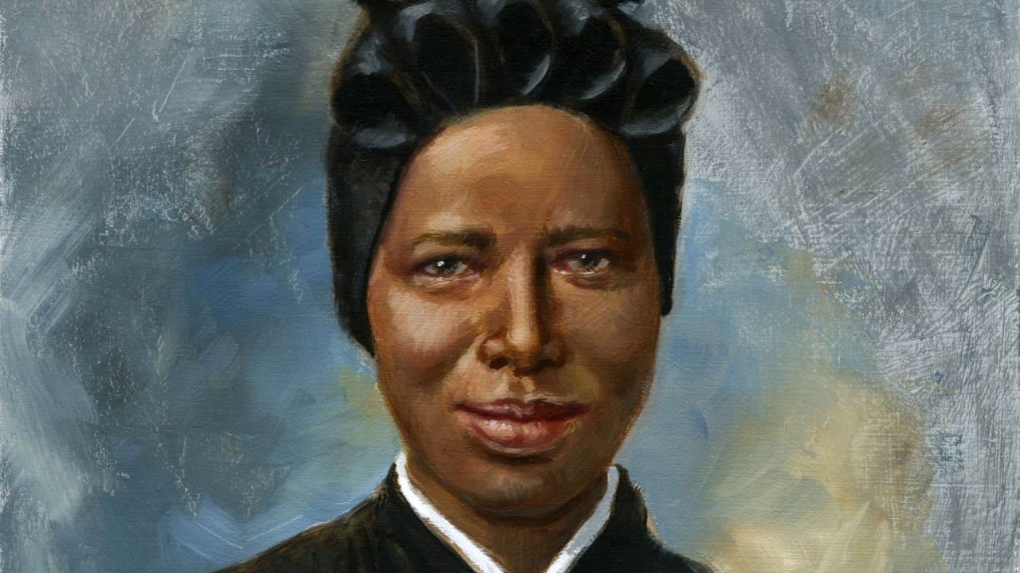
© Saint Mary's Press.

Sample Prayer Service

Opening Prayer

Loving God, you led St. Josephine Bakhita from the suffering of slavery to the dignity of the vocation to religious life.

We pray that by her example, we may show constant love for you and always be ready to show charity and compassion.

We ask this through our Lord Jesus Christ, who lives and reigns with you in the unity of the Holy Spirit, one God, for ever and ever.

All: Amen

Scripture
Luke 4:16-21

A reading from the Gospel of St Luke.

When he came to Nazareth, where he had been brought up, he went to the synagogue on the sabbath day, as was his custom. He stood up to read, and the scroll of the prophet Isaiah was given to him. He unrolled the scroll and found the place where it was written:
‘The Spirit of the Lord is upon me,
because he has anointed me
to bring good news to the poor.
He has sent me to proclaim release to the captives
and recovery of sight to the blind,
to let the oppressed go free,
to proclaim the year of the Lord’s favour.’
And he rolled up the scroll, gave it back to the attendant, and sat down. The eyes of all in the synagogue were fixed on him. Then he began to say to them, ‘Today this scripture has been fulfilled in your hearing.’
The Gospel of the Lord

All: Praise to you Lord Jesus Christ

Prayers of the Faithful

As we remember St. Josephine Bakhita, the patron saint of slavery, let us pray that God’s freedom and justice will be given to all people.

1. That leaders of the Church, like St. Bakhita, may become courageous
proclaimers of freedom and justice.
God of freedom and justice hear us.
All: Lord hear our prayer.

2. We pray for those who are victims of slavery, especially children, that they will
be respected as human beings.
God of freedom and justice hear us.
All: Lord hear our prayer.

3. We pray for all those who work for the dignity and humanity of those who
have lost their freedom.
God of freedom and justice hear us.
All: Lord hear our prayer.

4. We pray for an end to all discrimination, but especially discrimination against
children, so that they may live life to the full.
God of freedom and justice hear us.
All: Lord hear our prayer.

5. We pray that wealthy countries, such as Australia, may be generous in
supporting those nations where people live in circumstances that make them vulnerable to slavery.
God of freedom and justice hear us.
All: Lord hear our prayer.

Concluding Prayer

Loving God,
We humbly pray that those suffering due to slavery and discrimination may be given the dignity, respect, freedom, justice and peace that they deserve.
We ask this through Christ our Lord.

All: Amen

Sample Awareness Raising

Poster | Display the poster within the school each February.
Prayer Card | Pray the prayer on the prayer card within the school community.
Example Prayer of the Faithful | As we remember St. Josephine Bakhita, we pray for those who are victims of modern slavery. We pray for their freedom and healing. Let us pray to the Lord.  All: Lord hear our prayer
Prayer Service | Taking into consideration your school context, at some time throughout the year children participate in a prayer service dedicated to St. Bakhita.
English | Use modeled, shared and guided reading as opportunities to explore the concepts of slavery, freedom and justice.
Religious Education | Complete storytelling (story, wondering, exploring and prayer) to explore the concept of slavery.  - ‘The Birth of Moses’ - KWL Prep/Kindergarten Chapter 13, pages 90 to 98.  - KWL Big Book Year 1 ‘Joseph the Dreamer’.  - ‘Moses and the Burning Bush’ - Unit 1.5 Resource Sheet 2.  - ‘God of Freedom’ - KWL Year 2 Chapter 8, pages 86 to 95.  - ‘The Exodus’ - Unit 4.1 Resource Sheet 2.  - ‘Let Justice Flow’ - Unit 5.1 Amos 5:21-24 Resource Sheet 5.  Explore the concept of justice.  - Reaching Out in Justice - 5.1 Unit Content 1, 2 and 3.  - Unit 5.2 Lent: A Time for Growth - Unit Content 2.  - ‘The Beatitudes’ - KWL Year 6 Chapter 2, pages 15 to 17.  - A Just World - 6.2 Unit Content 2 and 3.  Songs  - John Burland - ‘The Beatitudes’, ‘Act Justly’, ‘Raise Your Voice for Justice’, ‘Building God’s Kingdom’.  - Andrew Chin - ‘Beatitudes’.  - As One Voice - 1-50 ‘Act Justly’, 2-14 ‘Give Thanks’, 2-60 ‘We Are Called’, 2-126 ‘Prayer of St. Francis’, 2-150 ‘We Are The Church’, 2-169 ‘The Servant Song’.

