

200 Years of Catholic Education
Launch Materials

This resource has been designed to assist schools with 200 Years of Catholic Education. It can be adapted to suit the needs of the local context.
Order of Service

Introduction

Leader:
Catholic Education is celebrating 200 years in Australia, marking the bicentenary of the first Catholic school established in Parramatta in October 1820. We gather today in prayer and reflection, to commemorate this most significant celebration.

Let us join in together as a school community, as we pray:

Sign of the Cross
In the Name of the Father, Son and Holy Spirit ✠
All: AMEN

Collect:
Leader:
O God, who sent your Son into the world as the true light,
pour out, we pray, the Spirit he promised,
may through Catholic Education, continue to sow seeds of truth
constantly in people’s hearts
and to awaken in them a deep understanding of the faith,
so that, being born to new life through Baptism,
all may become part of your one people.
Through our Lord Jesus Christ, your Son,
who lives and reigns with you in the unity of the Holy Spirit,
one God, for ever and ever.
Amen.

Ritual Prayer
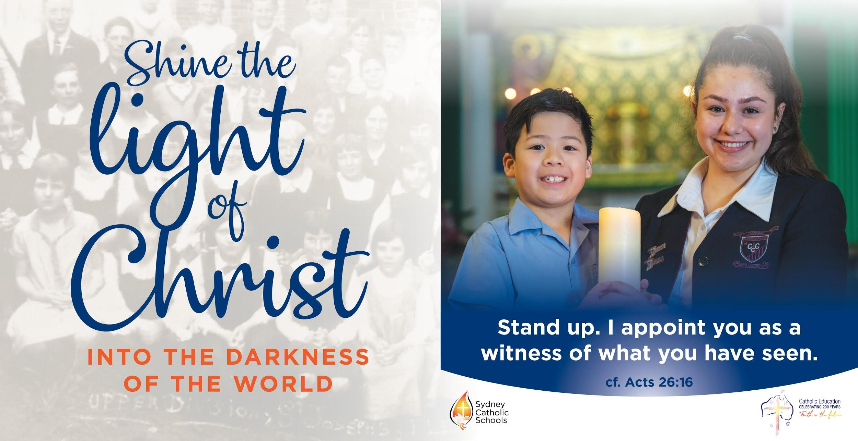
In keeping with the Sydney Catholic Schools theme, “Shine the light of Christ into the darkness of the world”, a ritual of lighting the candle and passing onto those who will take the faith into the future will now take place.

Resources needed:
- A large Candle, (School candle)
- Primary schools might like to use a Battery operated candle.
- Microphone stand; microphone for Readers to use
- Prayer space constructed. Image of Our Lady with Jesus

Leader:
Throughout the history of the Church there have been many changes. These changes, however, are God’s revelation of himself to us, and our faith in God. As we celebrate 200 years of Catholic Education in Australia, we acknowledge those who have brought the light of Christ to our communities in the past, and we recommit ourselves to continue their work and the mission of the Church. We remember the past with gratitude and inspired by the stories of struggle and success, we look forward with faith and hope to the future.

[Leader gives unlit candle to first student reader. Student #1 reads their part whilst the Leader then lights the candle from the School candle]

Student #1: The Church began at Pentecost when the tongues of fire, sparked a community to bring the light of Christ into the world.

[Student #1 passes on the lit candle carefully to the next student reader and so on]

Student #2: In the early days of our nation's history, the light of Christ emerged as a beacon for those who had endured difficult circumstances. The early schools in our history were determined to keep the faith alive.

[Student #2 passes on the lit candle carefully to the next student reader and so on]

Student #3: Through growth, challenges and change over time, we recognise the light of the Religious Orders, Clergy and lay Catholics. We are grateful for their sacrifices and dedication to the education of the young.

[Student #3 passes on the lit candle carefully to the next student reader and so on]

Student #4: Today we recognise the importance of knowing and loving Christ in all our work. Our school is a part of a broader community that aims to be a place that thrives through, excellent teaching and learning.

[Student #4 passes on the lit candle carefully to the next student reader and so on]

Student #5: As we head towards the future, we take the light of Christ into uncharted places. Let us recognise that our faith in God and trust in Jesus Christ, will not waver amid uncertain challenges that lay ahead.

[Student #5 places candle in a suitable area around prayer space]

Prayer of The Faithful

Leader: In this season of Lent, let us pray to see beyond the daily cares of this world and towards the glory of Jesus’ death and resurrection, which gives us purpose.
The response is Lord guide our steps.
All: Lord guide our steps.

Intercession #1
For the Church leaders, especially our Bishops and Clergy, may they continue to bring the light of Christ into the hearts of the faithful and draw them into a deep appreciation of God’s presence in our world. Hear us as we pray;

All: Lord guide our steps.

Intercession #2
For the young people in our Catholic schools. May they be inspired by Jesus Christ and be nurtured by Catholic education, to become young men and women of good character and ideals and contribute as leaders and disciples in our world. Hear us as we pray;

All: Lord guide our steps.

Intercession #3
For teaching staff in Catholic education. In this year of celebrations that they recommit to the mission of the Church through good practice, leadership and quality teaching. Help them to be aware that their responsibilities extend to the moral, spiritual and social aspects of life. Hear us as we pray;

All: Lord guide our steps.

Intercession #4
For our dearly departed, that they find rest in the light of God’s love. Hear us as we pray;

All: Lord guide our steps.

Intercession #5
For our school community, that we journey through this year with wisdom, optimism and confidence. Help us to realise that the presence of Christ is always there to guide our steps and light our path. Hear us as we pray;

All: Lord guide our steps.

Leader:
Lord, we thank you for calling us forth to do your work. Guide our steps when we falter, and keep our path clear before us. Spark our hearts to shine for you. Let all our words, thoughts and actions give you praise and glory.

All: Amen

Principal’s Address

A few words from the Principal about the occasion

· Recognition of 200 Years of Catholic Education
· Statement of intention in support of the celebration.
· Local history - mention significant aspects of the local history.
· Recognition of Charism and Religious who either built or contributed to the foundations of the school or College.

Leader: May the presence of the Holy Spirit be with us.
May we ignite sparks of beauty wherever we are.
May the wisdom of those who travelled in the wilderness encourage us.
May we have the commitment to be witnesses wherever we are.

May we go forth into today and tomorrow, with open eyes to the light of the Divine Presence around us, in the people we meet and places we go.

May Christ guide our steps and light our path.

All: AMEN

National Prayer (PDF)

Almighty and all-loving God,
with gratitude for the endeavours of Catholic education in the past,
with confidence in our Catholic pre-schools, schools and universities today,
and with faith in their continuing contribution in the future,
we celebrate 200 years of Catholic education in this Great South Land.
As our Heavenly Father,
we thank you for your providential care for your children in this land
in inspiring priests, religious and lay people
to found and staff our schools in ages past.
Through them the Good News of your Son was brought to the young
even in colonial times – and ever since.
As Christ the Teacher,
you grace the staff and leaders of Catholic education today.
As they build on the achievements of their predecessors
direct them in their present efforts
to ensure that every young Australian has the opportunity
for an excellent education and formation in faith.
As our Inspiring Spirit,
you lead us into the future.
In the century ahead grant those teaching and
learning in our schools,
those planning and leading,
and the families and community that entrust
their young people to us,
a love of learning and a willingness to be the
face of Christ
in the world of tomorrow.
Pour out your abundant blessings upon all involved in
the ministry of Catholic education. Amen.

Our Lady of the Southern Cross – pray for us.
St Mary of the Cross MacKillop, Patron of Catholic
Education in Australia – pray for us.

In the Name of the Father, Son and Holy Spirit ✠
ALL: AMEN

National Song

“Faith in the Future”
Accessible via NCEC website
https://200years.catholic.edu.au/resources-2/

© 2020 Fr Rob Galea
Words and Music Fr Rob Galea & Luke Batterbury
Used With Permission

Lyrics Slide for assembly
Please find PowerPoint slides for Lyrics of the National song
Lyrics Slides

National Catholic Education Commission - National song 45 second clip for school assemblies

Other suggestions to include during this time:
- Share an inspiring story of your own school history
- Refer to stories about Mary Mackillop as a Catholic educator
- Play the National Song as the school bell for celebration days.
- Invite the Parish Priest to give a blessing
- Invite alumni to share their experience of their Catholic education at the school
- Encourage devotions to Our Lady Help of Christians as the Patron Saint of Australia.
- Interview a teacher about their experiences of a Catholic School.
- Present lapel pins formally to staff (not at assembly)

Share your celebration

To assist with the celebration of this wonderful occasion, please forward any media captured so that it can be shared with the Sydney Catholic Schools Communications Team and published on the RE Online page.

If schools are doing events with a historical focus please submit them to us.

Contact Glen Thompson glen.thompson@syd.catholic.edu.au or Isabella Fichera isabella.fichera001@syd.catholic.edu.au

