**St Therese of Lisieux**

**Early Years**

The Martin household was a lively place. Therese was the baby and everyone's favourite, especially her mother's. However, Due to Therese's weak and frail condition at birth, she was taken care of by a nurse for her first year and a half. Because of this care, she became a lively, mischievous and self-confident child.

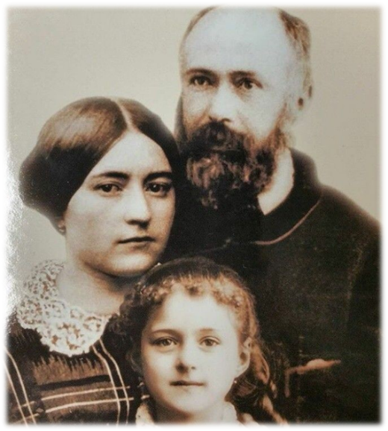Therese was, her mother wrote, "incredibly stubborn. When she has said 'no', nothing will make her change her mind." Little

Therese was blond, blue-eyed, affectionate, stubborn, and alarmingly precocious. In a note, Zelie advised her daughter Pauline: "She (Therese) flies into frightful tantrums; when things don't go just right and according to her way of thinking, she rolls on the floor in desperation like one without any hope. There are times when it gets too much for her and she literally chokes. She's a nervous child, but she is very good, very intelligent, and remembers everything."

Through it all, however, Therese thrived on the love which surrounded her in this Christian home. It was here, where prayer, the liturgy, and practical good works formed the basis of her own ardent love of Jesus - her desire to please Him and the Virgin Mary.

Therese with her mother Zelie and father Louis

Therese's mother, Zelie (after an illness of twelve years), died of breast cancer in August, 1877. Therese was only four years old at the time.

In October, 1881, Louis enrolled his youngest daughter (Therese) as a day boarder at Lisieux's Benedictine Abbey school of Notre-Dame du Pre. Therese hated the place and stated "the five years (1881 - 1886) I spent there were the saddest of my life."

**School Years**

Classes bored her. She worked hard, and loved catechism, history and science, but had trouble with spelling and mathematics. Because of her overall intelligence, the good nuns advanced the eight-year-old to classes for fourteen-year-olds. Her keenness aroused the envy of many fellow pupils, and Therese paid dearly for her academic successes.

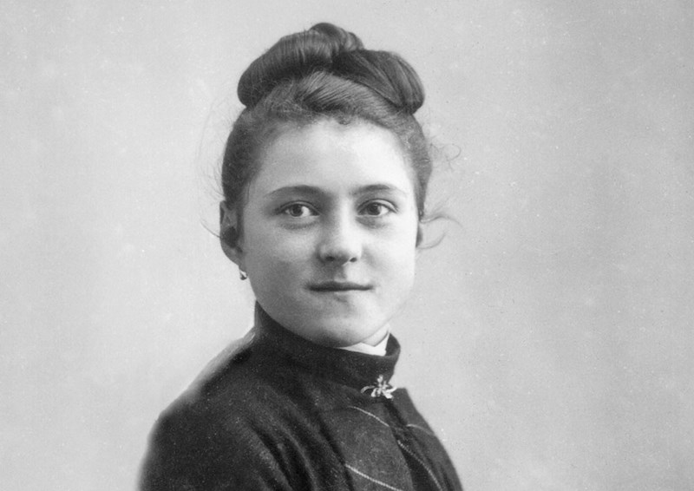Therese was most close with her sister Pauline who was like a second mother. However, when Pauline entered the convent to become a Carmelite nun, Therese was devastated. Therese fell seriously ill. She suffered intensely during this time from constant headaches and insomnia. She took fits of fever and trembling and suffered cruel hallucinations.

None of the treatments helped. Then, on May 13, 1883, Therese turned her head to a statue of the Virgin near her bed, and prayed for a cure. "Suddenly" Therese writes, "...Mary's face radiated kindness and love." Therese was cured. The statue has since been called "Our Lady of the Smile."

It was shortly after Pauline's departure that Therese decided to join her at Lisieux's Carmelite Convent. Therese explained she wished to enter, not for Pauline's sake, but for Jesus' sake. The prioress advised her to return when she grew up. Therese was only nine years old at the time.

During her long illness, her resolve to join the Carmelites grew even stronger. "I am convinced that the thought of one day becoming a Carmelite made me live," she later declared. After her illness, Therese was more than ever determined to do something great for God and for others. She thought of herself as a new Joan of Arc, dedicated to the rescue not only of France but of the whole world.

With unbelievable boldness the ten-year-old stated, "I was born for glory." And thus another great theme of Therese's life manifested itself. She perceived her life's mission as one of salvation for all people. She was to accomplish this by becoming a saint.

At the age of eleven, on May 8, 1884, Therese received her first "kiss of love", a sense of being "united" with Jesus, of His giving Himself to her, as she gave herself to Him by making her First Holy Communion. A few months later on June 14, 1884,, she received Confirmation, "the sacrament of Love," which filled Therese with ecstasy. Therese became fearful of sining

On October 15, 1886, her other sister Marie, who had also became very close with Therese, like her sister Pauline, also entered the Lisieux Carmel This was very hard on Therese, who at the age of thirteen, had now lost her "third" mother. However, Therese eventually recovered she embarked on her "Giant's Race." She was consumed like Jesus with a thirst for souls. "My heart was filled with charity. I forgot myself to please others and, in doing so, became happy myself."

Now, she could fulfill her dream of entering the Carmel as soon as possible to love Jesus and pray for sinners. At Mass in the summer of 1887 Therese received a grace that left her with a vision of standing at the foot of the Cross, collecting the blood of Jesus and giving it to souls. Convinced that her prayers and sufferings could bring people to Christ, she boldly asked Jesus to give her some sign that she was right. He did.

Therese was not yet fifteen when she approached the Carmelite authorities again for permission to enter. Again she was refused. So Therese spoke to the Bishop of Hugonin of Bayeux She came to his office with her father one rainy day and put her surprising request before him. "You are not yet fifteen and you wish this?" the bishop questioned. "I wished it since the dawn of reason," young Therese declared. Bishop Hugonin did not immediately grant Therese's request. He wanted time to consider it.

Therese had planned that, should the Bayeux trip fail, she would go to the Pope himself. Thus in November, 1887, Louis took his daughters, Therese and Celine, to Italy with a group of French pilgrims. The great day of the audience with Pope Leo XIII came at the end of their week in Rome. On Sunday, November 20, 1887, "they told us on the Pope's behalf that it was forbidden to speak as this would prolong the audience too much. I turned toward my dear Celine for advice: 'Speak!' she said. A moment later I was at the Holy Father's feet...Lifting tear-filled eyes to his face I cried out: 'Most Holy Father, I have a great favour to ask you!...Holy Father, in honour of your jubilee, permit me to enter Carmel at the age of fifteen.'"

"Well, my child," the Holy Father replied, "do what the superiors tell you." "Resting my hands on his knees," Therese continued, "I made a final effort, saying, 'Oh, Holy Father, if you say yes, everybody will agree!' He gazed at me speaking these words and stressing each syllable: 'Go - go - you will enter if God wills it.'"

**Entering the Monastery of Carmel Lisieux**

On New Year's day, 1888, the prioress of the Lisieux Carmel advised Therese she would be received into the monastery. On April 9, 1888, an emotional and tearful, but determined Therese Martin said good-bye to her home and her family. She was going to live "for ever and ever" in the desert with Jesus and twenty-four enclosed companions: she was fifteen years and three months old. Louis her father who had become gravely ill and managed to attend the ceremonies of Therese's clothing in the Carmelite habit on January 10, 1889. Therese's father made one last visit to the Carmel in May, 1892.

He died peacefully two years later, in 1894, with his daughter Celine at his side. Celine then joined her three sisters at Carmel in September of 1894. Therese spent the last nine years of her life at the Lisieux Carmel. Her fellow Sisters recognized her as a good nun, nothing more.

She was conscientious and capable. Sister Therese worked in the sacristy, cleaned the dining room, painted pictures, composed short pious plays for the Sisters, wrote poems, and lived the intense community prayer life of the cloister. Superiors appointed her to instruct the novices of the community. Externally, there was nothing remarkable about this Carmelite nun.

Therese Develops Her "Little Way"

Therese was aware of her littleness. "It is impossible for me to grow up, so I must bear with myself such as I am with all my imperfections. But I want to seek out a means of going to heaven by a little way, a way that is very straight, very short and totally new."

Therese went on to describe the elevator in the home of a rich person. And she continued: "I wanted to find an elevator which would raise me to Jesus, for I am too small to climb the rough stairway of perfection. I searched then in the Scriptures for some sign of this elevator, the object of my desires and I read these words coming from the mouth of Eternal Wisdom: 'Whoever is a little one let him come to me.' The elevator which must raise me to heaven is your arms, O Jesus, and for this I have no need to grow up, but rather I have to remain little and become this more and more," And so she abandoned herself to Jesus and her life became a continual acceptance of the will of the Lord.

Therese died on 30 September after a 3 months suffering with Tuberculosis. She was 24 years of age. Her cause for Beatification was introduced at Rome on June 10, 1914 and she was canonised a Saint on April 29, 1923. She is known as St Therese the Child of Jesus” and also referred to as “The Little Flower. ” St Therese was declared a Doctor of the Church on October 19, 1997.