**Saint Therese of Lisieux**

Therese was born in the country of France on January 2, 1873.

She was the youngest of 9 children, and she was often spoilt by her family.

When Therese was just 4 years old, her mother became sick and died. Therese soon became ill and no one had a cure. Her family was concerned for her.

A miracle occurred when Therese saw a statue of the Virgin Mary come to life and smile at her.

She became well and knew that everything was going to be alright, all because of the Virgin Mary and her son, Jesus.

St Therese’s older sisters left to live in the convent. This made Therese sad because she also wanted to become a nun.

She even asked Pope Leo. He kindly told her to pray. But Therese loved God so much and she became a Carmelite nun at the age of 15.

St Therese would devote herself to God with small acts of Love. She could not travel to help others, so she did little things. Little chores like cooking and cleaning. Doing little things became known as St Therese’s the “Little Way.” St Therese said “*I will seek out a means of getting to Heaven by a little way—very short and very straight little way that is wholly new. Well, I mean to try and find a lift by which I may be raised unto God, for I am too tiny to climb the steep stairway of perfection.”*

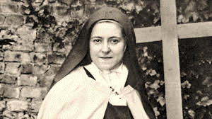Therese became very ill with a sickness called Tuberculosis and she died when at the age of 24. Before she died, she wrote a book called “Story of a Soul” which tells us how we all can do little things to love God.

Therese is now a Saint. Someone who is friends with God and lives in Heaven. She is called “The Little Flower” and “The Child of Jesus.”

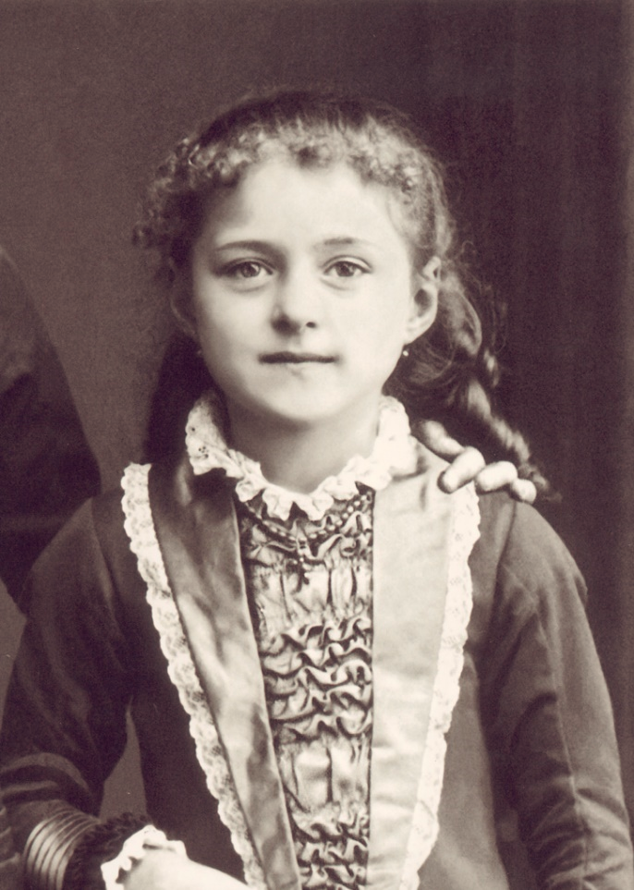Saint Therese is our heavenly friend. Reminding us that little acts of love can also lead us to Heaven.

St Therese’s feast day is on the First of October.

She is the patron saint of missionaries and florists.

St Therese when she entered the Carmelite Convent in Lisieux and her as young child.

**St Zelie Martin**

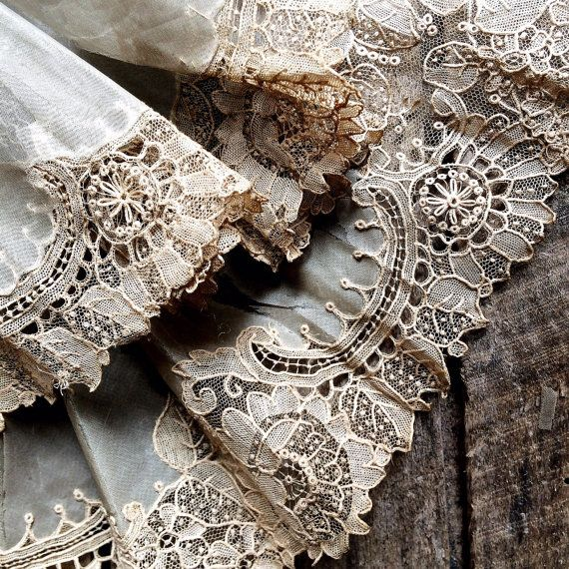Zelie had a very sad childhood and her mother and father did not show her much affection. As she grew into a young lady, Zelie wanted to become a nun, but instead she learned how to make beautiful lace. Zelie started her own business selling the lace she made and became successful. She became a wife and mother where her strength, her courage and her faith in God was an inspiration to her nine children and her husband whom she loved very much.

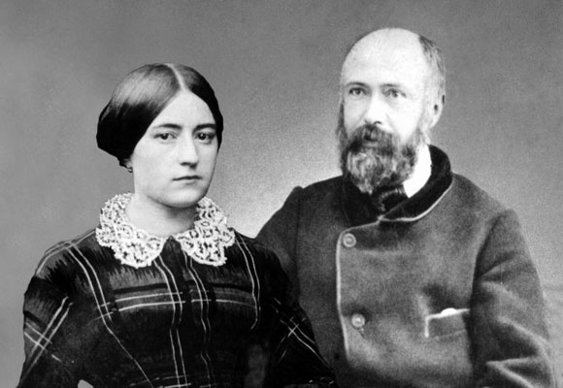

An example of the special type of lace called ‘Alencon Lace’ that Zelie would have made by hand.

Zelie and Lewie Martin, parents of St Therese were made saints in 2015.

**St Louis Martin**

Louis Martin was a successful watchmaker and he managed his wife Zelie’s lace business. At twenty two years of age he also tried to enter religious life however he left the monastery because he got sick and because he had to learn Latin which was very hard for him.

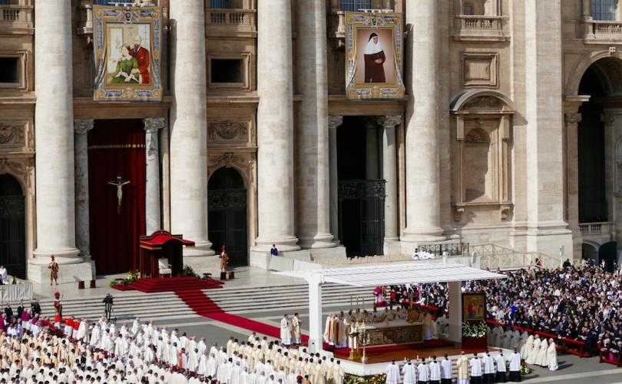Louis married Zelie, and as a very spiritual man, he still tried to be holy by being a loving husband to his wife and children. Both Zelie and Louis show us the example of a loving marriage and a family life which were guided by faith and love for God. They were made saints in 2015.

Pope Francis offers the Mass of Canonization for Louis and Zélie Martin, parents of Saint Thérèse of Lisieux, in 2015