Bottom of Form

**Student Resource Sheet Upper Secondary**

**The practice of venerating the relics of the saints**

From the Shroud of Turin, or the finger of St. Thomas, to the miraculous blood of St. Januarius, or the brain of St. John Bosco, the Catholic Church keeps and venerates many curious but nevertheless holy artifacts, known as relics, from Jesus and the saints. But the roots of the tradition pre-date Jesus, and the practice is based in Scripture and centuries of Church teaching.

While it’s one of the most fascinating traditions of the Church, it can also be one of the most misunderstood. Father Carlos Martins, CC, is a Custos Reliquiarum, which is an ecclesiastically appointed Curate of Relics with the authority to issue relics. He is a member of Companions of the Cross, and the head of Treasures of the Church, a ministry that aims to give people an experience of the living God through an encounter with the relics of his saints in the form of an exposition. The ministry brings expositions of various relics throughout North America by invitation.

*In the following interview with CNA, Fr. Martins answers questions and dispels some common misunderstandings about the tradition of relics.*

**First of all, what is a relic?**

Sacred relics are physical objects that have a direct association with the saints or with Jesus Christ. The word relic means ‘a fragment,’ ‘part of a thing that once was but now is no longer’ or ‘things left behind.’ Relics are usually broken down into three classes.

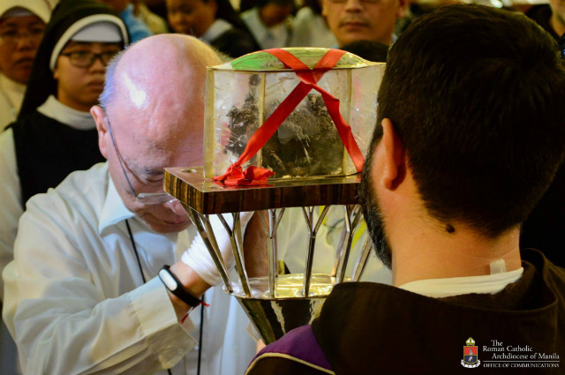First class relics are the body or fragments of the body of a saint, such as pieces of bone or flesh.

Second class relics are something that a saint personally owned, such as a shirt or book (or fragments of those items.)

Third class relics are those items that a saint touched or that have been touched to the tomb or a first or second class relic of the saint.

First class relic. Catholics pray before the incorrupt heart relic of Saint Padre Pio at the University of Santo Tomas on October 8, 2018. Photo by Eric Paul Guanlao/Archdiocese of Manila Office of Communications

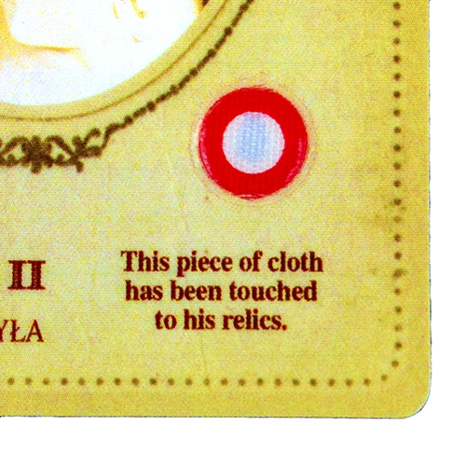

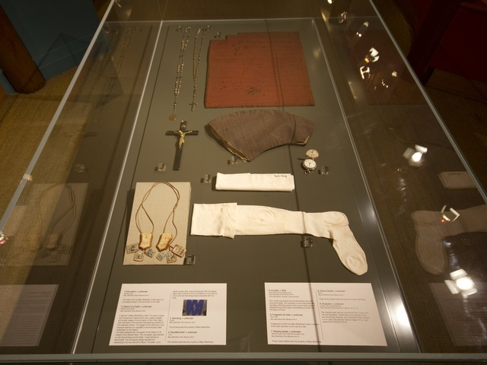

Second class relics. Items that belonged to Saint Mary of the Cross Mackillop

Third class relic of St Pope John Paul II.

A Relic is preserved and honoured by believers as an expression of faith in God and belief that we have eternal life because of Jesus’ death on the cross.

**Where did the Catholic tradition of venerating saints’ relics come from?**

Scripture teaches that God acts through relics, especially in terms of healing. In fact, when surveying what Scripture has to say about sacred relics, one is left with the idea that healing is what relics “do.”

When the corpse of a man was touched to the bones of the prophet Elisha the man came back to life and rose to his feet (2 Kings 13:20-21).

A woman was healed of her haemorrhage simply by touching the hem of Jesus’ cloak (Matthew 9:20-22).

The signs and wonders worked by the Apostles were so great that people would line the streets with the sick so that when Peter walked by at least his shadow might ‘touch’ them (Acts 5:12-15).

When handkerchiefs or aprons that had been touched to Paul were applied to the sick, the people were healed and evil spirits were driven out of them (Acts 19:11-12).

In each of these instances God has brought about a healing using a material object. The vehicle for the healing was the touching of that object. It is very important to note, however, that the cause of the healing is God; the relics are a means through which He acts. In other words, relics are not magic. They do not contain a power that is their own; a power separate from God.

Any good that comes about through a relic is God’s doing. But the fact that God chooses to use the relics of saints to work healing and miracles tells us that He wants to draw our attention to the saints as “models and intercessors” (Catechism of the Catholic Church, 828).

**When did the veneration of relics begin?**

It was present from the earliest days of Christianity, during the Apostolic age itself. The following is an account written by the Church in Smyrna (modern day Izmir, Turkey) when its bishop, St. Polycarp was burned alive:

“We adore Christ, because He is the Son of God, but the martyrs we love as disciples and imitators of the Lord. So we buried in a becoming place Polycarp’s remains, which are more precious to us than the costliest diamonds, and which we esteem more highly than gold.”   
(Acts of St. Polycarp, composed approx. 156 AD)

Polycarp was a significant figure. He was converted by John the Apostle, who had baptized him and subsequently ordained him a bishop. Thus we see that from its outset the Church practiced devotion to the remains of the martyrs.

**What is the spiritual significance of relics?**

I think that St. Jerome put it best when he said:

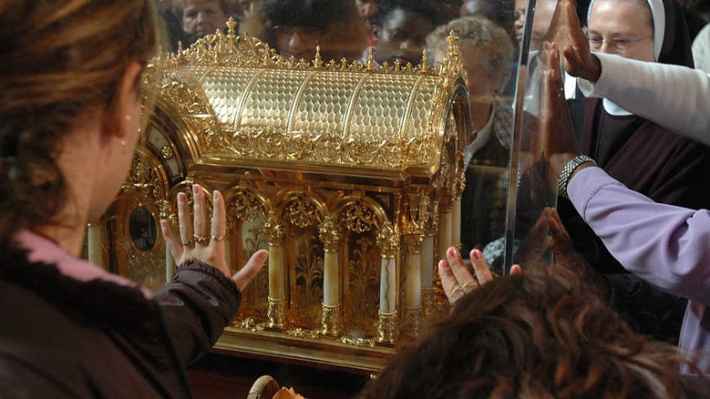“We do not worship relics, we do not adore them, for fear that we should bow down to the creature rather than to the creator. But we venerate the relics of the martyrs in order the better to adore him whose martyrs they are.” (Ad Riparium, i, P.L., XXII, 907).

We venerate relics only for the sake of worshiping God.

Parishioners venerate the Relics of St Therese of the Child Jesus

**When we collect relics from the body of a saint, what part of the body do we use?**

Any part of the saint’s body is sacred and can be placed in a reliquary. Any and every bone may be used. In addition, flesh, hair, and sometimes blood, are also used. Sometimes everything from the tomb is dispersed from it. Sometimes a tomb is preserved.

**At what point in the canonization process are items or body parts considered official relics by the Church?**

Before the beatification takes place, there is a formal rite whereby the relics are identified and moved (the official word is “translated”) into a church, a chapel, or an oratory. Put simply, the grave is exhumed and the mortal remains are retrieved.

Only the Church has the juridical power to formally recognize the sanctity of an individual. When the Church does this – through beatification and canonization – their relics receive the canonical recognition as being sacred relics.

There is an importance difference between beatification and canonization. Beatification is the declaration by the Church that there is strong evidence that the person in question is among the blessed in heaven. Nevertheless, beatification permits only local devotion. That is, devotion in the country in which the individual lived and died. When Mother Teresa was beatified, for instance, only in India and in her native Albania was her devotion permitted. Her Mass could not be celebrated, for example, in the United States, nor could her relics be placed within its altars.

Whereas beatification permits local devotion, canonization, on the other hand, mandates universal devotion. It grants to the canonized individual the rights of devotion throughout the universal Church.

**What is the proper way to keep relics? Are lay Catholics allowed to have first class relics in their homes?**

Relics are very precious. They are not something that was alive at one time and is now dead. In the case of first class relics, we are talking about flesh that is awaiting the general resurrection, where the soul of a saint will be reunited with his physical remains.

As such, the way we treat relics is of the utmost importance. Ideally, relics should be kept in a Church or chapel where they can be made available for public veneration.

The highest honour the Church can give to a relic is to place it within an altar, where the Mass may be celebrated over it. This practice dates from the earliest centuries of the Church. In fact, the sepulchers of the martyrs were the most prized altars for the liturgy.

As an alternative to encasing them within altars, they may be installed within a devotional niche where people may venerate them. Such shrines are important as they afford people a deeper experience of intimacy with the saint.

The Church does not forbid the possession of relics by lay persons. They may even keep them in their homes. However, because of the many abuses that have been committed concerning relics, the Church will no longer issue relics to individuals – not even to clergy.

Thus, to protect relics, the Church only issues them to Churches, chapels, and oratories.

**How important is the authenticity of the relic? How does the Church go about determining authenticity of very old relics from the beginning of the Church?**

The authenticity is critically important.

But for the ancient saints, determining identity is much easier than you might think.  It was tradition to build a church over top of a saint’s grave. That is why St. Peter's Basilica is where it is, or why St. Paul Outside the Walls is there. Both encompass the tomb for the saint, which is located directly beneath the altar.

Modern archaeology has only affirmed what the ancient tradition has believed.

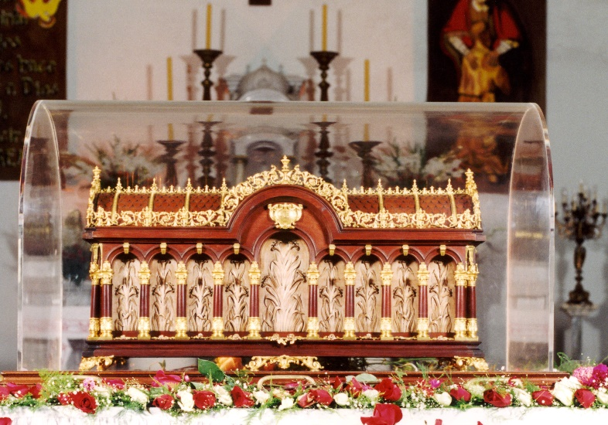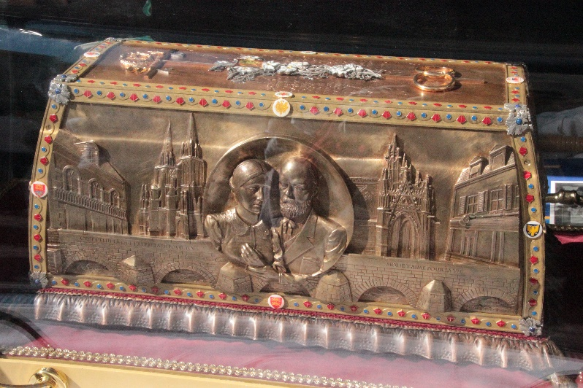Bottom of Form

Reliquary of St Lewie and St Zelie parents of St Therese

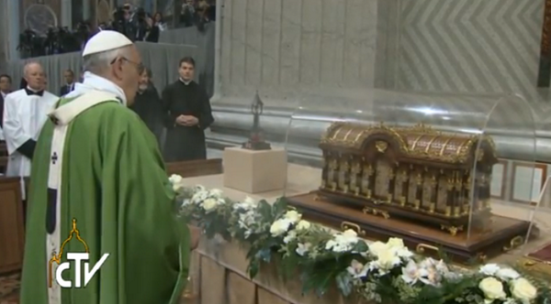

**Source:** *The original article* By [Mary Farrow](https://plus.google.com/112632115544901082873/?rel=author) *was published on CNA Aug. 11, 2017.*

<https://www.catholicnewsagency.com/news/is-it-weird-that-catholics-venerate-relics-heres-why-we-do-72479>

Pope Francis incenses the relics of St. Therese and of her parents, Blessed Louis and Zelie Mart*in (now both saints) St Pe*ter's Basilica, October 5, 2014. Photo credit: CTV

Reliquary of St Therese