**Student Resource Sheet Upper Primary/Lower Secondary**

**The Practice of Venerating the Relics of the Saints**

**What is a Sacred Relic?**

Sacred relics are physical objects that have a direct association with the saints or with Jesus Christ. The word relic means ‘a fragment,’ ‘part of a thing that once was but now is no longer’ or ‘things left behind.’ Relics are usually broken down into three classes.

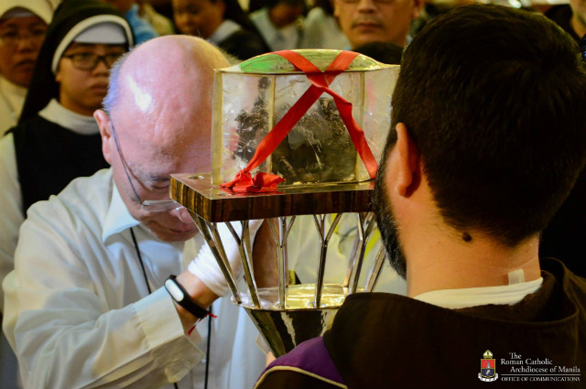First class relics are the body or fragments of the body of a saint, such as pieces of bone or flesh.

Second class relics are something that a saint personally owned, such as a shirt or book (or fragments of those items.)

Third class relics are those items that a saint touched or that have been touched to the tomb or a first or second class relic of the saint.

First class relic. Catholics pray before the incorrupt heart relic of Saint Padre Pio at the University of Santo Tomas on October 8, 2018. Photo by Eric Paul Guanlao/Archdiocese of Manila Office of Communications

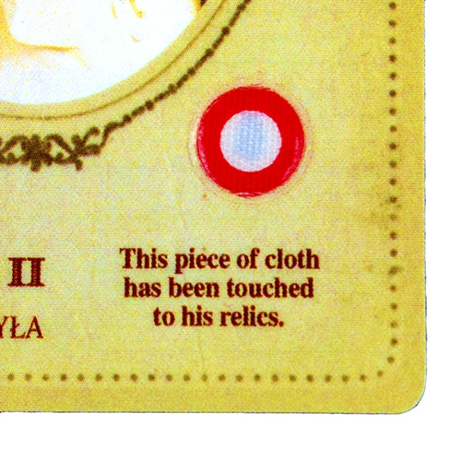

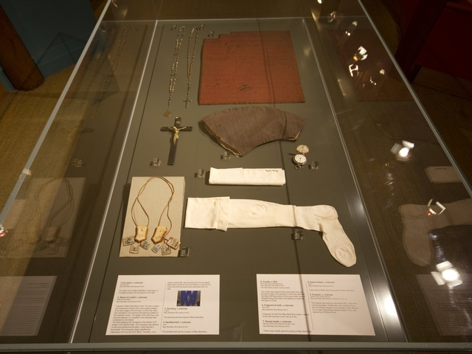

Second class relics. Items that belonged to Saint Mary of the Cross Mackillop

Third class relic of St Pope John Paul II.

A relic is preserved and honoured by believers as an expression of faith in God and belief that we have eternal life because of Jesus’ death on the cross.

**Why are Sacred Relics important for Catholics?**

When we venerate the relics, we are not worshipping the saint to whom the relics belong. Rather, we venerate them because the saint was so holy and close to God. By venerating the saints’ relics we worship God and give him thanks and praise for the life and the holy examples shown to us by the saint, as well as giving thanks for the miracles performed by God through the saint’s intercession.

St Jerome tells us:

“We do not worship relics, we do not adore them, for fear that we should bow down to the creature rather than to the creator. But we venerate the relics of the martyrs in order the better to adore him (God) whose martyrs they are.” (Ad Riparium, i, P.L., XXII, 907). In other words, we venerate relics only for the sake of worshiping God.

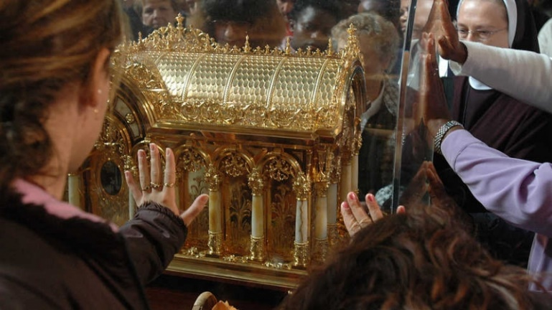

**Our belief in the Communion of Saints**

We believe that the saints in heaven have special intercessory power because of their very close and intimate relationship with Jesus. We also believe that we here on Earth have a special connection to the saints. This special connection is a sharing in what we call the *“Communion of the Saints.*” It is a communion because we are all members of the Church here on Earth and they are members of the Church in heaven as they share in eternal life with God.

Parishioners venerate the Relics of St Therese

**When we collect relics from the body of a saint, what part of the body do we use?**

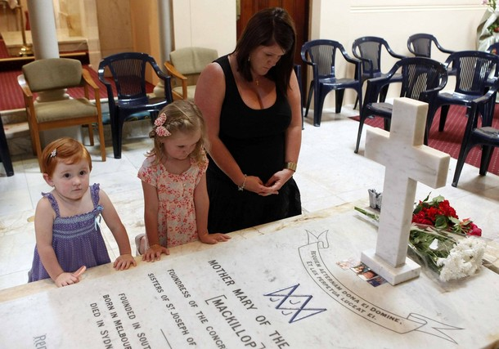Any part of the saint’s body is sacred and can be placed in a **reliquary,** a special container for holding the relics. Bones, flesh, hair, and sometimes blood, are also used. The relics may be given to several parishes or religious orders who had a significant connection to the saint. In some cases, the entire tomb where the saint is buried is preserved.

The faithful venerate the tomb of St Mary of the Cross Mackillop

**What is the history of venerating the relics of the saints?**

Veneration of relics was present in the earliest days of Christianity, even during the time of the apostles. In 156 AD, the remains of Bishop Polycarp, a martyr, were venerated and considered holy (a martyr is someone who dies for their belief in God.)

Scripture also teaches us that God acts *through relics,* especially in terms of healing. There are several examples in the scripture two of which include when a woman is healed by touching Jesus’ cloak (Matthew 9:20-22), and that people were healed when handkerchiefs touched by St Paul were applied to the sick (Acts 19:11-12). In 2 Kings 13:20-21, the body of a man was touched to the bones of the prophet Elisha and the man came back to life.

Any good that comes about through a relic is God’s doing. However, the fact that God chooses to use the relics of saints to work healing and miracles tells us that he wants to draw our attention to the saints as “models and intercessors” (Catechism of the Catholic Church, 828).

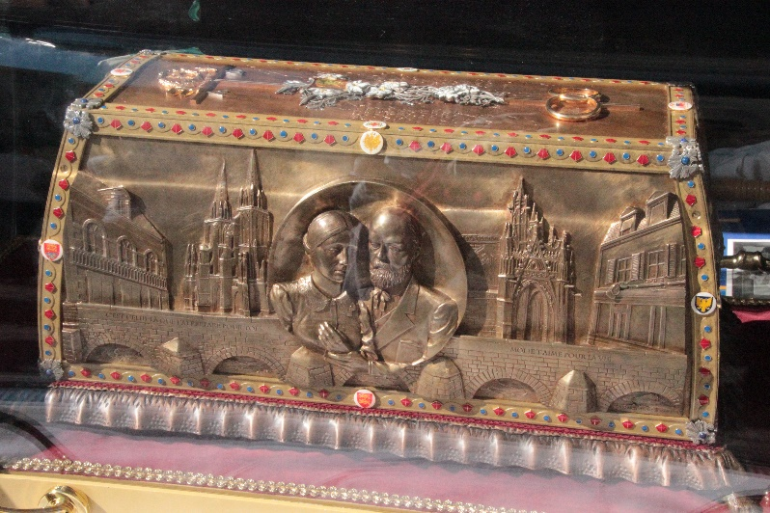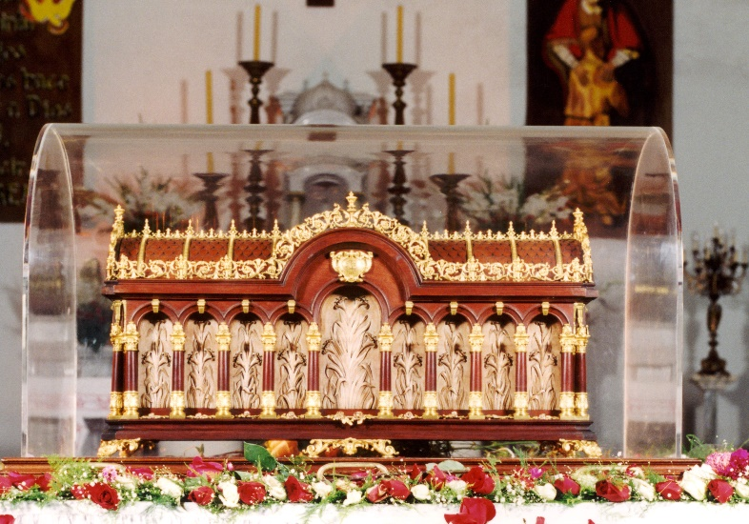.

Reliquary of St Lewie and St Zelie parents of St Therese

Reliquary of St Therese

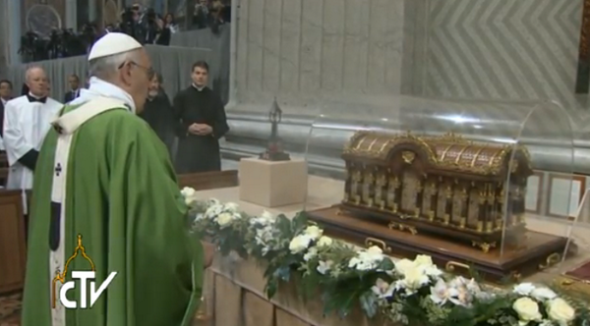

Pope Francis incenses the relics of St. Therese and of her parents, Blessed Louis and Zelie Mart*in (now both saints) St Pe*ter's Basilica, October 5, 2014. Photo credit: CTV

**Sources** https://www.catholicnewsagency.com/news/is-it-weird-that-catholics-venerate-relics-heres-why-we-do-72479 CNA Aug. 11, 2017, <https://www.catholiceducation.org/en/culture/catholic-contributions/church-teaching-on-relics.html>, Laurie Woods (2002). *A Dictionary for Catholics.* Harper Collins Religious: Pymble NSW