Prayers of the Faithful
Prayer Leader: As we remember Saint Josephine Bakhita, the patron saint of trafficked people, let us pray that God’s freedom and justice will be given to all people.
We pray for Pope Francis who speaks of human trafficking as being ugly and cruel and whose leadership calls for an end to all forms of human slavery and trafficking.
God of freedom and justice hear us.
All: God of freedom and justice, hear our prayer.
We pray for those who are victims of slavery, especially the children, that they will be respected as human beings.
God of freedom and justice hear us.
All: God of freedom and justice, hear our prayer.
We pray for all those who work to restore the dignity and humanity of those deprived of their freedom.
God of freedom and justice hear us.
All: God of freedom and justice, hear our prayer.
We pray for an end to all discrimination, but especially discrimination against children, so that they may live without fear.
God of freedom and justice hear us.
All: God of freedom and justice, hear our prayer.
We pray that wealthy countries such as Australia may be generous in supporting those nations where people live in circumstances that make them vulnerable to human trafficking.
God of freedom and justice hear us.
All: God of freedom and justice, hear our prayer.

Concluding Prayer
Loving God,
we humbly pray that those suffering due to human trafficking, slavery and persecution, be given the dignity, respect, freedom, justice and peace that they so deserve. We ask this through Christ our Lord.
All: Amen

Prayer Service
for
St. Josephine Bakhita

Patron of those who have been trafficked or enslaved.
February 8th

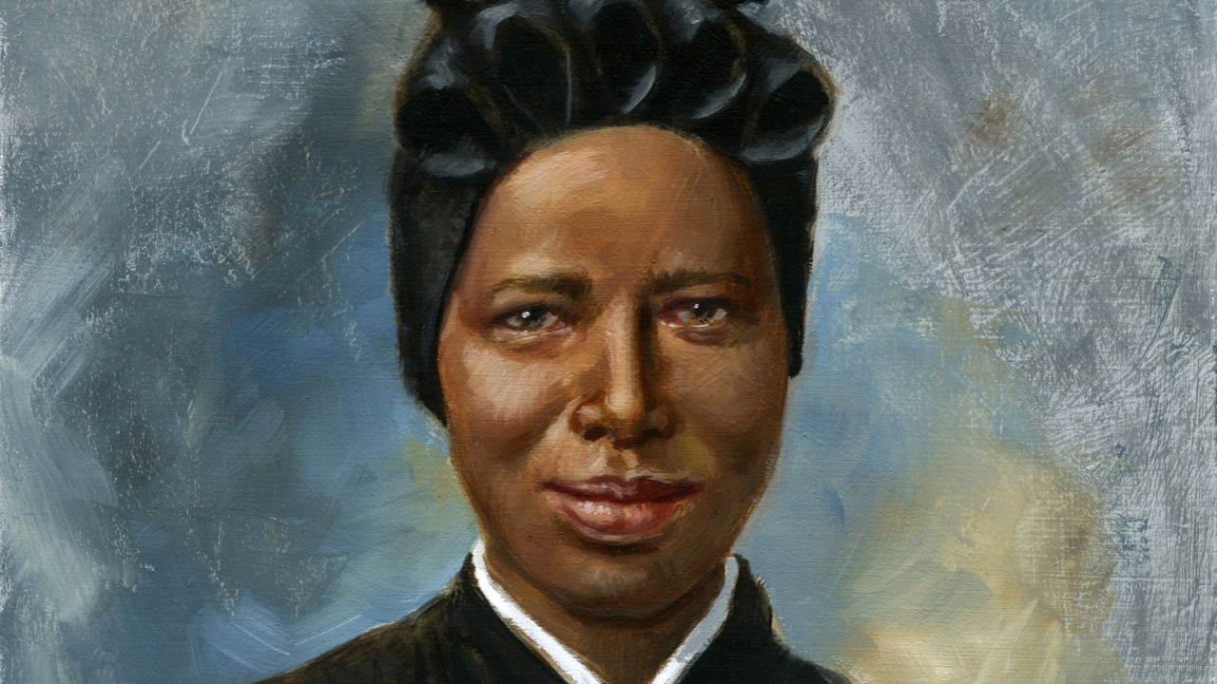

Introduction
Prayer leader: Today is the feast day of Saint Josephine Bakhita. She was born in Sudan in 1869 and she died in Italy in 1947, aged 78 years. She was a woman who was kidnapped and sold many times as a slave. Saint Bakhita is the patron saint of Sudan and because of her life experiences she also is known as the patron saint for the victims of slavery and for trafficked persons.
Pope Francis has designated the feast of St Josephine Bakhita as the world day of prayer, reflection and action against human trafficking.
Pope Francis often speaks on the issue of human trafficking. In 2017 he said
Each year, thousands of men, women and children are innocent victims of sexual and organ trafficking, and it seems that we are so accustomed to seeing it as a normal thing. This is ugly, it is cruel, it is criminal! I would like to draw on everyone's commitment to make this aberrant plague, a modern form of slavery, adequately countered. Let us pray together to the Virgin Mary to support the victims of trafficking and to convert the hearts of traffickers.
http://en.radiovaticana.va/news/2017/07/30/pope_francis_appeals_for_end_to_human_trafficking/1327867

Today we pray for those who have been enslaved and those in danger of becoming victims of slavery. We also pray for those who are working to rescue, protect, raise awareness about the evil of human trafficking and for people and organisations who have pledged to eradicate the crime of human trafficking.

Opening Prayer
Reader 1: Loving God, you led St Josephine Bakhita from the suffering of slavery to the dignity of the vocation to religious life.
We pray that by her example, we may show constant love for you and always be ready to show charity and compassion.
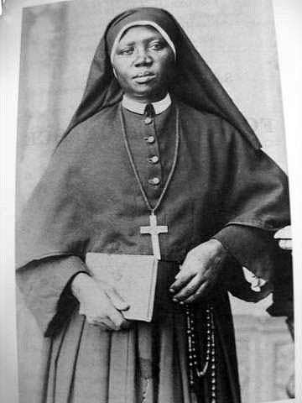
We ask this through our Lord Jesus Christ, who lives and reigns with you in the unity of the Holy Spirit, one God, for ever and ever.
All: Amen

Scripture - Luke 4:16-21
Reader 2: A reading from the Gospel of St Luke.
When he came to Nazareth, where he had been brought up, he went to the synagogue on the sabbath day, as was his custom. He stood up to read, and the scroll of the prophet Isaiah was given to him. He unrolled the scroll and found the place where it was written:
‘The Spirit of the Lord is upon me,
because he has anointed me
to bring good news to the poor.
He has sent me to proclaim release to the captives
and recovery of sight to the blind,
to let the oppressed go free,
to proclaim the year of the Lord’s favour.’
And he rolled up the scroll, gave it back to the attendant, and sat down. The eyes of all in the synagogue were fixed on him. Then he began to say to them, ‘Today this scripture has been fulfilled in your hearing.’
The Gospel of the Lord
All: Praise to you Lord Jesus Christ

