K.5 God’s Great Family
This unit begins with the story of Abraham and Sarah. It is a story of promise and trust and formative to our identity as the People of God. The second part of the unit introduces Jesus’ family and tells two short stories of Jesus as a boy. The story of the people of God begins a new chapter in the person of Jesus. This unit focuses on belonging both in the family and with all the people of God.

Outcomes
Students will be able to:
ES1.2 respond to Scripture stories
ES1.3 communicate basic knowledge about Jesus
ES1.5 express an understanding that God is always with us
ES1.6 name Mary as the Mother of Jesus

Scripture |  |  | Doctrine
Students are introduced to doctrine through Scripture and the living Tradition of the Church.
 | Genesis 12:1-9 God’s Call and  Genesis 15:1-6, 18-21 Covenant with  Genesis 17:1-8, 15-22 Abraham and Sarah | - God made human beings to live in relationship with God and with other people  - Families can help us to know God better
 | Luke 2:22-40 Jesus is Presented in the Temple | - I belong to God’s family
 | Luke 2: 41-50 Jesus is Found in the Temple | - Jesus, Mary and Joseph lived as God’s Holy Family
 |  | - God is always with us

Spiritual Reflection for Teachers
In 1963, a year after the Cuban missile crisis that threatened to engulf major superpowers in war, President John F Kennedy reflected on the theme of peace in a speech at the American University:
What kind of peace do we seek? I am talking about genuine peace - the kind of peace that makes life on earth worth living. Not merely peace in our time, but peace in all times… For in the final analysis our most basic common link is that we all inhabit this small planet. We all breathe the same air. We all cherish our children’s future. And we are all mortal.
Listening to these words brings a sense of connection with the rest of the world. A realisation that each person’s actions do impact on others. Whilst waters may divide us, all are very much part of God’s family. What a responsibility this brings and yet we trust that God is living and active amongst us.
- Who are the people in your life who are part of your extended family?
- Have you had an experience where you have felt connected to people who live in different parts of our world?
- If we believe that we are all part of God’s family what responsibilities or challenges does this present?

Catechism of the Catholic Church
Excerpts from the Catechism of the Catholic Church are included below as information for teachers. They present the Church’s teachings contained in the unit.
59 In order to gather together scattered humanity God calls Abram from his country, his kindred, and his father’s house, and makes him Abraham, that is, “the father of a multitude of nations” (Genesis 12:1). “In you all the nations of the earth shall be blessed” (Genesis 17:5; 12:3).
60 The people descended from Abraham would be the trustees of the promise made to the patriarchs, the chosen people, called to prepare for that day when God would gather all his children into the unity of the Church. They would be the root onto which the Gentiles would be grafted, once they came to believe.
488 … From all eternity God chose for the mother of his Son a daughter of Israel, a young Jewish woman of Nazareth in Galilee, “a virgin betrothed to a man whose name was Joseph, of the house of David; and the virgin’s name was Mary” (Lk 1:26-27).
525 Jesus was born in a humble stable, into a poor family…
2207 The family is the original cell of social life. It is the natural society in which husband and wife are called to give themselves in love and in the gift of life. Authority, stability, and a life of relationships within the family constitute the foundations for freedom, security, and fraternity within society. The family is the community in which, from childhood, one can learn moral values, begin to honour God, and make good use of freedom. Family life is an initiation into life in society.
2212 … In our brothers and sisters we see the children of our parents; in our cousins, the descendants of our ancestors; in our fellow citizens, the children of our country; in the baptised, the children of our mother the Church; in every human person, a son or daughter of the One who wants to be called “our Father”…

Scripture: Background Information

Abraham and Sarah

Genesis 12:1-9 The Call of Abraham

Abraham and Sarah are told to leave their country and their family for an unknown land. And they do! This is a major move for them. Blessings and promises accompany such a journey of faith. They are promised land, descendents and fame. It requires great faith in God to believe in a new life in a foreign land. Such a journey is symbolic of the many refugees over the centuries and up to our present time who continue to travel to freedom and new life. We are all on a symbolic journey with our loved ones. The journey of Abraham and Sarah, their nephew Lot and all their flocks progresses through the land of Canaan from Shechem, to Bethel to the Negeb desert. This same route is repeated later by their grandson Jacob (Gen 33:18; 35:1,6,27; 46:1) and also by the conquering Joshua (Josh 7:2; 8:9,30). Thus it would seem to be a sacred, symbolic biblical route.

Genesis 15:1-6, 18-21 Abraham’s family

God had promised Abraham, in chapter 12 of Genesis, that he would be the father of a great nation. But here in chapter 15 “some time later” Abraham is still childless. His faith in God’s promise is being severely tested. Yet God again promises “your heir shall be of your own flesh and blood” (verse 4). Furthermore God is even more eloquently generous. Abraham is promised as many descendents as the stars in the heavens, which we now know are practically countless. Despite all conditions to the contrary, Abraham believed God. We call Abraham our father in faith. He certainly showed great faith in the goodness of God’s pledge. So we, like our father in faith, Abraham, can rely on God to be faithful. We can interpret those final verses (19, 20, 21) to mean that a great variety of peoples are included in God’s family.

Genesis 17:1-8, 15-22 Abraham’s family and covenant relationships with God

These remarkable verses reiterate the profound covenant that God has with Abraham and all peoples. It is a covenant of care and security, of protection and love. God is very involved and interested in Abraham and his family as well as us and our families. This is what covenant means. It is all about loving relationships - God with us and we with others. God again promises what seems impossible - many children to a childless and elderly couple. This is a moving metaphor of the concern and interest God takes in our lives and our families.

Jesus’ Family

Luke 2:22-40 Jesus is Presented in the Temple

These verses from Luke’s version of the birth stories of Jesus are different from Mathew’s version. They depict Mary as mother and observer of Jesus. She and Joseph, as good Jews, do what the law requires of them by offering sacrifice for her purification after childbirth and having Jesus circumcised. During these events the elderly Simeon and Anna meet the parents and Jesus in the Temple. The picture we are given of Mary in these verses is of a wondering, not fully understanding mother. She too, Simeon suggests, will have to decide and choose to believe in Jesus and his message. “And (he) said to Mary “You see this child: he is destined for the falling and the rising of many in Israel, destined to be a sign that is rejected – and a sword will pierce your own soul too.” It will not be easy for her as it is not always easy for us. Luke is the only New Testament writer to record any of these events.

Luke 2:41-50 Jesus is Found in the Temple
When we reflect carefully on Mary, Jesus’ mother, in this text we perceive her as a good Jewish woman making the yearly Passover pilgrimage to Jerusalem with her family. But when they return to Nazareth, Jesus stays behind in the Temple asking questions of and discussing with the educated men the finer points of the Law. Thus Mary and Joseph must search for and finally locate Jesus in the temple. Unexpectedly, it is Mary who speaks and questions Jesus. Mary does not understand Jesus’ response to her question - “Why have you done this to us…?” (verse 48) and so again she needs to ponder (verse 52) what is happening in her life. Mary “stored up all these things in her heart” (verse 51). Mary is listening within herself in order to understand how to respond to God and her family.

Suggested Assessment
Suggestions for determining students’ development towards the achievement of the outcomes are included below:
ES1.2 respond to Scripture stories
The students typically might:
- retell the story of Abraham and Sarah
- recount a story about the childhood of Jesus
- relate their own experiences to parts of these stories

ES1.3 communicate basic knowledge about Jesus
The students typically might:
- name the Holy Family
- identify Jesus as the son of God

ES1.5 express an understanding that God is always with us
The students typically might:
- share a prayer of praise and trust
- talk about times when they experience God with them

ES1.6 name Mary as the Mother of Jesus
The students typically might:
- pray the ‘Hail Mary’

Resources
To Know Worship and Love – Prep/Kindergarten, Chapters 12 and 16 (2005), James Goold House Publications, Melbourne, Victoria
To Know Worship and Love – Big Book, Old Testament Stories, ‘Abraham and Sarah’

Teacher Resources
Bretherton B A, (1997), You and Me God: Prayer Themes and Guided Meditations For Children, Social Science Press, Wentworth Falls, NSW
Macdonald, Sr Anthony, (2004), To God on a Magic Carpet – Meditating With Children, Spectrum Publications, Victoria

Music
Burland J, (1999), Let’s Celebrate Too! People Who Love Me, Ovation Music Services, Earlwood, NSW
Landry C & Kinghorn C J, (1986), ‘God Has Made Us A Family, Hi God 3, North American Liturgy Resources, Phoenix, Arizona
‘Welcome to the Family’, Kids Praise 3

Children’s Literature
Gold A & Perlman M J, (2001), Where Does God Live? SkyLight Paths Publishing, Woodstock, Vermont

Websites
www.ebibleteacher.com/children/songs.htm Bible songs with actions

NOTE: See RE Online for additional resources for this unit.

Unit Content A: Abraham and Sarah

The story of Abraham and Sarah reveals God’s faithfulness and constant presence.
Students will:
- listen and respond to the story of Abraham and Sarah
- reflect on experiences of promise and trust

Background Information
The story of Abraham is one of the great narratives from the Hebrew Scriptures foundational to our belief in the continuing presence of God throughout the history of humankind. Handed down from generation to generation it is formative to our identity as the people of God.
God’s call and covenant with Abram (Abraham) and Sarai (Sarah) is a story of great promise and trust. Abram and Sarai hold firm to God’s promise and are willing to stake their security on it. Leaving behind all that is sacred to them, their country and their family, they journey into the unknown. In their journey they discover that God is with them in every place.
Introducing this story to young children addresses their need for security and protection and their fears of being alone. As Stewart and Berryman describe, ‘Children have needs for love, security, growth, continuity, belonging and caring for others and the environment. They also need to create meaning and order in their lives, and particularly in facing their fears.’ The story of Abraham and Sarah speaks to their fear of being abandoned or lost or alone. Encouraging them to enter the story presents them with the opportunity to discover that God is with them in any place, at any time.
This story is best told using 3D materials and a ‘sand box’. Translating the story into figures and materials that can be easily seen and manipulated gives children a sensorimotor way of engaging with and responding to the story.
In the presentation of the story the focus should be on the essential elements of Abraham and Sarah’s journey in faith to the place God had promised them. Unnecessary description and detail is to be avoided. Engaging with the children in wondering about this story can help them to know God’s faithfulness and love. It can allay fears of the unknown. Abraham and Sarah put their trust in God’s promise. God was with them.

Suggested teaching/learning strategies
Suggested activities are organised around the key elements of Telling the Story, Wondering, Responding/Exploring and Prayer. Teachers select, adapt or substitute activities, ensuring that each of the elements of storytelling is evident in the cycle of learning.
- Read stories from children’s literature relating to the concept of promise. Tell stories of people who make promises to others and the importance of promises. Identify some actions people use when making a promise such as crossing their hearts.
- Before telling the story ‘Our Parents in Faith’ about Abraham and Sarah, involve students in a drama activity relating to family members/friends moving away to a new place or leaving to go a great distance. Create body sculptures to express associated feelings, eg fear, uncertainty, expectation, doubt, relief, surprise, joy.
- Tell the story of ‘Our Parents in Faith’, KWL ch 12, using 3D concrete materials and ‘sand box’. Refer to ‘Resource Sheet 1’ for script.
- Engage with some ‘I wonder’ statements in KWL p88.
- Give students opportunity to engage further with elements of the story through one or more of the following activities. The activities could be done as rotation activities over several sessions. Ideally, give children choice about which activities they do.
- Students use the 3D materials used by the teacher to retell story in their own words. This helps them to ‘stay with the story’ and ponder it.
- Students choose a part of the story they would like to paint or draw. Create a display around the word PROMISE.
- In a small group, students reread the story using KWL Big Book, Old Testament Stories, ‘Abraham and Sarah’.
- Send home KWL student books with a note inviting parents to read ch 12 with their child and do the Home Activity. Later, allow time for children to share stories about their ancestors. It is important that parents have the opportunity to engage with the stories that are being told at school.
- Read the story ‘Where Does God Live?’ by August Gold and Matthew J Perlman or similar. Invite students to draw/paint their own picture in response to question ‘Where is God?’ (perhaps using ‘Paint’ or ‘Kids Pix’) and write a simple statement beginning: God is…
- Invite students to look at some images of a night sky or a star map of the sky. There are many examples that are easily found on the internet. Alternatively, roll out a length of black material and sprinkle it liberally with tiny silver stars. Talk about the idea of counting stars.
- Place a large bowl of sand in the centre of a circle. Invite children to come one or two at a time to feel the sand and allow it to run through their fingers. Talk about the idea of counting the grains of sand. Discuss how difficult it would be to count the grains.
- Relate experiences to God’s promise to Abraham and Sarah to make their descendants more than the stars in the sky and the grains of sand on a beach. Present a simplified family tree for Abraham and Sarah. Link this to student’s experiences of their extended family: grandparents, aunties, uncles, cousins, great grandparents and so on.
- Invite students to cut out a star and write their name on it. Decorate the star with coloured sands or glitter. Attach stars to pieces of string and hang on an old Christmas tree or a branch set in a pot. Display with captions: ‘You will have more children than the stars in the sky’ and ‘You will have more children than the grains of sand on a beach’.

- Learn song with actions ‘Father Abraham had many sons’. Lyrics and actions can be found on several websites including www.ebibleteacher.com/children/songs.htm. Explain how Abraham and Sarah are sometimes called ‘The Great Family’. Their family became the people of God. Explain how everyone belongs to God’s family because they were created by God.
- Learn prayer KWL p89, with actions as follows:
Teacher: God, you are a God of love
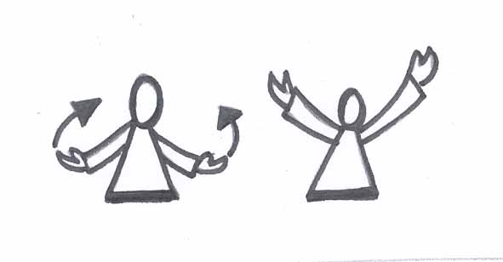
Students: We praise you
(Extend arms outwards to the sides and raise with palms
facing upwards into a gesture of praise)
Teacher: God, you are a God of hope
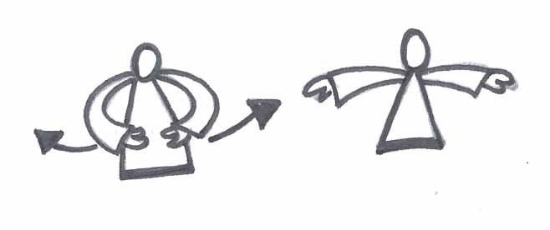
Students: We give you thanks
(Extend arms outwards to the front of body with palms facing
each other, then open arms out wide in a gesture of thanksgiving)

Unit Content B: Jesus’ Family
Jesus, Mary and Joseph are the Holy Family.
Students will:
- be introduced to the members of the Holy Family
- listen and respond to the stories of The Presentation in the Temple and The Boy Jesus in the Temple

Background Information
The family is the basic unit of society and of the Church. It is within the family that each person’s religious sensitivities are first called to life. Love, trust, wonder, reassurance, belonging, gratitude, a growing sense of responsibility and commitment – all of these set the foundations for experiencing God and growing in relationship with God and others.
We are all born into a family that has its own story. Members of a family belong to each other and are connected to each other in a special way. Understandings about ‘family’ can be related to the Catholic belief that all are part of God’s family, also connected to each other in a special way. As members of God’s family we all share in the continuing story of the people of God.
The story of the people of God begins a new chapter in the person of Jesus. Born into a Jewish family, descended from Abraham and Sarah, Jesus is the fulfillment of God’s promise. In opening up some of the stories relating to Jesus’ childhood the focus is on giving the students opportunity to come to know more about Jesus. As the Son of God made human, Jesus was born into a family, into a particular society and culture, and lived in a certain geographical location, at a precise time in history. In telling the stories it is important that students have opportunities to wonder about Jesus as a child and about his family, Mary and Joseph. As young children construct their images of Jesus, it is important that they identify with Jesus as someone who grew up in a family and experienced needs similar to their own.
In exploring the stories of Jesus’ childhood, foundations are laid for students to discover that God is with them in all places and at all times. God is revealed in an unique way in the person of Jesus.

Suggested teaching/learning strategies
Suggested activities are organised around the key elements of Telling the Story, Wondering, Responding/Exploring and Prayer. Teachers select, adapt or substitute activities, ensuring that each of the elements of storytelling is evident in the cycle of learning.
- Read stories from children’s literature relating to families and family life. This should be done frequently throughout the unit. Lead students in a discussion in response to the question: ‘What does your family like doing together?’
- Brainstorm a list of things families do together. Role play situations which show different examples of family life, eg having fun together, eating together, learning together, going shopping together, saying sorry, working, playing and so on. Encourage students to express different family experiences which show the variety of roles within a family and examples of showing care and love.
- Create a wall mural representing all class families. Invite students to draw their family members and label it with their family name, eg The Brown Family. Explain that we are part of our family and God’s family. Add captions ‘God Gave Us Our Family’ and ‘My Family is Special to God’. Discuss.

- Show images of the Holy Family or figures from a crèche scene and invite students to identify and name the people. Ask the students why we name Jesus’ family, the ‘Holy Family’. Clarify comments if needed. Add one of the images to the family mural. Reinforce how we are all part of God’s great family.

Part 1
- Tell the story of Jesus’ Family from KWL ch 16. See ‘Resource Sheet 2’ for suggested script and 3D materials.
- Engage with the first five ‘I wonder’ statements in KWL p126.
- Learn a song like ‘God Has Made Us a Family’ from Hi God 3 or ‘People Who Love Me’ from Let’s Celebrate Too. Relate the words to what students understand and appreciate about their families.
- Look at the stories in KWL ch 16. Talk about the illustrations and identify the different stories relating to Jesus as a child.
- Retell the story of Jesus’ Presentation in the Temple using a children’s Bible. Explain the Jewish custom of taking the new baby to the Temple to be blessed and presented to God. Link to students own experiences of what happens when a baby is born – naming, Baptism. Engage students in some ‘I wonder’ statements, eg:
- I wonder why Jesus was a special child
- I wonder how Simeon and Anna knew Jesus was a special child of God.
- Make a Holy Family ‘Photo Album’ using ‘Resource Sheet 3’. Invite students to make a page for the photo album showing Jesus’ presentation in the Temple – draw pictures of Mary and Joseph, Simeon and Anna, and Jesus and write a brief caption. Make a class photo album. Include each child’s page and a decorated cover entitled ‘A Special Child of God’.
- Learn a song like ‘Welcome to the Family’ from Kids Praise 3. Use as part of Morning Prayer.
- Lead students in a guided meditation, eg ‘Family’ in You and Me God, p14 or ‘A Visit to Joseph’ in To God on a Magic Carpet, p22.

Part 2
- Tell the story of ‘Jesus Lost in the Temple’, KWL ch 16, pp122-125 using 3D figures and ‘Resource Sheet 4’.
You will need to become familiar with the story and practise with the materials to prepare the key actions of the story.
- Engage with the last three ‘I wonder’ statements in KWL p126.

- Give students opportunity to engage further with aspects of the KWL stories through one or more of the following activities. The activities could be done as rotation activities over several sessions.
  - Students use the 3D materials used by the teacher to retell one of the stories of Jesus in their own words.
  - Students choose a favourite story from Jesus’ childhood they would like to draw or paint. ‘Paint’ or ‘Kids Pix’ could be used.
  - Students make own story materials for telling the story of Simeon and Anna. Use ‘Resource Sheet 5’ – figures could be glued to paddle pop sticks.
  - Students make a ‘thank you’ card for their family.

- Prayer Celebration: Use ‘Resource Sheet 6’ for prayers.
  - Create a prayer space with a candle, Bible and picture of the Holy Family.
  - Begin with a suitable song such as ‘God Has Made Us A Family’.
  - Make the Sign of the Cross.
  - Invite students to follow you in praying a prayer similar to one Jesus might have said.
  - Invite students to share their own prayers of thanks for the Holy Family and their own families.
  - With arm outstretched in gesture of blessing read the Blessing Prayer over the students or use Prayer in KWL p127.
Resource Sheet 1
our parents in faith
KWL Ch 12
(based on Genesis 12-18)

You will need:
- sand box (sand in large tray or box)
- 4 wooden figures (Abraham, Sarah, Isaac, Rebekah)
- small stones or pebbles for building altars
- wooden blocks to represent places stopped at along the way and Hebron

Children are seated in a semi-circle ready to listen to the story. When the children are settled, go to the shelf and carry the materials as you would the Bible. Place these beside you.
Begin by placing the sand box in front of you and saying:
This is the desert box.
Slowly run your fingers through the sand as you say:
Deserts can be very hot in the daytime and very cold at night. They can be lonely places and places of danger. There is not much water in the desert and sometimes the wind blows all the sand around.
Lots of important stories about the people of God happened in the desert.
Let’s listen to one today.
Hold up the wooden figures of Abram and Sarai.
There once was a great family that loved God very much.
Place Abram in the desert box close to the edge next to a block representing their home. Place Sarai next to Abram.
Abram and Sarai belonged to this family. God loved Abram and Sarai very much.
Move Abram and Sarai a little bit away from their home
One day, God asked Abram and Sarai to move to a new land far, far away.
Place hand over their heads as in a blessing as you say:
God promised to always be with them.
Move your hand across the desert.
They were sad to leave their home. They wondered if God would really keep them safe and be with them everywhere.
Move the figures across the desert to a new place marked by a block. Build an altar with small stones.
Abram and Sarai trusted God and they set out on a very long journey. They stopped at many places along the way.
Repeat the action of building an altar for several more stops.
In each place they found that God was with them and they built a special place called an altar and gave thanks to God.
Point to all the places.
As they moved on to each new place they wondered if God would be there too.
Move them to their final destination at Hebron. Build an altar.
Finally they reached their new home in Hebron. God had shown Abram and Sarai the way. Again they built an altar and gave thanks to God.

Gesture a blessing over Abram and Sarai.
God had been with them all the time in every place just as God had promised.
Move Abram a short distance from Hebron.
In their new land God said to Abram, ‘You and Sarai will become the parents of a great family. You will have more children than the stars in the sky and the grains of sand on the beach’. Abram laughed because he and Sarai were very old.
Move Abram back with Sarai. Gesture a blessing over them.
But once again, God’s promise came true.
Place the Isaac figure in the desert box next to Abraham and Sarah.
God changed their names to Abraham and Sarah and they became the parents of a son named Isaac. They were very happy. God loved them very much.
Move Isaac a short distance away and place Rebekah in the desert box next to him.
Isaac grew up and married Rebekah. They had children, and their children had children, and those children had more children.
Abraham and Sarah’s family continued to grow and grow and became as many as the stars in the sky and the grains of sand on the beach.
Sit quietly for a moment and begin to wonder together.
Use ‘I wonder’ from KWL p88.
Carefully pack story materials into storage box and put on shelf. Ensure that children are watching so they know how to pack the materials away and where to find them.
Resource Sheet 2

Jesus’ Family
KWL Ch 16
(based on Luke 2:22-40)

Part 1: Jesus’ Family

You will need:
- felt road
- Mary, Joseph, baby Jesus and donkey from Nativity set
- Simeon
- Anna
- Jesus as a boy
- Jerusalem (perhaps made with building blocks, have a doorway)

Children are seated in a semi-circle ready to listen to the story. When the children are settled, go to the shelf and carry the materials as you would the Bible. Place these beside you.
Lay the road out vertically in front of you
Place the baby Jesus at the far end of the road away from you.
Jesus lived in a Jewish family.

Place Mary and Joseph near Jesus.
His parents were Mary and Joseph.
Jesus was the special child of God. We call his family the Holy Family.

Place Jerusalem at the side of the road a short distance from the family and towards you.
Place donkey on the road with the family.
Slowly move the family and donkey to Jerusalem.
Forty days after Jesus was born, Mary and Joseph took him to the temple in Jerusalem.

Place Simeon and Anna in front of Jerusalem facing the family.
Two holy people saw Jesus.
Their names were Simeon and Anna.
They said that Jesus was a very special child of God.

Move the family slowly along the road to the end near you.
When Mary and Joseph had finished in the temple,
they returned to their own town of Nazareth.

Replace the baby Jesus with the boy Jesus.
Jesus grew up in a town called Nazareth.
He helped his father, Joseph, who was a carpenter.

Sit quietly for a moment and begin to wonder together.
Use first five ‘I wonders’ from KWL p126.
Carefully pack story materials into storage box and put on shelf. Ensure that children are watching so they know how to pack the materials away and where to find them.

Resource Sheet 3

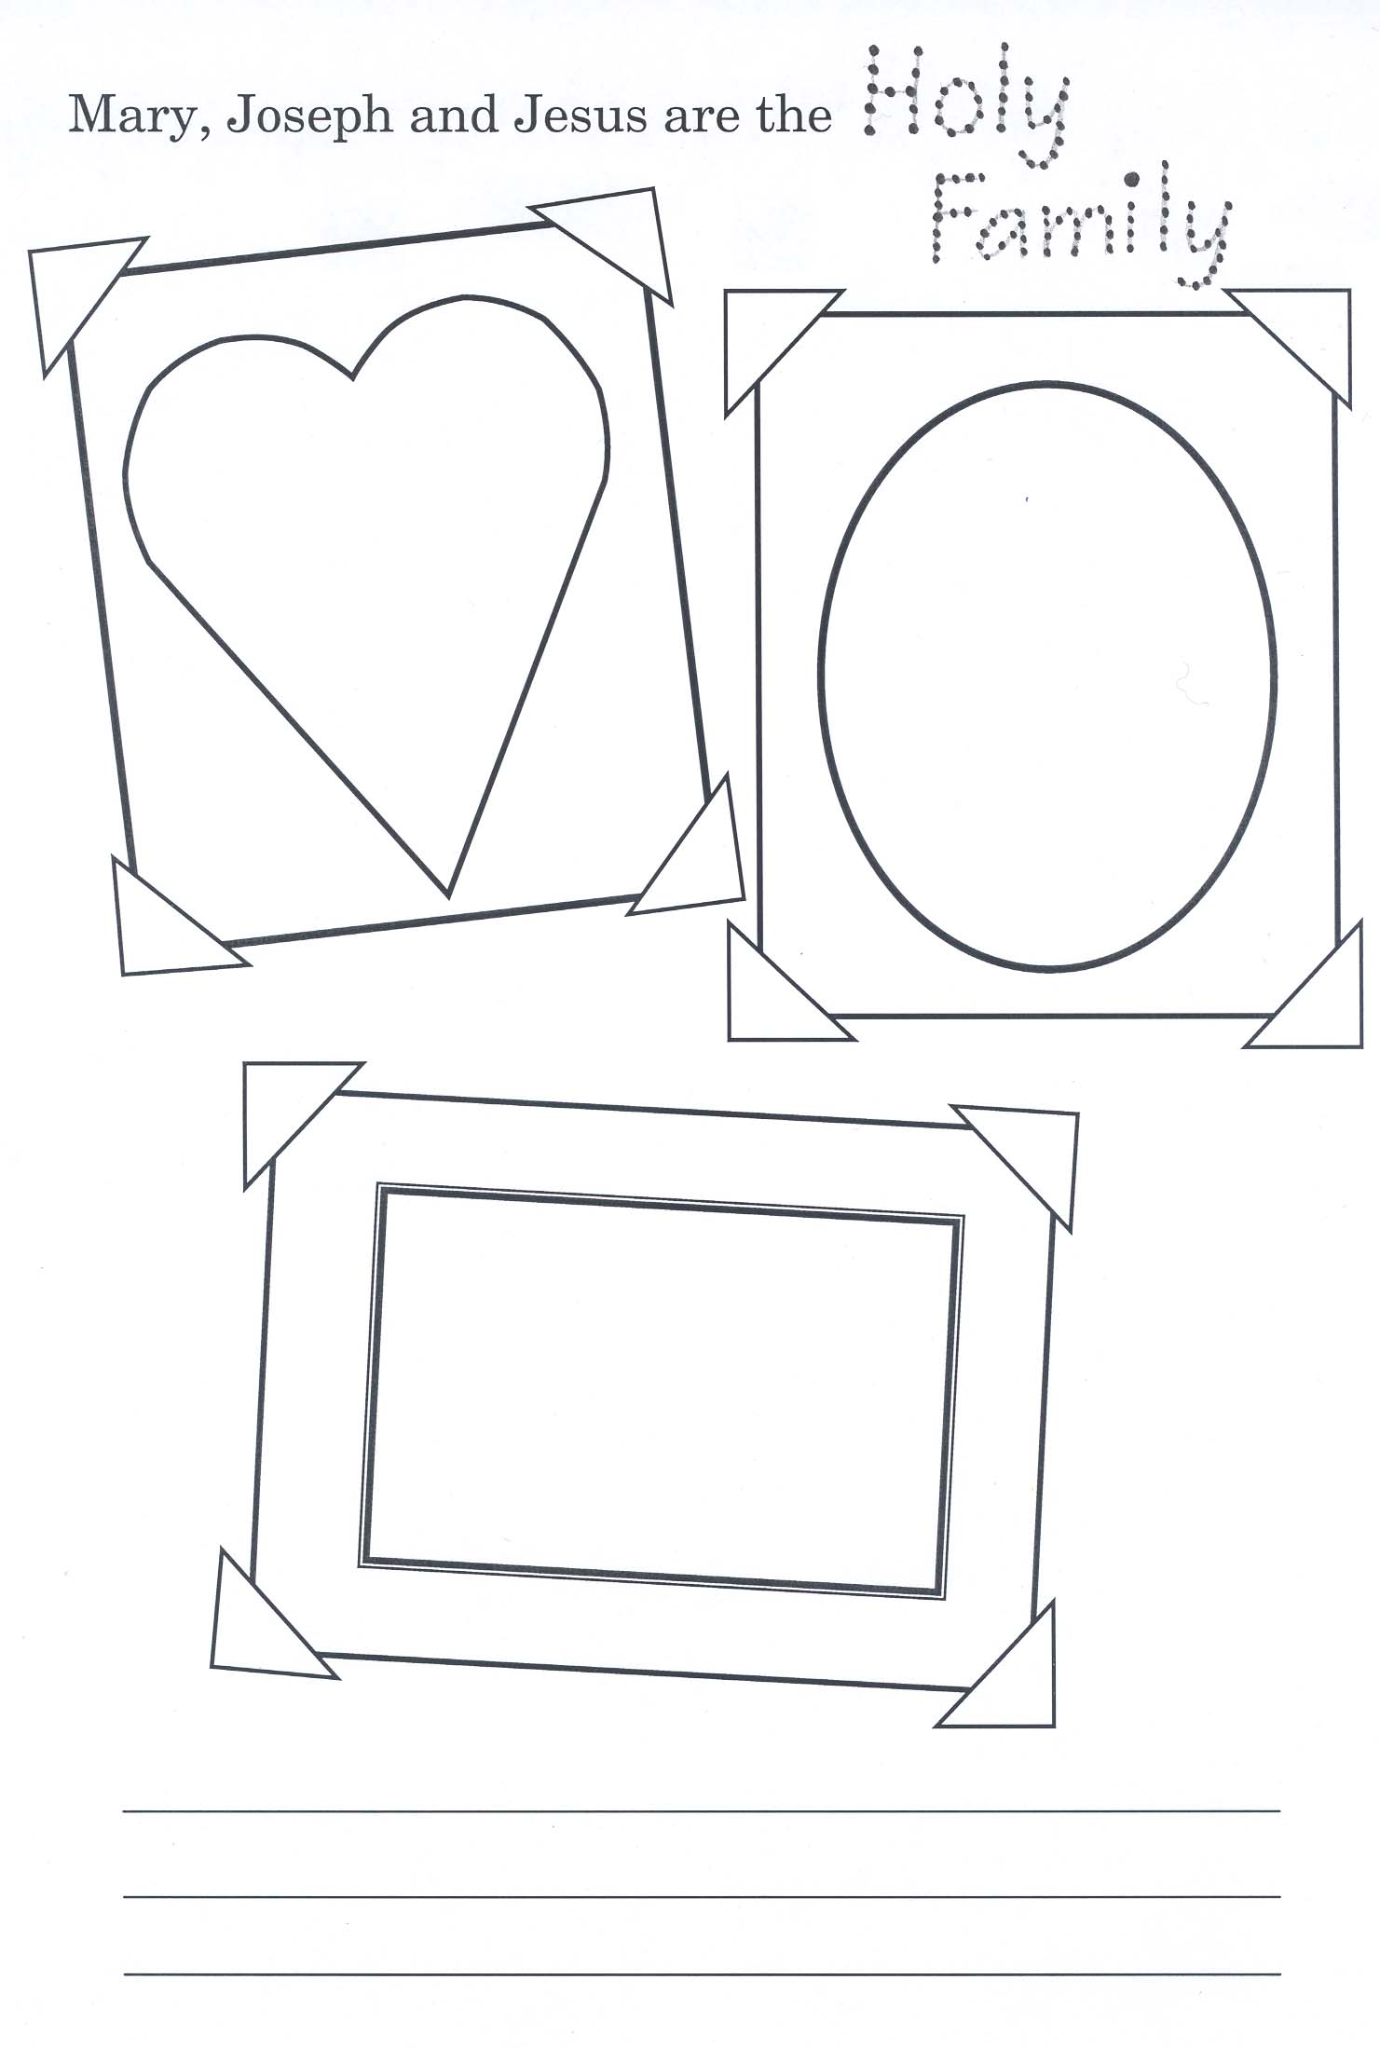

Resource Sheet 4

Jesus’ Family
KWL Ch 16
(based on Luke 2:45-50)

Part 2: Jesus Lost in the Temple

You will need:
- felt road
- Mary and Joseph from Nativity set
- Jesus as a boy
- Jerusalem (perhaps made with building blocks, have a doorway)

Children are seated in a semi-circle ready to listen to the story. When the children are settled, go to the shelf and carry the materials as you would the Bible. Place these beside you.

Lay the road vertically in front of you.
Place the boy, Jesus, Mary and Joseph on the side of the road near you.
Jesus grew up with Mary and Joseph in a town called Nazareth.

Place Jerusalem half way down the road, off to one side.
Move the family down the middle of the road, and then off to stand in front of Jerusalem.
When Jesus was twelve years old, his family
and relatives went to Jerusalem for the feast of the Passover.

Walk Jesus through the doorway to stand behind Jerusalem.
Move Mary and Joseph along the road back towards you.
When the feast was ended, they started to return to Nazareth.

Turn Mary and Joseph to face each other.
On their way home, Mary and Joseph saw that Jesus was not with them.

Move Mary and Joseph back to Jerusalem. Place them on one side of the doorway to Jerusalem.
They went back to Jerusalem to look for Jesus.

Move Mary and Joseph to the other side of the doorway.
They could not find Jesus for three days.
They looked everywhere.

Move Mary and Joseph to either side of the doorway to Jerusalem.
Move Jesus from the back of Jerusalem to the doorway.
Then at last Mary and Joseph found Jesus in the temple.
They asked him why he had made them worry so much.
He said to them,
“Didn’t you know I had to be in my Father’s house?”
Sit quietly for a moment and begin to wonder together.
Use last three ‘I wonders’ from KWL p126.
Carefully pack story materials into storage box and put on shelf. Ensure that children are watching so they know how to pack the materials away and where to find them.

Resource Sheet 5

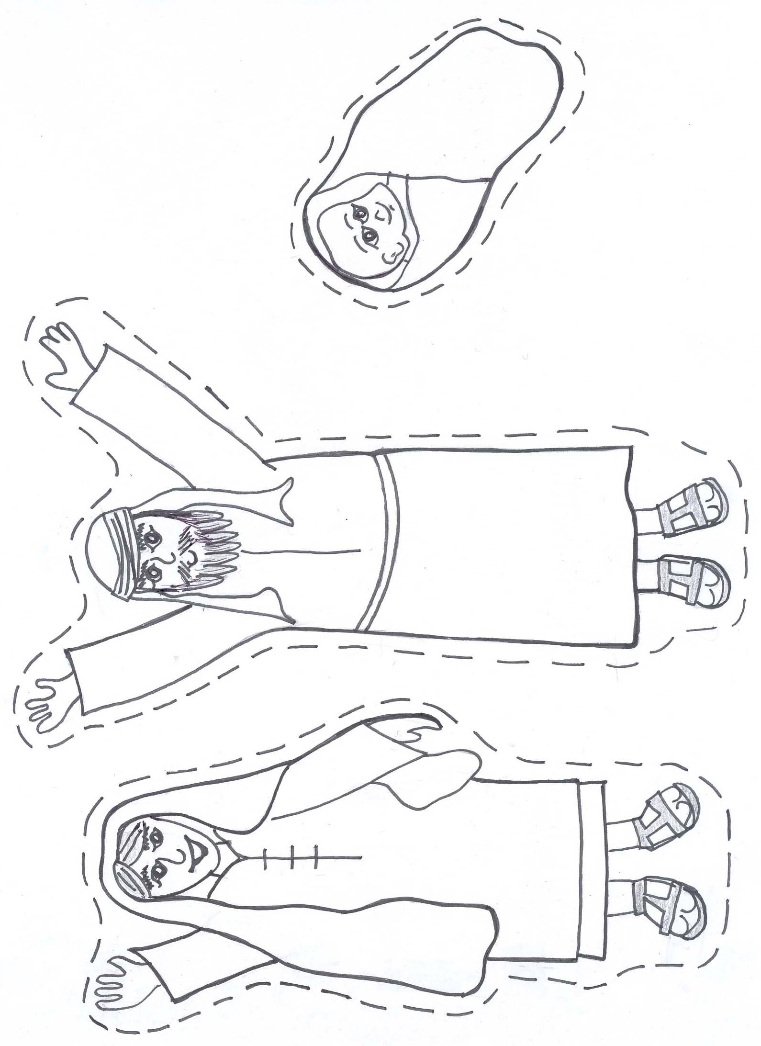
Colour and cut around Anna, Simeon and baby Jesus. Glue onto pop sticks to use to tell story.

Resource Sheet 6

PRAYERS
Invite students to pray this prayer. It is similar to one Jesus would have prayed with his family.
Teacher reads a line with accompanying action and invites children to echo the words and action.

PRAYER
I will love the Lord my God (hands crossed over chest)
with all my heart (both hands on heart)
and with all my soul (hands raised up)
and all my mind (hands on head)
(Deuteronomy 6:4-9)

Teacher holds out hand in gesture of blessing and prays the following over students.

BLESSING PRAYER
May God bless you
in your waking and your sleeping.
May God guide you
in your learning and your growing.
May God’s love and peace
be with you now and always.
Amen

Stewart S and Berryman J (1989), Young Children and Worship, Westminster John Knox Press, Louisville, p26

