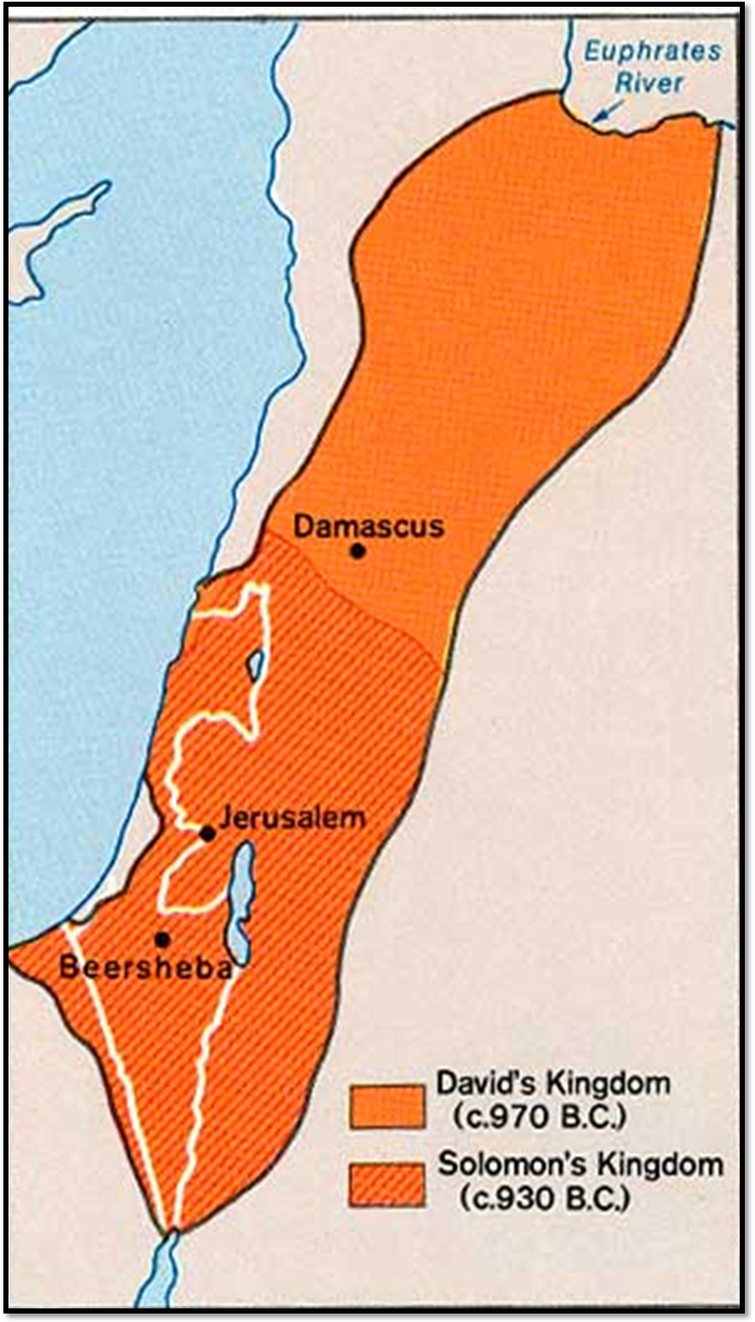
"Used by permission of the University of Texas Libraries, The University of Texas at Austin."
Print to A3 size paper.

