**3.6 Relationships: Sharing God’s Love**

Made in the likeness and image of God, human beings are called to live in relationship with God, with self, with others, and with the whole of creation. This unit focuses on our response to and sharing of God’s love through the ways we live in right relationship with God and other people. The unit explores the Second and Eighth Commandments as guides to building relationships based on respect, dignity and honesty through which God’s love is shared. The unit concludes by examining the importance of prayer in developing our relationship with God and others. It looks at the Eucharist as the prayer *par excellence* that expresses sacramentally our relationship as the Body of Christ, the Church.

|  |  |  |
| --- | --- | --- |
| **Values & Attitudes**  *Students will demonstrate that they are:* | **Knowledge & Understandings**  *Students will demonstrate that they can:* | **Skills**  *Students will demonstrate that they can:* |
| O2.1 able to choose to be guided and challenged by the message of Jesus in their relating to others | describe the actions and teachings of Jesus in his relationships | examine ways in which they can be guided and challenged by the message of Jesus |
| S2.2 attentive to the opportunities in their own lives where the actions and teachings of Jesus might be applied | identify the actions and teachings of Jesus | apply the actions and teachings of Jesus to their own lives |

Syllabus Outcomes  
Others/Self – Stage 2

Classroom Outcomes

*Students will be able to:*

* list actions which help to build right relationships based on love and respect
* describe how they can respond to Jesus’ command to love God and love others
* explain prayer as a way of communicating and building their relationship with God
* recognise that the celebration of Eucharist expresses their relationship with God and others

|  |  |
| --- | --- |
| Scripture | Doctrine |
| Luke 7:36-50 *Jesus recognises the gift of each person*  Mark 1:40-45 *Cure of a leper*  Luke 10:25–37 *The Good Samaritan*  Luke 11:1-4 *The Our Father* | * We can be signs of God’s love for each other * We grow in relationship with God through prayer * God’s grace helps us choose to do what is right * God has given each person free will and the power to choose * Jesus sees the gift and worth of each person * We are called to be followers of Jesus |

Spiritual Reflection for Teachers

*‘No one is an island’ – John Donne*

To be human is to be relational. We are not created as solitary beings but as social beings intended to live in relationship with ourselves, with others and with all of creation. We become more fully human when we are connected with others.

Loneliness in life can often be accompanied by isolation and a descending sense of inner darkness. This can lead to a sense of disconnection and even alienation.

Relationships are about being present to one another, treating each other with dignity and respect, not trying to control the other but seeking to bring out the uniqueness and best in each person.

We need to work at building relationships, whether it is at home, at work, or with our friends and acquaintances. As responsible human beings we are also called to consider our relationships with our planet and indeed, the whole cosmos.

God invites us into relationship too. We respond to this relationship through prayer and gratitude for life in all its fullness.

* What are the important relationships in your life just now?
* What do you need to do to keep them strong, healthy and full of life?
* What relationships give you life and how do you nourish them?
* How aware have you been of your relationship with God and how do you nourish it?

Catechism of the Catholic Church

**Excerpts from the Catechism of the Catholic Church are included below as information for teachers. They present the Church’s teachings contained in this unit.**

**1730** God created man a rational being, conferring on him the dignity of a person who can initiate and control his own actions. “God willed that man should be ‘left in the hand of his own counsel,’ so that he might of his own accord seek his Creator and freely attain his full and blessed perfection by cleaving to him.”

Man is rational and therefore like God; he is created with free will and is master over his acts.

**1738** Freedom is exercised in relationships between human beings. Every human person, created in the image of God, has the natural right to be recognised as a free and responsible being. All owe to each other this duty of respect.

**1878** All men are called to the same end: God himself. There is a certain resemblance between the union of the divine persons and the fraternity that men are to establish among themselves in truth and love. Love of neighbour is inseparable from love for God.

**2161** The second commandment enjoins respect for the Lord’s name. The name of the Lord is holy.

**2144** Respect for his name is an expression of the respect owed to the mystery of God himself and to the whole sacred reality it evokes.

**2464** The eighth commandment forbids misrepresenting the truth in our relations with others. This moral prescription flows from the vocation of the holy people to bear witness to their God who is the truth and wills the truth. Offences against the truth express by word or deed a refusal to commit oneself to moral uprightness; they are fundamental infidelities to God and, in this sense, they undermine the foundations of the covenant.

**2507** Respect for the reputation and honour of persons forbids all detraction and calumny in word or attitude.

**2565** In the New Covenant, prayer is the living relationship of the children of God with their Father who is good beyond measure, with his Son Jesus Christ and with the Holy Spirit. The grace of the Kingdom is “the union of the entire holy and royal Trinity … with the whole human spirit”. Thus, the life of prayer is the habit of being in the presence of the thrice-holy God and in communion with him. This communion of life is always possible because, through Baptism, we have already been united with Christ. Prayer is *Christian* in so far as it is communion with Christ and extends throughout the Church, which is his body. Its dimensions are those of Christ’s love.

Scripture: Background Information

**Luke 7:36-50** **Jesus recognises the gift of each person**

In this passage we find Jesus recognising the good in others. Jesus is compassionate and respectful to a woman whom others see as unworthy. In this scene it is important to remember that Simon was a Pharisee. In an attempt to fulfil the law authentically, the Pharisees acted separately from other groups in society. So, in this passage Simon questions Jesus’ acceptance of the woman. Jesus’ response was very different. We find in the actions of Jesus, a way to respond and direct our actions, so that they can help rather than limit our capacity to be compassionate and responsible people.

**Mark 1:40-45 Jesus heals a Leper.**

In this text Jesus is approached by a leper for healing. Leprosy is a contagious skin disease which, at that time made the leper ‘unclean’ and as such, not able to participate in the liturgical life of the community. The leper, being unclean was subject to the laws in Chapters 13 and 14 of Leviticus. Lepers were to live apart from the community to separate the ‘clean’ from the ‘unclean’.

We read in this text (v41) that Jesus was moved with pity, sometimes translated as *anger.* Whether Jesus was moved by pity or anger, it would seem he felt strongly for this man who was treated with contempt in his society. Although the disease was contagious, requiring separation from others, it was still possible to treat him with compassion. Jesus’ healing shows his power to save even those excluded by the Mosaic law. In vs44 Jesus tells the man to go and show himself to the priest and “offer for your cleansing what Moses commanded”. Here Jesus shows his regard for the Mosaic law, which soon in Mark’s Gospel, he is accused of breaking. The levitical priests were the ones who determined who was ‘clean’ and ‘unclean’.

**Luke 10:25-37 The Good Samaritan**

The familiar story of the Good Samaritan is particularly challenging for those who strive to live as Jesus’ followers. The opening debate within the encounter with the lawyer is about fulfilment of religious law and inclusion in the Kingdom of God. In the interchange with Jesus, the lawyer seeks affirmation that he is following the Law and that his place in the Kingdom is assured. Jesus however, challenges him to go beyond the letter of the law when he tells him the Parable of the Good Samaritan.

To understand this story fully we need to realise that Samaritans were considered outsiders, due to intermarriage with other peoples and a long history of aggression between Samaritans (who worshipped on Mount Gerezim) and other Palestinian Jews. At the time of Jesus, Samaritans had been accused of desecrating the Temple and were banned from worship in Jerusalem. Therefore they were viewed as outcasts. In this passage, of all those who passed by, and who were recognised as followers of the Law, it would have shocked Jesus’ listeners to hear that it was the Samaritan who had shown true compassion.

Jesus’ story challenges listeners to think about their enemies in a totally different way. It is the Samaritan who shows us how to fulfil the law of love, going beyond what he was expected to do. This story reveals that God’s love is abundant and open to all people, regardless of race or religion

(KWL, Teaching Companion, 3a, p163)

**Luke 11:1-4 The Our Father**

The version of the Our Father in the Gospel of Luke is simpler and shorter than Matthew’s version (Matt. 6:9-13). It is worth the time to compare the two texts and note the differences. Luke is writing for the needs of his community, as does Matthew, hence the variations in the two prayers. The Lucan version here is for a poorer group and reflects this. “Give us each day our daily bread” is a genuine prayer for food for a peasant: just enough bread for one day. “May your name be held holy” - the holiness of the name of God is a very Jewish concept. Indeed God’s name is so holy that it is not pronounced. Luke does not situate the Father in heaven, as does Matthew. Why? Does Luke want to encourage in his community a sense of the presence of God as among them? It would seem possible. “And do not put us to the test” is a simple prayer asking to be protected from temptation altogether.

The whole text is an intimate, direct prayer of trust to the Father. It suggests a close and loving relationship with God and those around us. The prayer is saying we need to forgive because God has forgiven us.

The Church’s Teaching and Lived Tradition

**In Tradition: *To Know, Worship and Love* Year 3, p121 – The Confiteor**

Every time we come to Mass, we acknowledge our sinfulness and ask for God’s love and forgiveness. One form of the Penitential Rite uses the prayer, the Confiteor. This practical prayer, dating from the early Middle Ages, reminds us that at times we have been consciously sinful. It also asks forgiveness for the times when we have failed to act or to speak out against injustice.[1]

**In Tradition: *To Know Worship and Love* Year 3, p129 – ‘ … through Christ our Lord. Amen.’**

For the Christian there is no other way to pray except “through Jesus Christ our Lord”. Jesus lived a human life and therefore experienced all that we experience. In John’s Gospel, Jesus reminds us that “No servant is greater than his master” (John 13:16). It is in Jesus’ name that we gather together and through him we make our prayers to the Father. As true followers of Christ our unique relationship with him begins at Baptism. We model his example and draw on his strength as we seek to live out our Christian lives. Our tradition in prayer has been always to seek this divine care in our lives, especially in times of trial.[2]

Celebration: Prayer and Liturgy

**Celebration is a key part of Religious Education. The following suggestions provide opportunities throughout the unit for celebration in prayer and liturgy. Most of these suggestions are included as ‘teaching/learning’ activities in Unit Content sections.**

* A celebration of thanksgiving for the times when we make good choices. Pray a classroom blessing prayer based on ‘Family Blessing,’ located in KWL, Year 3, p26.
* During class prayer, invite students to spend some quiet time asking the Holy Spirit to help them in making choices.
* Pray in class, using one of the sample prayers in ‘Prayer Box II’. ‘Prayer Box II’ contains two sample prayers (‘The Face of God’ p32 and ‘It Wouldn’t Be The Same’ p33) that are based on ‘We pray through image and song’.
* Guided Meditation: The Good Samaritan. Invite the children to enter into the story and build the images in their mind. Invite students to respond freely to the scripture passage. They may wish to draw, write a prayer or talk to God as they sit quietly.
* Develop a classroom celebration of sorrow for the times we have not loved as we should. Incorporate the Confiteor as a communal prayer of sorrow. Pray prayers of petition asking God to help us be more loving to those around us.
* Provide regular opportunities for the students to engage in prayer. Plan a classroom prayer roster. Each day nominate a different prayer type: praise, thanksgiving, sorrow and petition. Resource Sheet 4 provides a model for students to construct prayers of praise, thanksgiving, sorrow and petition. Invite students to write and/or share their prayer during general intercessions or spontaneous prayer.
* Display a chart with the words of the final doxology used at the end of the Eucharistic prayer: *‘Through him, with him, in him, in the unity of the Holy Spirit, all glory and honour is yours Almighty Father, for ever and ever. Amen’*. Discuss the meaning of the words and the importance of our ‘Amen’. In groups students prepare a creative movement to express the words.
* Pray the Our Father, daily with the students. Explore the use of movement when praying the Our Father. Invite students to create their own actions to accompany the Our Father. Actions could be set to a sung version of the prayer.

Assessment

**Interim Assessment Statement 2014**

The identification of Teaching/Learning strategies as ‘suggested assessment’ has been removed from the 3-6 RE curriculum. The type of assessment activity and the way evidence of learning is gathered will vary, depending on such factors as; the outcomes being assessed, the evidence being gathered, the teaching and learning activity, context and students’ learning needs (NSW Board of Studies, <http://syllabus.bos.nsw.edu.au/support-materials/k-6-assessment-strategies/>) .

Assessment in Religious Education is based on the same principles as in other key learning areas. Please refer to the CEO Sydney site supporting the implementation of the Australian Curriculum in the context of the NSW BOS Syllabus. At this site <https://sites.google.com/a/syd.catholic.edu.au/professional-learning-modules/home> professional learning modules are provided to support teachers as they engage with the NSW BOS Syllabuses for the Australian Curriculum.

**Module 4, Assessment and Planning** explores the principles of effective assessment ***for***, ***as*** and ***of*** learning and considers a range of strategies and methods for assessing student learning. Activities focus on moving beyond assessment as an index of learning, towards assessment that motivates, enhances learning and achieves deeper understanding to meet the diverse learning needs of all as students. Participants are encouraged to reflect on assessment as a driver for improvement in teaching and learning.

**Religious Education Curriculum and Assessment**

In Year 3-6 Religious Education Curriculum, both Syllabus Outcomes and Classroom Outcomes are key reference points for decisions about students’ progress and achievement. Classroom outcomes are more specific to the unit content. Unit Content statement and *Students will learn* statements in each unit should also be taken into account in planning and developing learning and assessment opportunities. Outcomes and Unit Content Statements are derived from Syllabus objectives.

Effective Religious Education involves teaching the Catholic faith (Scripture, doctrine, traditions, prayer and sacraments) and nurturing the faith of the child. There is no attempt to assess the child’s faith. Assessment is concerned with skills, knowledge and understanding of the Catholic faith taught in the curriculum and supported in the religious life of the school.

Resources

***To Know Worship and Love* – Year 3, Chapters 3, 15 and 16, (2003), James Goold House Publications, Melbourne, Victoria**

BrethertonB A, *(*2002), *Praying With Children: A resource book for Primary Teachers*, Social Science Press, Katoomba NSW

Children’s Mission, (1996), *Prayer Box II,* Catholic Mission, Ashfield, NSW

Creative Arts K-6, (2003), *Dance and Drama Moments and Movements in Life*, CEO Sydney

Fleming J and Carswell M, (1999), *Sabbath of Sabbaths*, HarperCollins Religious, East Melbourne, Victoria

HalversonD,(1989), *Teaching Prayer in the Classroom*, Griggs Educational Resources, Abington Press, Nashville

McGrath H and Francey S, (1996), *Friendly Kids, Friendly Classroom,* Longman, Melbourne. (Activities for developing an understanding of qualities of a good friend.)

Pfister M, (1995), *Rainbow Fish*, North-South, New York

Raue M, (1997, 2003), ‘The Face of God’, *Restless Heart*, Justus Productions

Reasoner R W, (1982), *Building Self-Esteem: Teacher's Guide and Classroom Materials*, Consulting Psychologists Press Inc, California

SteadB M,(1997), *A Time of Jubilee*, Desbooks, Thornbury

White D, O’Brien K, and Todd S, (2003), *Into the Deep,*  K D Publications, Marayong

Wintour R,(2000), *Just Imagine: Creative Ways of Presenting Scripture*, Mountjoy Enterprises, Brisbane Qld

**Videos**

Collodi C, *The Adventures of Pinocchio*

Cronin Gaynell, (1981), *Commandments for Young People, Part One Commandments 1-5*, Ikonograhics, Louisville, Kentucky

**Website**

[www.peersupport.edu.au](http://www.peersupport.edu.au) Peer Support Foundation

(Activities for developing an understanding of qualities of a good friend.)

Key to Symbol

✪ denotes higher order activity

Unit Content 1

**We are called to right relationship with each other and to be a sign of God’s love to others.**

*Students will learn:*

* about the gift of freedom of choice given to us by God
* to recognise that making decisions based on love, justice and respect is a responsible way to live

Unit Content: Background Information

As Christians, we understand that all life is a gift from God. As human beings we have grace and dignity because we have been created in the likeness and image of God. Through this gift of life we share in God’s own life. We acknowledge that each person has the freedom to accept and develop his or her gift, or to reject it. We have been given the gift of free-will and we are meant to use this gift responsibly in living a full and authentic human life. ‘Free will’ enables us to reflect on what is right and just, and to make good decisions about how to live in relationship with God and others.

The gift of life is lived out in relationship to others – we are ‘persons-in-community’. Our claims to individual rights are always to be experienced within the social context of community. To live in right relationship with others challenges us to make decisions based on love, respect and justice. Human beings show their love for God by showing love to others and respecting their grace and dignity.

In sharing the gift of ourselves we reflect God’s love to others. We act in love based on truth, compassion and justice in the ordinary events of our life. Our actions speak to others of who we are and who they are as human beings created in the likeness and image of God.

In Luke 7:36-50we find Jesus recognising the good in others. Jesus is compassionate and respectful to a woman whom others see as unworthy. In this scene it is important to remember that Simon was a Pharisee. In an attempt to fulfil the law authentically, the Pharisees acted separately from other groups in society. So, in this passage Simon questions Jesus’ acceptance of the woman. Jesus’ response was very different. We find in the actions of Jesus, a way to respond and direct our actions, so that they can help rather than limit our capacity to be compassionate and responsible people.

Similarly, the story of the leper in Mark 1:40-45 shows Jesus acting with justice, integrity and love. In Jesus’ time leprosy was much feared because to get leprosy meant being shunned, having to leave the community and become an outcast. Jesus acted with love and compassion for the leper, recognising him as a person created by God, not a person with a disease who was an outcast. By Jesus acting with justice, integrity and love, the man’s dignity was restored and he was healed and able to live again in relationship with his family and the community.

In this section of the unit, students examine the way to interact with others and how actions can reflect the love of God. Such a way of acting is part of an ongoing process. Students look to the important adults in their lives as models of how to interact with others. For primary school children, this includes the classroom teacher. The example we present to students can be powerful. They will know we are Christians by our love!

Suggested Teaching/Learning Strategies

* Have children imagine they are a roving photographer who is asked to take five ‘snap-shots’ of key images in their school which say something about relationships in the school community or people being signs of God’s love for others. What would the five ‘snap-shots’ be? Students are asked to record individually their responses through text and drawings to this task. In small groups share with others why they chose these ‘snap-shots’ and what they show about relationships or sharing God’s love?
* Talk about the concept of being ‘persons-in-community’. Identify the communities or groups we belong to such as family, class, school, parish, sport, world, earth and so on. Explore what it means to belong to a community. What responsibilities come with being part of a community? Identify and record qualities or virtues that are important for living in relationship with others such as dignity, respect, compassion, showing justice and love.
* View sections of *The Adventures of Pinocchio* by C Collodi or read the story *Pinocchio*. Discuss the relationship between the puppet and the puppeteer. How does the puppeteer give life to the puppet? What happens when the puppet wishes to become alive? Focus on the themes of freedom, choice and their consequences. Introduce the idea of responsible freedom.
* Read ‘God Calls us to Respect Ourselves and Others’ (KWL Year 3, p22-23). Discuss how we are not like puppets in the control of a puppeteer. God gives us freedom to make choices. Explore the meaning of free will and ‘choice’, particularly in relation to how we interact with others.
* During class prayer, invite students to spend some quiet time asking the Holy Spirit to help them in the way they make choices.
* Prepare to read Luke 7:36–50 A woman anoints Jesus. Reflect on how Jesus acted in relation to those around him. Describe each person in the story. *A Time of Jubilee* Barbara M Stead, p46–47 could be used for further background information.
* Read the Scripture Luke 7:36-50. A chorus play would be one creative way to present this scripture (*Just Imagine*, Rina Wintour, p34–36).
* Organise students into groups and use Resource Sheet 1 ‘Group Strategy’ to explore the central theme of Luke 7:36-50.
* Invite the students to wonder about the story. The following ‘I wonder’ statements are suggestions:

I wonder why the woman came to see Jesus.

I wonder why the woman was weeping.

I wonder why the woman washed and anointed Jesus feet.

I wonder why Simon the Pharisee didn’t provide water for Jesus’ feet as was the custom in those times.

I wonder why Jesus was ready to forgive the woman’s many sins.

I wonder why the people were angry that Jesus had forgiven the woman.

I wonder if you have ever felt like anyone in this story.

* Listen to and discuss the Scripture of Jesus healing the leper from Mark 1:40-45. Divide class into groups to discuss possible conclusions to these statements:
  + By not shunning the leper but by touching him and healing him Jesus did the right thing and acted with…(justice, acceptance, compassion, goodness …)
  + Jesus did not have to touch the man. What made him?…(integrity, respecting the dignity of the other, always challenging to do what was right and just…)
  + When Jesus healed the man he showed… (love, compassion…)

Compare and record group responses. Identify how we need to develop these qualities to live in right relationship with others.

Have students select one of the qualities listed and journal how they show that quality in the way they live their lives; eg I show the quality of justice when I … or I show acceptance of others when I…

* Some activities from personal development programs develop effective strategies for communication. These include strategies from ‘*Friendly Kids, Friendly Classroom*’, modules from the Peer Support Foundation or from ‘Building Self Esteem’. Explore the ‘Do’s’ of positive communication as a way of showing how to care for and respect others.
* Read the picture book *Rainbow Fish* with the students. Explore the themes of relationship, sharing and love, joy and beauty presented in the book. Invite the students to respond to “What does this story tell us about how we relate to others?”
* Invite students to reflect on situations that occur in the classroom or playground or at home that can cause conflict. In small groups, students select one situation identified, and prepare a role-play to show how we can respond to these situations. Use the ‘Street Kids’ strategy to assist students to create images such as still pictures of the conflict situations identified (Dance and Drama, CEO Sydney, p26). Students first present their still picture and allow others to identify the issue. Then they role-play their solution. After the group presentations, students identify actions in the role-play that promote love and respect.
* Use pictures from magazines to create a collage of people who are loving to others. Invite students to respond to: “How do the people in the collage show love for others?”
* Identify ways we can share our gifts and love with others at school and home. Record on a wall chart.
* Provide students with journal writing time: ‘God gave each person special gifts to be used.’ What are your special gifts? How can you use your gifts to love and help others in the classroom and at home? How do you use your gifts to build relationships with others at home, in your parish, at school?
* Students take digital photographs of examples that identify care and respect of others in the playground, in the class and around the school. Display these with the doctrinal statement “We are signs of God’s love for each other.” (Compare with ‘snap-shot’ activity)
* “We are signs of God’s love for each other.” What does this mean to us today? Students list the daily choices they make and describe how these choices show love and care for others.
* Invite students to keep a journal for a day to assist in identifying the choices and decisions they make.
* Share the ‘*Family Blessing’* (KWL, Year 3, p26). Use this prayer to write a blessing prayer for the classroom. Pray this during classroom prayer.
* Make prayer cards for each other “______, you are a sign of God’s love!” Present prayer cards during a classroom prayer celebration.

Unit Content 2

**Jesus taught us how to live in right relationship with God and one another.**

*Students will learn:*

* about the commandment to love and respect God and the commandment to speak respectfully of others
* about making decisions based on love and respect
* to apply Jesus’ commandment to love one another by identifying how they relate to others

Unit Content: Background Information

Human beings share in the gift of God’s love when they live by the wisdom of the Ten Commandments. The first three Commandments invite people to love God with all their heart, and all their strength and all their might. The next Commandments teach people how to give God’s love to others. They guide us in the way of showing love, respect and care for all people by acting with justice and fairness. The Commandments prepared the way for Jesus’ law of love. Jesus’ law of love did not replace the Ten Commandments but rather summarised them and showed how they are fulfilled by the way we love God and love others. In this unit content, we explore two of the Ten Commandments and how they guide us in loving and honouring God and others.

The Second Commandment speaks of respect for the name of God. The power of a ‘name’ goes back to the ancient Eastern belief that to know the name of a god meant having power with that god. For the people of the Old Testament, God is known to them through the name ‘I AM’ (Yahweh) given to Moses and his descendants (Exodus 3:13-15). For the Israelites Yahweh is present and active wherever the name of Yahweh is known, recognised and invoked. Christians believe in the power of the divine name by gathering “In the name of the Father and of the Son and of the Holy Spirit.” We often invoke the holy name of Jesus. But knowing the revealed names of God does not give us the right to manipulate God like magic, or to be over-familiar or abusive, by blasphemy. The divine name calls for reverence, responsibility and respect. Naming is the language of relationship. In the divine name we encounter the holy One. God’s name was revealed to Moses on ‘holy ground’. In prayer we encounter the holy One on ‘holy ground’.[3]

God’s name should always be used with reverence because God is holy and good. When we use God’s name with reverence we also reverence God’s presence, in friendships and in the world. By showing respect for God’s name people show their love for God and for others.

The Eighth Commandment, ‘You shall not bear false witness against your neighbour’ calls us to speak respectfully and truthfully of others. The preoccupation by the media to report the private life of public figures as entertainment, and ‘gossip’ columns in magazines have become part of the culture of our time. We can easily slip into this in our daily life at home and school. The Eighth Commandment reminds us that everyone has the right to a good name. We have the responsibility to speak truthfully, to act truthfully and to live truthfully.

In the story of the Good Samaritan, Jesus gives a clear message to love all people. This is the spirit of the commandments of God. To live God’s love requires us to address injustice, poverty and rejection in whatever form it is presented. Regardless of how we may ‘feel’ about a person, the activity of the Holy Spirit within us means we are called to treat all people with respect and dignity. It is easier to love those whom we know and like. It is the Christian challenge to love all. Our mission is to build relationships built on honesty, justice and respect. The Holy Spirit gives us the strength and courage to do this.

Suggested Teaching/Learning Strategies

* Read ‘To Love God and My Neighbour’ (KWL, Year 3, p118-119). Discuss the Second and Eighth Commandments as presented in Year 3 Student book. Divide the class in half, and assign either Commandment Two or Eight. Explain the think, pair, share model (1:2:4) to students. Ask the students to record in point form and report back to the whole class:
  + - What do you understand about the commandment?
    - List ways we live the commandment in our actions and words
* Watch the video *Commandments for Young People, Part One Commandments 1-5* (Gaynell Cronin, 1981). The first section of the video introduces the commandments and the second section presents examples of real situations where the commandments apply today. The video provides a good stimulus for discussion about the Second Commandment. When discussing the Second Commandment use the information in ‘Did You Know?’ (KWL, Year 3, p123)
* Talk with the students about the Eighth Commandment. Identify people who are not spoken about respectfully by others. Explore how the words of some can influence the thinking of others. Use Photo language to generate discussion.
* In relation to the Eighth Commandment explore the idea that to give witness is to tell the truth about something. False witness is to tell lies. Have students identify ways people give witness and give false witness. (This could be extended as an examination of conscience activity in preparation for the Sacrament of Penance)
* Students work in small groups and talk about how they could express what each of these Commandments means for children their age by creating human sculptures. Whole class sharing of efforts. Identify and discuss how these two commandments help us live in right relationship with God and others.
* Students design an action plan based on the Second and Eighth Commandments shared in Chapter 15 (KWL, Year 3), eg:
  + - The Second Commandment says… (use the sentence from the Student book)
    - Therefore we shall …
* Pray in class, using one of the sample prayers in ‘Prayer Box II’. ‘Prayer Box II’ contains two sample prayers (‘The Face of God’ p32 and ‘It Wouldn’t Be The Same’ p33) that are based on ‘We pray through image and song’. Discuss what it means to see the face of God in others. Develop the implications of seeing God in others. Sing ‘The Face of God’ by Mark Raue.
* Provide students with background information to understand how the social structures in the time of Jesus treated some as outcasts.
* Tell the story of The Good Samaritan (Luke 10:25-37) using 2D materials and story script (see Resource Sheet 2).
* Invite the students to engage with the story using wondering statements. Suggested statements are:

I wonder why the Samaritan helped the injured man.

I wonder if you know a Good Samaritan in your life.

I wonder if you have ever felt like anyone in the story.

I wonder how we can be more like ‘The Good Samaritan’.

I wonder who our neighbours really are.

* To further explore Luke 10:25-37, a chorus play technique could be used (*Just Imagine*. Rina Wintour, p27). Invite students to respond: “I wonder what Jesus was trying to tell us in this story.” Students identify and record the central message of the story. Relate to contemporary examples of ‘Good Samaritans’ – I wonder who the ‘Good Samaritans’ are in our world today?
* Students are asked to pinpoint the key episodes of the scripture passage, Luke 10:25-37. In groups students discuss the key episodes and think of an alternative storyline that is relevant from their current life experiences in a family, school or local community setting. eg Episode One: Who is my neighbour (scriptural) - What new student? (modern example) (Refer to ‘Triple Play’ strategy in *Into the Deep,* p95-97*)*.
* Make task cards for the students based on the moral dilemma situations in the Year 3 student book ‘Living the Gospel’ (KWL, Year 3, p122). Resource Sheet 3 could be used for this. Students work individually or in small groups to respond to one of the task cards. Students record a Christian response to the scenario. Suggested response forms could be:
  + - Written - script writing, recount, comic strip
    - Visual - posters, sequenced paintings, photographs (photo board)
    - Performance - role plays, frieze frames
* Students complete a self-evaluation of their individual or group response to the moral dilemma task. They explain how the response demonstrates a good decision.
* Pray the Confiteor with the students. (KWL, Year 3, p121). This prayer expresses sorrow for times when we may not have lived truthfully and justly.Students identify key words in the prayer that express sorrow. Have students locate in the *Roman Missal* or *The Mass Book for Young People* when this prayer is used in communal celebrations. Discuss how this prayer relates to living together in right relationship with each other.
* Students pray during a classroom celebration of sorrow for the times we have not loved as we

should. Incorporate the Confiteor as a communal prayer of sorrow. Pray prayers of petition asking

God to help us love our neighbour.

Unit Content 3

Jesus taught us how to pray. We develop our relationship with God through prayer.

*Students will learn:*

* about prayer as listening and talking to God
* to identify when and how they can speak with God
* about the Our Father
* to value prayer as a special time with God
* about the Eucharist as the sacrament which celebrates our relationship with God and one another

Unit Content: Background Information

Prayer brings us closer to God. It is one way we can express our relationship with God. Talking with and listening to God helps us to build our relationship with God. Prayer is central to our lives as Christians. The presence of God, the Holy Spirit, inspires us to prayer.

When asked how to pray, Jesus replied as is recorded in Luke 11:1-4, with what we know today as the Our Father or the Lord’s Prayer. This is a prayer of the Church. It is both personal and communal and through this prayer we seek God’s help daily in our lives. Jesus refers to God as Father. Calling God ‘Father’ invites us to be children of trust. God is our provider and parent. The *Catechism of the Catholic Church (n2761)* speaks of the Lord’s Prayer as a summary of the whole gospel. It is a vital prayer in expressing our relationship with God and with others.

In our Catholic tradition there are many ways of praying. Prayer can be private, communal or liturgical. Prayer can be communicated through words spoken or sung and through movement. We can engage in spontaneous prayer or pray using traditional or formal prayer. It is important that children be immersed in a variety of prayer experiences, helping them not only to acknowledge the style of prayer they prefer but to understand and be able to participate in all forms of prayer that are part of our Catholic tradition. In doing so, the teacher introduces the forms of prayer that we commonly experience: prayers of praise, petition, sorrow and thanksgiving (refer to the Catechism 2629-2643). Students will participate in a more detailed unit on prayer in Year 4.

Help students to make the connection between the time they listen, talk and share with family and friends to build relationships, and prayer as being the same experience of talking, listening and being with God. As with any relationship, our relationship with God is only as strong as the time and value that we give to nurturing it. The obstacle to building the relationship is not God, but our own limitations.

When considering our relationship with God through prayer it is important to recognise the centrality of the Eucharist as the prayer *par excellence* that expresses sacramentally our relationship as the Body of Christ, the Church. The Eucharist is at the heart of the Church’s life and is the central act of the worshipping community. Through the Eucharist we are united to God and to one another through Jesus. It is the sacrament that expresses and nourishes our relationship as the Body of Christ. It is important that the students come to appreciate the Eucharist as a vital source for reconciliation and nourishment as a community. It strengthens our relationships and helps us become a sign of Christ’s presence in the world.

Suggested Teaching/Learning Strategies

* Allow time for the students to *silently* consider
  + What do I know about prayer?
  + For me prayer is …

Invite the students to record all they know and understand of prayer into a simple concept map.[4]

* Explore with students the term ‘friendship’. How do we make and keep friends? What do friends do together? What are the qualities of a good friend? Assist students to respond to “I talk to my friend about…” and “I listen to my friend by….”
* Read *‘*Listening and Responding to God’(KWL, Year 3, p126–27). Discuss how we talk and listen to God through prayer. Discuss with the students: What is prayer? Why do people pray? What does prayer do for us
* Invite students to reflect on their own times of prayer. Provide Resource Sheet 4 as a journal page for the students.
* Place the headings - Praise Petition Thanksgiving Sorrow on a wall chart. Record the definitions for each prayer type from the Glossary in *Celebrating Our Journey* under each heading. Students examine and sort all their prayer ideas under each heading.
* Provide regular opportunities for the students to engage in prayer. Plan a classroom prayer roster. Each day nominate a different prayer type: praise, thanksgiving, sorrow and petition. Resource Sheet 5 provides a model for students to construct prayers of praise, thanksgiving, sorrow and petition. Invite students to write and/or share their prayer during general intercessions or spontaneous prayer. Link to the prayers used when we celebrate the Eucharist, eg Penitential Rite – Sorrow; Prayers of Intercession – Petition; Eucharistic Prayer – Thanksgiving, Praise. This will be covered in depth in Unit 3.7.
* Read and share the Our Father (KWL, Year 3, p128). Discuss what we are saying to God in this prayer. (An explanation of the Our Father can be found in *Teaching Prayer in the Classroom*, 1989, p27–29)
* Arrange for various response activities to the Our Father:
  + - complete a cloze passage
    - sequence the text activity
    - draw pictures to explain the sections of the Our Father (*Sabbath of Sabbaths*, 1999, p4)
* Explore the use of movement when praying the Our Father (*Praying With Children*, Barbara Ann Bretherton, p16). Invite students to create their own actions to accompany the Our Father. Actions could be set to a sung version of the prayer.
* Read the *‘*Aboriginal Our Father’ (KWL, Year 3, p130). Have students correlate this version of the Our Father to the traditional version we pray. Students create paintings to accompany either version of the Our Father. An extension of this activity could be for students to work in pairs or threes to write their own version of the Our Father and illustrate.
* Students record responses to:
  + - Name one thing we ask of God when praying the Our Father.
    - Identify and explain what a person needs to do to engage in prayer.
    - Identify two things which a person can speak to God about.
    - What is prayer?
* Discuss the word Eucharist and explain that it comes from a Greek word which means thanksgiving. When we celebrate the Eucharist we are giving thanks to God through, with and in Jesus. It is the most important way we build our relationship with God as a Church community. Show pictures of people celebrating the Eucharist and name why people come to celebrate the Eucharist. Record responses, eg worship God; give God thanks and praise; grow closer to Jesus; ask for forgiveness; be strengthened by Word of God; be nourished by the Body and Blood of Christ; bring all the joys and worries of life to offer to God through Jesus.
* In groups, have students reflect on and record what the Eucharist strengthens people to do as they ‘go in peace to love and serve the Lord’. Each group to select three responses to report back to class, eg live as followers of Jesus; care for others; be a sign of Jesus in the world; become bread broken for others in the world; forgive others; share with others who are in need; treat others with fairness and justice; be faithful and true.
* Display a chart with the words of the final doxology used at the end of the Eucharistic prayer: *‘Through him, with him, in him, in the unity of the Holy Spirit, all glory and honour is yours Almighty Father, for ever and ever. Amen’*. Discuss the meaning of the words and the importance of our ‘Amen’. In groups students prepare a creative movement to express the words.

**Resource Sheet 1**

Group Strategy

***Task:*** Read Luke 7:36-50

|  |
| --- |
| ***Step 1*** Answer the following questions by yourself: |
| * Who are the characters in this story? |
| * Is there some conflict in this text? What makes you think so? |
| * What is Jesus’ response? |
| * What does Jesus do? |
| ***Step 2*** Join with another person and discuss your answers. Combine the best of your answers for these questions. |
| ***Step 3*** Join with another group of two and discuss your answers. Combine the best of your answers and report to the whole class. |

(Adapted from KWL, Teaching Companion, 3a, p67)

**Resource Sheet 2**

#### The Good Samaritan

KWL Year 3 Chapter 15

(Luke 10:29-37)

**YOU WILL NEED:**

* Light yellow or cream felt background (the area between Jericho at Jerusalem was desert)
* Brown felt road and rocks
* 2D characters: Good Samaritan, 2 robbers, priest, Levite, man, donkey   
  (see RE Online for 2D masters)
* Jericho
* Jerusalem

*Children are seated in a semi-circle ready to listen to the story. When the children are settled, get the materials and carry them respectfully to the storytelling place as you would the Bible.*

*Place these in front of you. Place your hand on top of the bible and say:*

**This story comes from the Gospel according to Luke, which is in the New Testament section of the Bible. Jesus often told stories which we call parables.**

*Move the Bible to the side. Put your hand on top of the box and say:*

**Parables were stories told by Jesus. Jesus used parables to teach people. We need to listen to the parable with our heads and our hearts.**

*Engage with the material from the box:*

*Place the felt background in the middle of the story space.*

*Place the road on top of the background.*

*Place the rocks on both sides of the road with robbers under the rocks. Place Jericho at the far end of the road away from you. Place Jerusalem at the end closest to you.*

*Pick up the Bible and read the following:*

**One day a lawyer, who wanted to challenge Jesus, asked him, “Teacher, what must I do to gain everlasting life?” Jesus said to him “What do you read in the Law? The lawyer answered “You shall love the Lord your God with all your heart, with all your soul, with all your strength and with all your mind and your neighbour as yourself.” Jesus said “You have given the right answer. Do this and you will live” Then the lawyer asked Jesus “And who is my neighbour?**

**To answer him, Jesus told this parable.**

*Place the bible to the side of you and begin to tell the parable using the 2D material.*

*Place man on the road near Jerusalem. Move him down the road a little way as you say:*

**Once a man was going down a lonely road from Jerusalem to Jericho,**

*Bring robbers out and place on top of the man.*

**when he was attacked by robbers.**

*Move man to side of road. Remove robbers*

**They took all he had, beat him and then left him half dead on the side of the road.**

*Move priest down middle of road from Jerusalem. When he comes to the wounded man, move priest to the other side of the road, and then down to Jericho.*

**Now by chance a priest was going down that road, and when he saw him, he passed by on the other side.**

*Move Levite down middle of the road from Jerusalem. When he comes to the wounded man, move Levite to the other side of the road, and then down to Jericho*

**Next, a Levite, a man who helped in the Temple came to the place and saw him, and he also passed by on the other side.**

*Move Samaritan and his donkey down middle of road from Jerusalem. When he comes to the man, move Samaritan over next to him.*

**But, then, a Samaritan came down the road. He was moved with pity when he saw the wounded man.**

**He knelt down, bandaged his wounds and poured oil and wine on them.**

*Place wounded man on donkey and move the Samaritan and wounded man almost to Jericho,*

**Then the Samaritan lifted the wounded man onto his donkey and took him to an inn and took care of him.**

*Place 2 coins near the injured traveller.*

**The next day, he took out two denarii, gave them to the innkeeper and said, “Take care of him; and when I come back, I will repay you whatever more you spend.”**

*Sit back, keep looking down and say:*

**When Jesus had finished telling this story he asked, “Which of these three men was a true neighbour to the wounded man?”**

*Replace the Samaritan with the priest and ask*

**The priest, who served in the Temple?**

*Replace the Priest with the Levite.*

**The Levite, who helped in the Temple?**

*Replace the Levite with the Samaritan.*

**The Samaritan?**

**The Lawyer replied, “The one who looked after the wounded man was a true neighbour.” Jesus ended the story by saying, “Go, and do the same yourself.”**

*Pause quietly for a moment and then begin to wonder together.*

I wonder why the Samaritan helped the injured man.

I wonder if you know a Good Samaritan in your life.

I wonder if you have ever felt like anyone in the story.

I wonder how we can be more like ‘The Good Samaritan’.

I wonder who our neighbours really are.

*Carefully pack story materials into storage box and put away.*

**Resource Sheet 3**

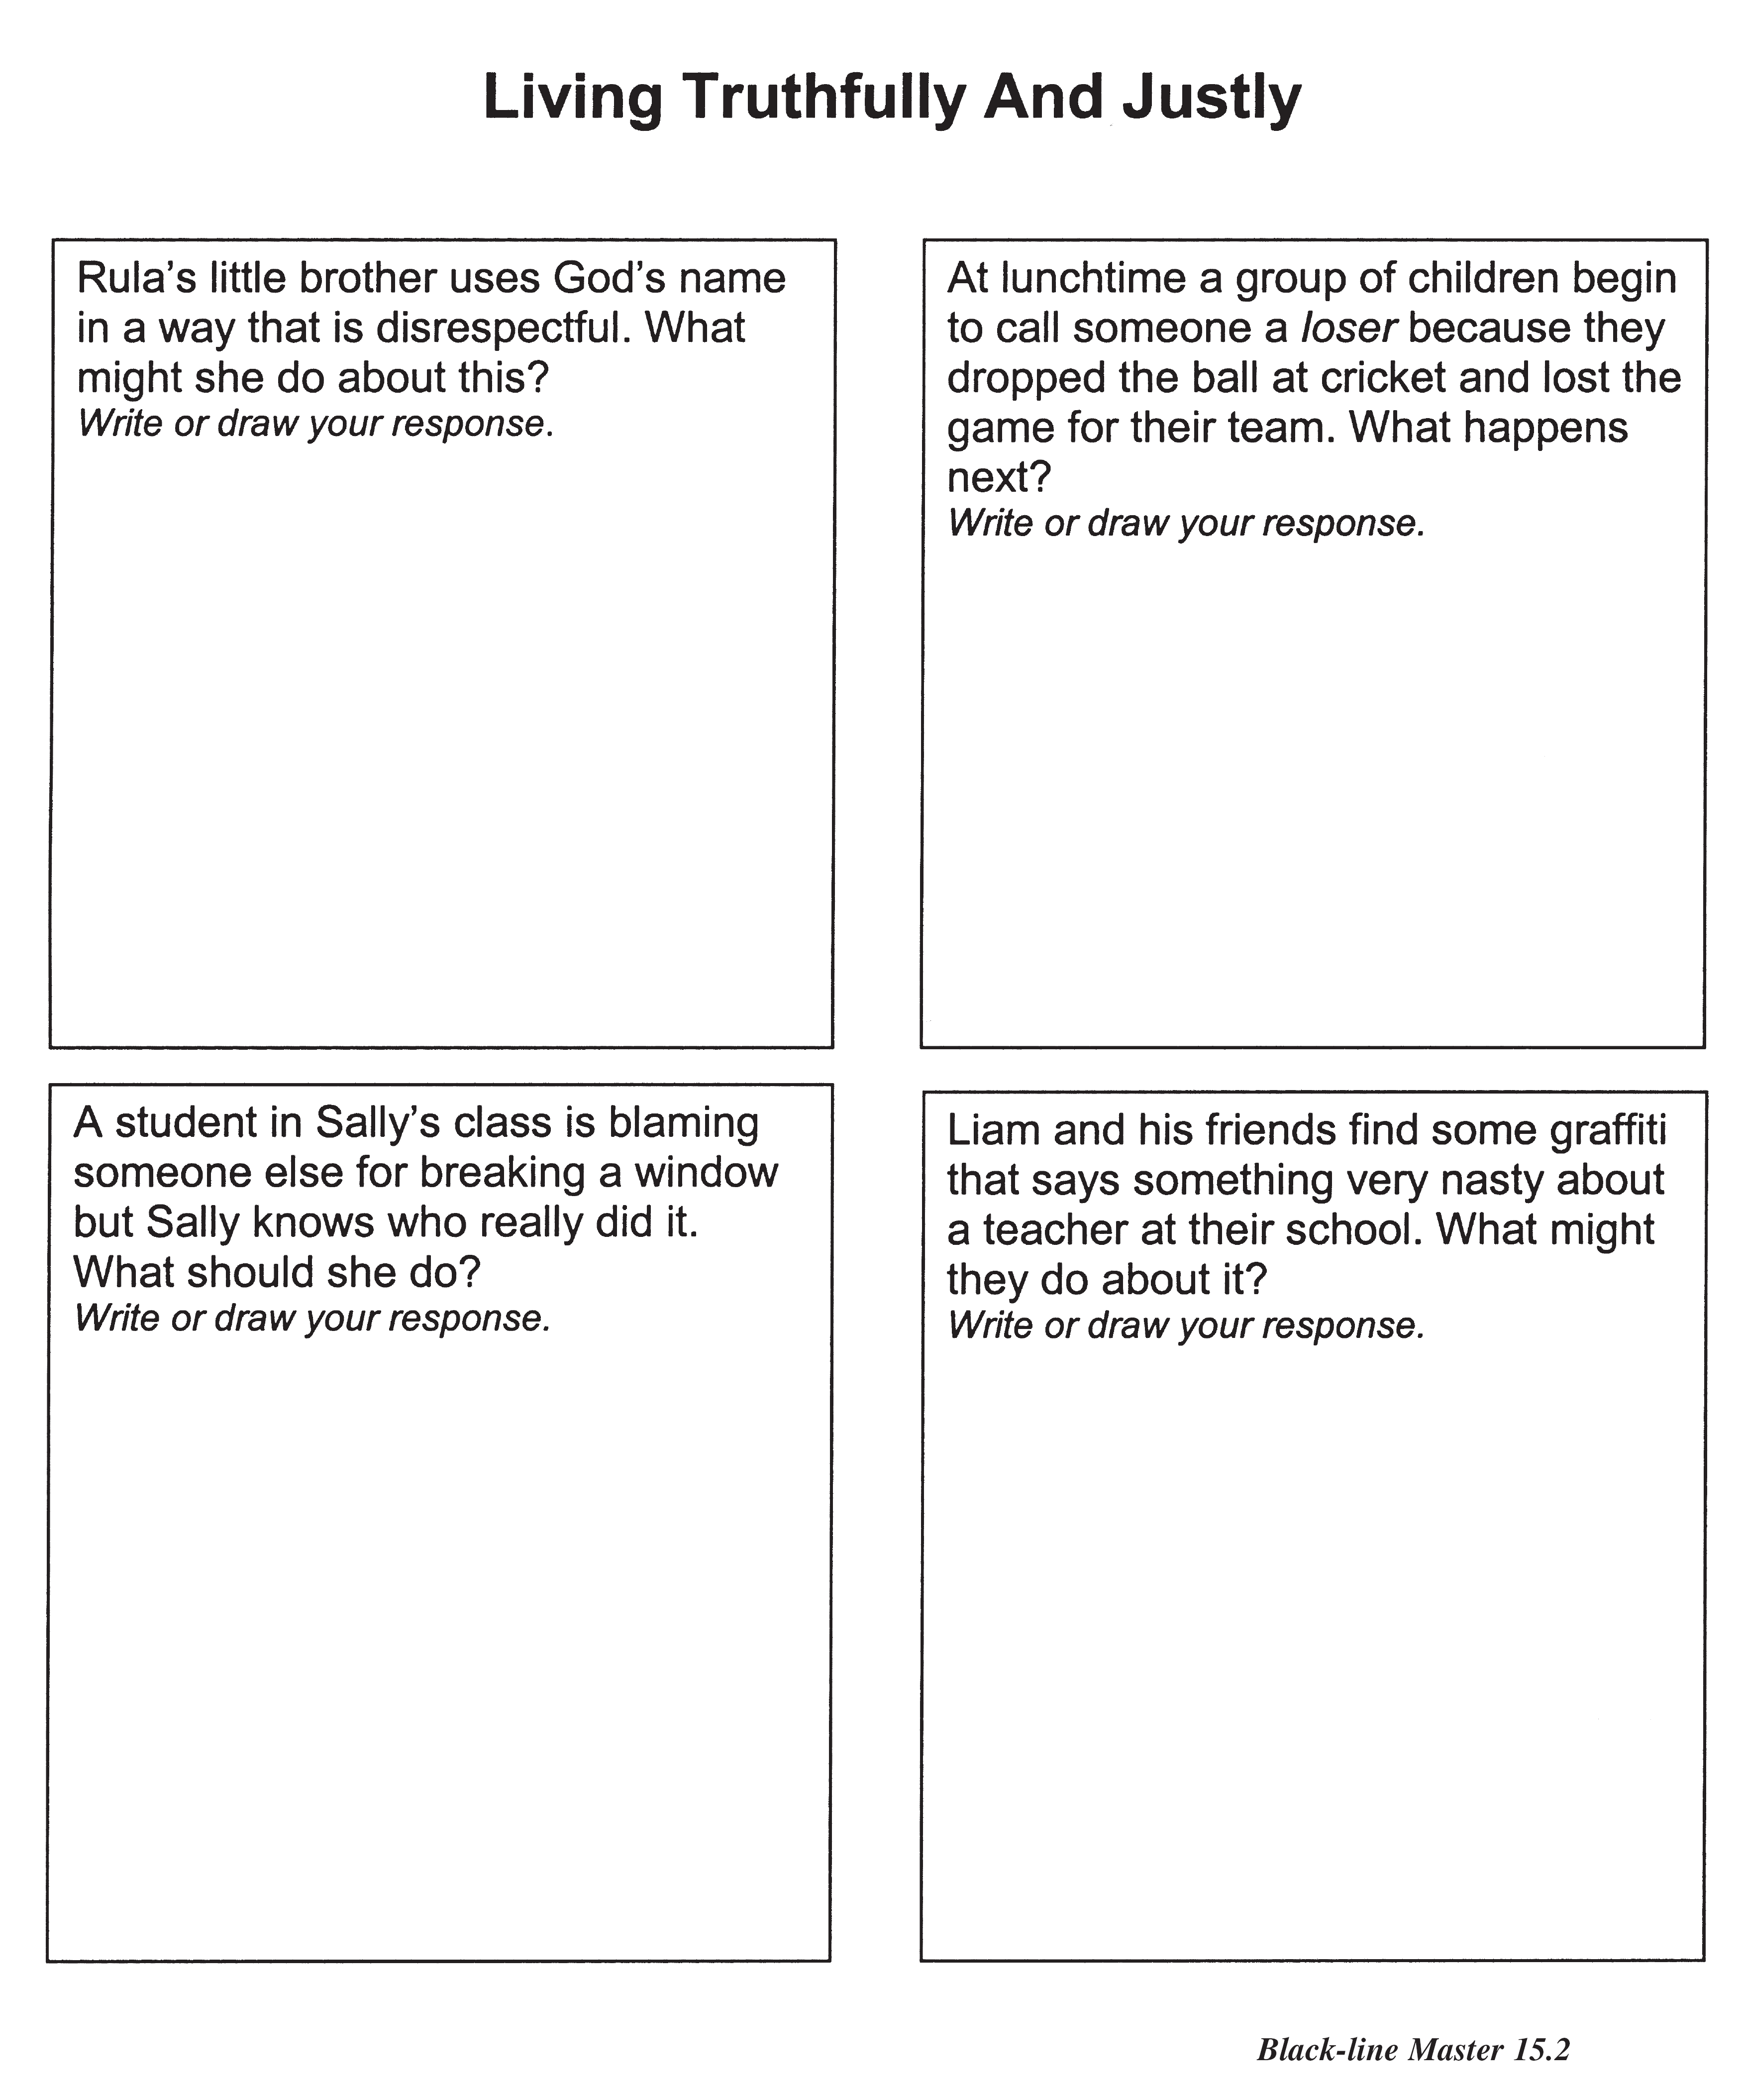

(KWL, Teaching Companion, 3a, p169)

**Resource Sheet 4**

**How I Pray**

**Reflect on the times and occasions when you pray and complete the following statements.**

|  |
| --- |
| Prayer is when I listen to and talk with God. When I talk with God: |
| * I usually pray when I am … |
| * I like to pray at … |
| * What helps me to pray is … |
| * I pray best when … |

**Resource Sheet 5**

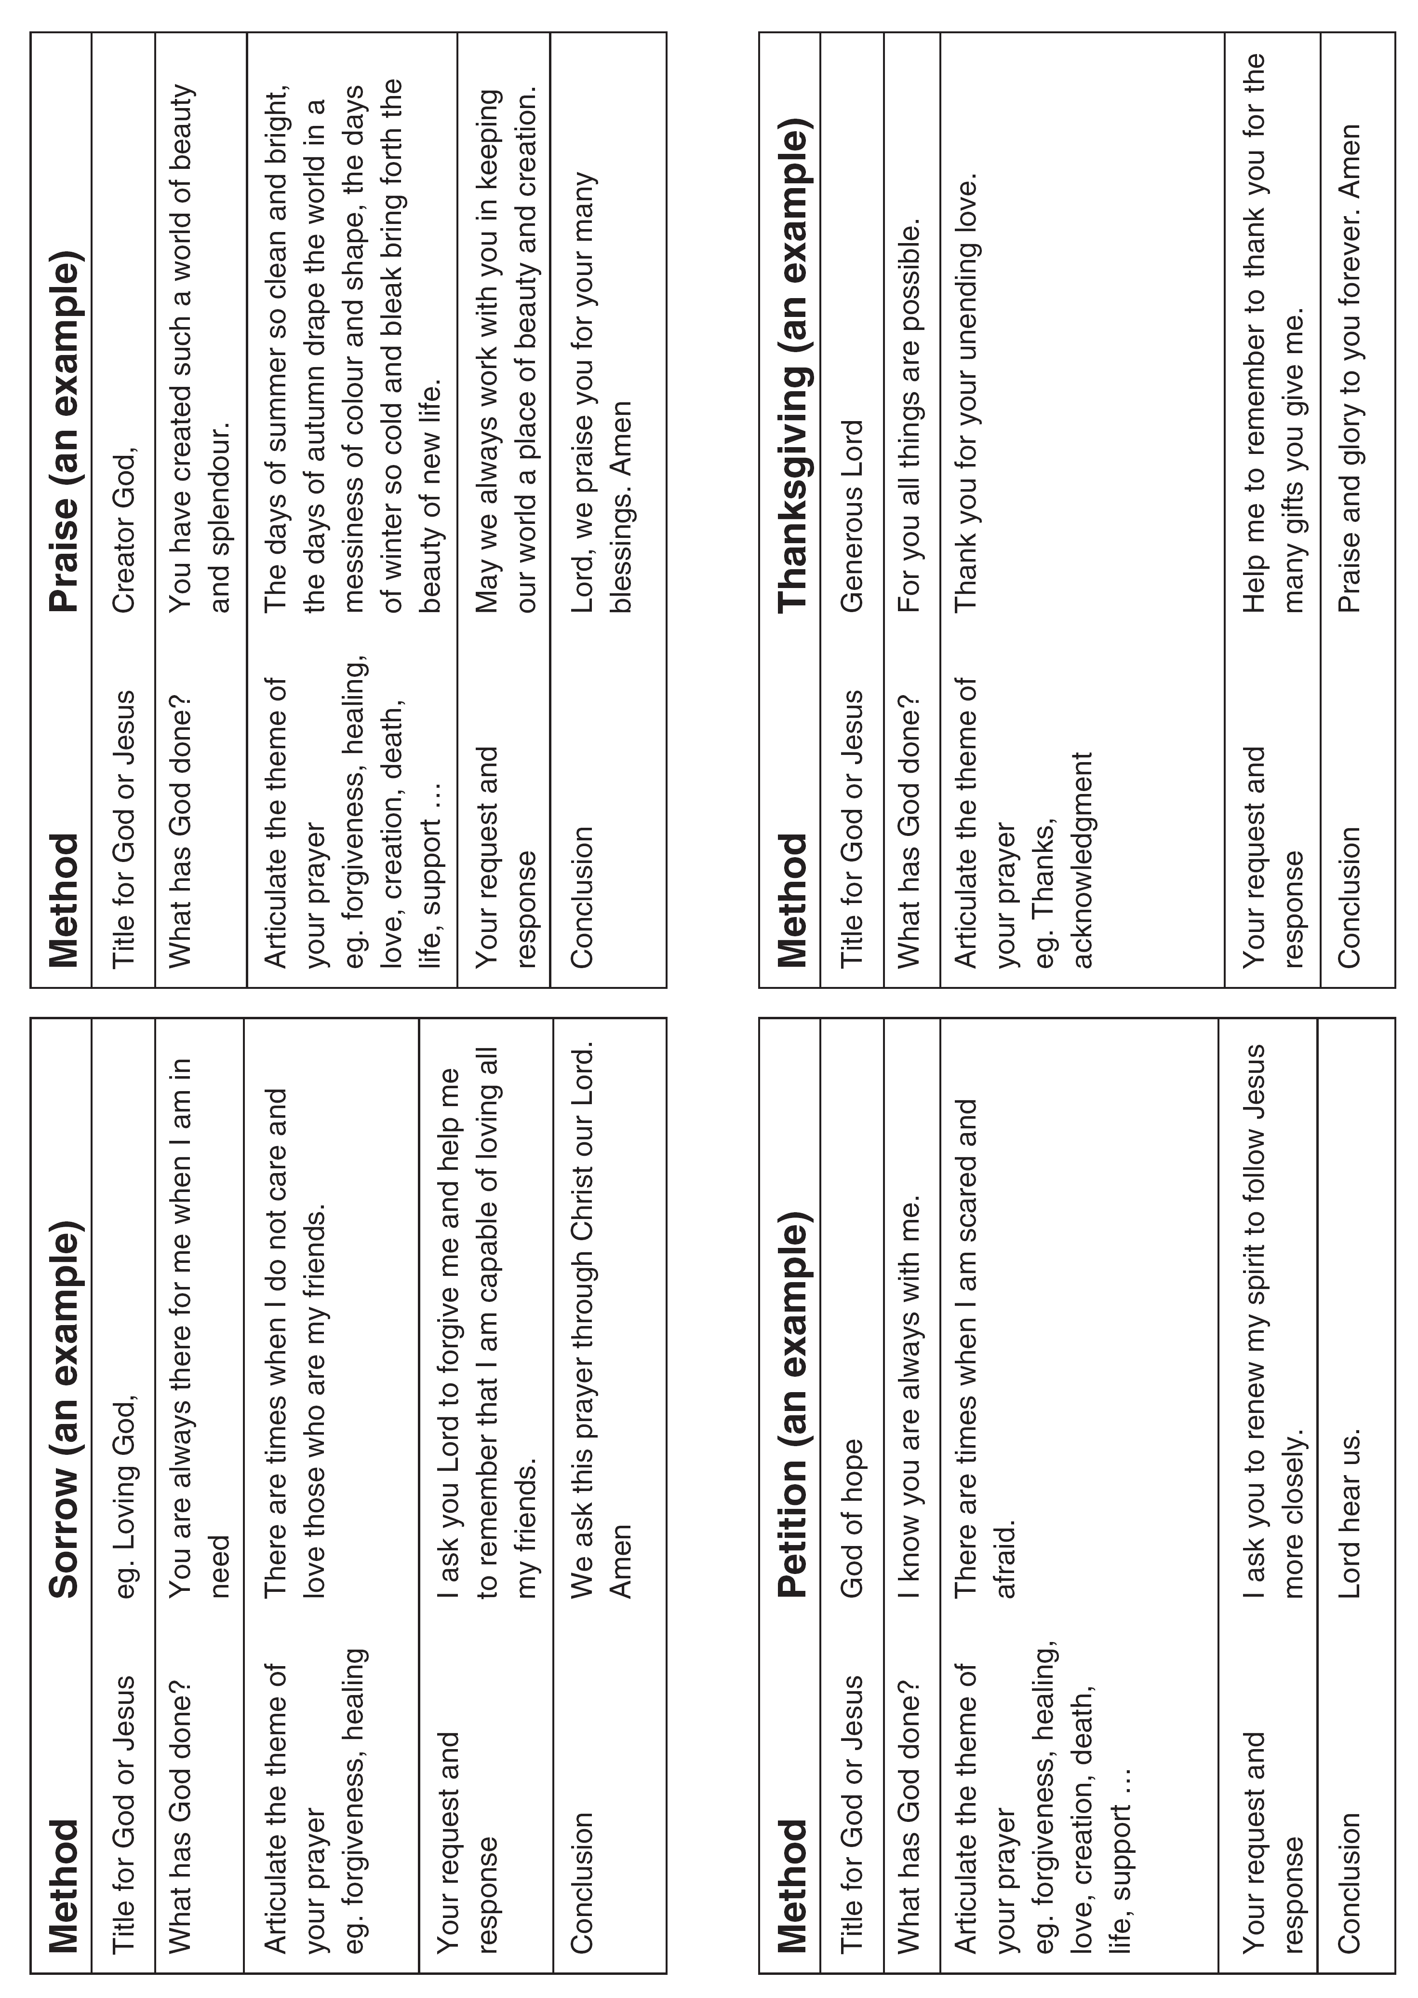

(KWL, Teaching Companion, 3a, p177)

**Resource Sheet 6**

|  |  |  |  |
| --- | --- | --- | --- |
| **Method** | **Sorrow (an example)** | **Method** | **Praise (an example)** |
| Title for God or Jesus | eg Loving God, | Title for God or Jesus | Creator God, |
| What has God done? | You are always there for me when I am in need | What has God done? | You have created such a world of beauty and splendour |
| Articulate the theme of your prayer  eg forgiveness, healing | There are times when I do not care and love those who are my friends. | Articulate the theme of your prayer  eg forgiveness, healing, love, creation, death, life, support … | The days of summer so clean and bright, the days of autumn drape the world in a maze of colour and shape, the days of winter so cold and bleak bring forth the beauty of new life. |
| Your request and response | I ask you Lord to forgive me and help me to remember that I am capable of loving all my friends | Your request and response | May we always work with you in keeping our world a place of beauty and creation. |
| Conclusion | We ask this prayer through Christ our Lord.  Amen | Conclusion | Lord, we praise you for your many blessings.  Amen |
|  |  |  |  |
| **Method** | **Petition**  **(an example)** | **Method** | **Thanksgiving**  **(an example)** |
| Title for God or Jesus | God of hope | Title for God or Jesus | Generous Lord |
| What has God done? | I know you are always with me | What has God done? | For you all things are possible. |
| Articulate the theme of your prayer  eg forgiveness, healing, love, creation, death, life, support … | There are times when I am scared and afraid. | Articulate the theme of your prayer  eg thanks, acknowledgment | Thank you for your unending love. |
| Your request and response | I ask you to renew my spirit to follow Jesus more closely. | Your request and response | Help me to remember to thank you for the many gifts you give me. |
| Conclusion | Lord, hear us. | Conclusion | Praise and glory to you forever.  Amen |

(Adapted from KWL, Teaching Companion, 3a, p177)

1. KWL, Teaching Companion, 3a, p165
2. KWL, Teaching Companion, 3a, p172
3. KWL, Teaching Companion, 3a, p161-162
4. KWL, Teaching Companion, 3a, p173