3.3 Easter: A Time to Celebrate the Presence of the Risen Lord

The Church celebrates the important events of the life, death and Resurrection of Jesus through the liturgical season of Easter. The unit recalls the events of the Journey to Emmaus and how the risen Jesus is present with us, through the Holy Spirit; in our relationship with Jesus, in the Word and in the ‘breaking of the bread’. The unit explores the celebration of Easter in the Church. It highlights the importance of Baptism in the Easter season as a sign of new life.

|  |  |  |
| --- | --- | --- |
| **Values & Attitudes**  *Students will demonstrate that they are:* | **Knowledge & Understandings**  *Students will demonstrate that they can:* | **Skills**  *Students will demonstrate that they can:* |
| L2.1 aware of the relevance of the Scriptures to the liturgical seasons | explain major events in the life of Jesus which are recorded in the Scriptures and celebrated in the liturgical life of the Church | interpret the significant events in the life of Jesus |
| L2.2 aware of ways in which they can respond to the presence of Jesus in their lives | describe ways people respond to the presence of Jesus | create rituals which celebrate their response to the presence of Jesus |

Syllabus Outcomes  
Liturgical Year – Stage 2

Classroom Outcomes

*Students will be able to:*

* retell the main events of Easter, outlining the disciples’ experience of the risen Jesus
* record key symbols of the liturgical season of Easter
* recognise in the celebration of Easter the importance of Baptism and Eucharist

|  |  |
| --- | --- |
| Scripture | Doctrine |
| Luke 24: 1-12 *The Resurrection of Jesus*  Luke 24: 13 – 35 *The Walk to Emmaus* | * Jesus rose from the dead on Easter Sunday * When we celebrate the Eucharist, Jesus Christ is present in the:   community gathered  Word proclaimed  bread and wine changed into the body and blood of Christ  priest who presides   * Through the Holy Spirit, Christ is present in the Church * In Baptism I become a member of the Catholic family |

Spiritual Reflection for Teachers

We often give people we love little things that will remind them of us: an engagement or wedding ring, photographs, a locket or bracelet. They are material things that help people remember the loving relationships they have.

Do you have any mementos of the people you love?

As Jesus came to the end of his life, he wanted to leave his followers a reminder of his love, and so he celebrated the Last Supper with his disciples.

When we gather together to hear God’s word and break the bread, it is a visible sign of God’s love for us.

What other things help you remember your relationship with Jesus?

Catechism of the Catholic Church

**Excerpts from the Catechism of the Catholic Church are included below as information for teachers. They present the Church’s teachings contained in this unit.**

**610** Jesus gave the supreme expression of his free offering of himself at the meal shared with the twelve apostles “on the night he was betrayed.” On the eve of his Passion, while still free, Jesus transformed this Last Supper with the apostles into the memorial of his voluntary offering to the Father for the salvation of men: “This is my body which is given for you.” “This is my blood of the covenant, which is poured out for many for the forgiveness of sins.”

**611** The Eucharist that Christ institutes at that moment will be the memorial of his sacrifice. Jesus includes the apostles in his own offering and bids them perpetuate it. By doing so, the Lord institutes his apostles as priests of the New Covenant: “For their sakes I sanctify myself, so that they also may be sanctified in truth.”

**1169** Therefore Easter is not simply one feast among others, but the “Feast of feasts,” the “Solemnity of solemnities,” just as the Eucharist is the “Sacrament of sacraments” (the Great Sacrament). St. Athanasius calls Easter “the Great Sunday” and the Eastern Churches call Holy Week “the Great Week.” The mystery of the Resurrection, in which Christ crushed death, permeates with its powerful energy our old time, until all is subjected to him.

1. The sacraments of Christian initiation — Baptism, Confirmation and the Eucharist — lay the foundations of every Christian life. “The sharing in the divine nature given to men through the grace of Christ bears a certain likeness to the origin, development and nourishing of natural life. The faithful are born anew by Baptism, strengthened by the sacrament of Confirmation, and receive in the Eucharist the food of eternal life. By means of these sacraments of Christian initiation, they thus receive in increasing measure the treasures of the divine life and advance toward the perfection of charity.”
2. According to the Apostle Paul, the believer enters through Baptism into communion with Christ’s death, is buried with him, and rises with him:

Do you not know that all of us who have been baptised into Christ Jesus were baptised into his death? We were buried therefore with him by baptism into death, so that as Christ was raised from the dead by the glory of the Father, we too might walk in newness of life (Rom 6:3-4; cf Col 2:12).

The baptised have “put on Christ” (Gal 3:27). Through the Holy Spirit, Baptism is a bath that purifies, justifies, and sanctifies.

Scripture: Background Information

Luke 24:1-12 The Resurrection of Jesus

Luke opens his Easter narrative with the coming of the dawn, symbolising a new beginning. Jesus’ death had completed one part of Luke’s story. Now the new life of the risen Lord begins. But it does not happen peacefully. Fear, confusion, disbelief, surprise and amazement are some of the reactions to the Easter event as depicted in the tradition Luke passes on to us.

In the Jewish culture of the first century, women had little legal status and could not give public witness, yet Luke presents women as the first to remember what Jesus had taught them about the meaning of his death and Resurrection. They were the first to believe and to proclaim that Jesus had really risen from the dead. Luke’s account tells us about faith and seeing with the eyes of faith. We must also look for the risen Lord in life with the eyes of faith.[1]

**Luke 24:13-35 The Walk to Emmaus**

This is an exquisite story that is full of Lucan ideas – journey, the richness of the word, faith, recognition and meals. This story is only in Luke’s gospel. We are not sure of the location of the village of Emmaus. Two followers of Jesus are travelling there on foot – a distance of about 15 kilometres from Jerusalem. One of them is identified as Cleopas. The other one remains anonymous. It is strange that they do not recognise the risen Jesus who joins them on the journey. Or is it so strange?

Do we always feel that Jesus is with us? Their experience might be much the same as ours. Jesus explains the scriptures to them from the Pentateuch to the prophets. No small feat! This experience later led the two followers to say, “Did not our hearts burn within us as he talked to us on the road and explained the scriptures to us?” (24:32). In light of the scriptures they understood the true meaning of what had happened to Jesus. Their sense of hospitality caused them to insist that the stranger stay with them for a meal. It was in the breaking of the bread that they recognised Jesus. Once they did, he was no longer there with them. Their faith enabled them to perceive Jesus in the Eucharistic ritual. They immediately returned to Jerusalem even though it was late in the day when they set out.

The Church’s Teaching and Lived Tradition

In Tradition *- To Know Worship and Love Year 3*, p41 - Exsultet

The Easter Proclamation from the Easter Vigil

In darkness at the beginning of the Easter Vigil, the risen Lord is proclaimed in the Exsultet. This proclamation is sung by the deacon in the light of the Easter candle, the light of the risen Christ. The vigil is a night to remember, when we read again the stories of God’s saving action in the lives of his people, culminating in the Resurrection, the foundation event of Christian faith. [2]

Celebration: Prayer and Liturgy

**Celebration is a key part of Religious Education. The following suggestions provide opportunities throughout the unit for celebration in prayer and liturgy. Most of these suggestions are included as ‘teaching/learning’ activities in Unit Content sections.**

* Tell the story, ‘Our Easter Prayer Place’ as you set the prayer place. See Resource Sheet 1 for suggested script.
* Organise a class prayer, giving thanks to God for the joy of celebrations in our lives. Students could write their own Litany of Thanksgiving for the response.

Prayer structure to include:

We gather… We Listen … We Respond… We Go Forth

A model to assist in preparing a Litany of Thanksgiving can be found in *Praying With Children. A Resource Book for Primary Teachers*, Barbara Ann Bretherton, p12–13.

* In prayer celebrate the new life of the risen Jesus. A model to assist in preparing a class prayer liturgy is ‘Easter: Jesus is Alive, He is with Us’ in *Praying With Children*: *A Resource Book for Primary Teachers*, Barbara Ann Bretherton, p50-51.
* Participate in a guided meditation of Luke 24:1–12. An example of how to organise a guided meditation using Scripture can be found in *Prayer Strategies: A Teacher’s Manual*, Beth Nolen, p58–60.
* Class prayer ideas:

Reflect on each stage of the Emmaus story. This prayer may be spread over four sessions/ days so the students enter into each section of the Emmaus story.

i) Over four days, reflect on each stage of the Emmaus story. Invite students to respond to each stage of the event by creating a mandala. Divide the mandala into four sections. Slowly read a given part of the Emmaus story, eg Lk 24:13-17 and invite the students to reflect on the feelings of the disciples. Students express these feelings through the use of colour and line in one quadrant of the circle. Repeat for the next part of the Emmaus story using another quadrant of the mandala.

OR

ii) Invite students to journal the story from the position of Jesus or a disciple. Use the sentence stem: “As I travelled on the road … “

* Participate in a celebration of the Eucharist with the parish community. Celebrate the Resurrection of Jesus proclaiming that ‘Jesus is Risen!’ Include the Memorial Acclamation B. After the celebration discuss with students the presence of Jesus Christ in the community, the priest, in the Word of God, and in Holy Communion. Remind the students that every Sunday celebration of the Eucharist celebrates the great event of Easter. When we gather at Mass we remember the life, death and Resurrection of Jesus.

Assessment

**Interim Assessment Statement 2014**

The identification of Teaching/Learning strategies as ‘suggested assessment’ has been removed from the 3-6 RE curriculum. The type of assessment activity and the way evidence of learning is gathered will vary, depending on such factors as; the outcomes being assessed, the evidence being gathered, the teaching and learning activity, context and students’ learning needs (NSW Board of Studies, <http://syllabus.bos.nsw.edu.au/support-materials/k-6-assessment-strategies/>).

Assessment in Religious Education is based on the same principles as in other key learning areas. Please refer to the CEO Sydney site supporting the implementation of the Australian Curriculum in the context of the NSW BOS Syllabus. At this site <https://sites.google.com/a/syd.catholic.edu.au/professional-learning-modules/home> professional learning modules are provided to support teachers as they engage with the NSW BOS Syllabuses for the Australian Curriculum.

**Module 4, Assessment and Planning** explores the principles of effective assessment ***for***, ***as*** and ***of*** learning and considers a range of strategies and methods for assessing student learning. Activities focus on moving beyond assessment as an index of learning, towards assessment that motivates, enhances learning and achieves deeper understanding to meet the diverse learning needs of all as students. Participants are encouraged to reflect on assessment as a driver for improvement in teaching and learning.

**Religious Education Curriculum and Assessment**

In Year 3-6 Religious Education Curriculum, both Syllabus Outcomes and Classroom Outcomes are key reference points for decisions about students’ progress and achievement. Classroom outcomes are more specific to the unit content. Unit Content statement and *Students will learn* statements in each unit should also be taken into account in planning and developing learning and assessment opportunities. Outcomes and Unit Content Statements are derived from Syllabus objectives.

Effective Religious Education involves teaching the Catholic faith (Scripture, doctrine, traditions, prayer and sacraments) and nurturing the faith of the child. There is no attempt to assess the child’s faith. Assessment is concerned with skills, knowledge and understanding of the Catholic faith taught in the curriculum and supported in the religious life of the school.

Resources

*To Know Worship and Love,* Year 3, Chapters 5 and 10,(2003) James Goold House Publications, Melbourne, Victoria

Bretherton B A, (2002), *Praying With Children: A Resource Book for Primary Teachers,* Social Science Press, Katoomba NSW

Liturgical Calendar – available from the Mustard Seed Bookshop, Catholic Adult Education Centre, Lidcombe NSW

Nolen B, (1999), *Prayer Strategies: A Teacher’s Manual,* Harper Collins Publishers, East Melbourne, Vic

Key to Symbol

✪ denotes higher order activity

Unit Content 1

The liturgical seasons celebrate the mystery of Christ. Easter is the most important liturgical season.

*Students will learn:*

* about the place of the Easter season in the liturgical calendar of the Church
* to identify the use of colour, action, symbol and word in celebrating the Church’s liturgy

Unit Content: Background Information

The Easter Triduum (3 days) celebrates the passion, death and Resurrection of Jesus as one feast. The Easter Triduum begins with evening Mass of the Lord’s Supper on Holy Thursday. Good Friday celebrates the Lord’s Passion. The Holy Thursday and Good Friday liturgies do not have a dismissal. Each flows into the other and culminates in the Easter Vigil on Saturday night. The Triduum concludes on Easter Sunday with Evening Prayer. Easter Sunday is both the last day of the Triduum and the first day of the Easter season, which lasts for 50 days.

We often attach colour and symbol to life experiences as a means of conveying mood and emotion. The meaning of colour and symbol is not universal and it would be beneficial to explore how colour varies in different cultures. It is important to draw children’s attention to the expression of joy and hope which permeates the liturgical celebrations of Easter. As students develop a prayer place in the classroom, the teacher discusses with students the selection of colour and symbol, and their relevance to the Easter season.

Suggested Teaching/Learning Strategies

* Tell the story, ‘Our Easter Prayer Place’ as you set the prayer place. See Resource Sheet 1 for suggested script.
* Brainstorm and list important events we celebrate. Discuss with students how we prepare for special events. Select a family celebration for discussion (e.g. birthday, New Year’s Eve).
* Our Church family also prepares and celebrates special events. Students identify these events and match the events to the liturgical year.
* Share the passages about Easter in KWL, Year 3, p39. Discuss the importance of Easter in the Church calendar. Review the liturgical calendar and identify the season of Easter.
* Review the work on colour, symbol, words and mood developed during the Lent unit. Build on students’ prior knowledge of the liturgical year.
* Students recall their experiences of Easter liturgies. Use the questions in Reflecting Together At Home and At School (KWL, Year 3, p43) to guide class sharing.
* Visit the church or participate in a parish Mass as a class. Have the priest share the symbols of the Easter season found in the church. Observe: colour, action, symbol and words spoken. What mood or feeling do they convey?
* Share a section of the Exsultet, the Easter Proclamation from the Easter Vigil (In Tradition, KWL, Year 3, p41). Identify and list words in the Exsultet that express the joy of Easter. Invite students to create a poster or artwork that expresses the message of joy proclaimed at Easter.
* Identify the symbols in the church that are used during the Easter season to express joy and new life. Discuss with the students words and actions used during the celebration of Mass that express joy and new life.
* Individual Reflection: Students complete a Y chart for the Easter season. I can see… I can hear…I can feel (eg joy, happiness)… as a way of expressing the changes they have seen in the church OR construct a whole class retrieval chart using headings of I see…, I hear…, I feel.
* Draw and label some of the key words, symbols and actions used in the Church celebrations during the Easter season.
* Students add symbols of Easter to the classroom prayer place.
* Learn an Easter hymn. Invite the students to explore the words and imagery of the hymn through movement.
* Class prayer to celebrate the new life of the risen Jesus.

Unit Content 2

God raised Jesus to new life. The disciples experienced the presence and new life of Jesus through: their relationship with him, his word, the action of breaking the bread.

*Students will learn:*

* about the Scripture passages which speak of the Resurrection of Jesus
* to explore how the disciples and other followers experienced the new life of the risen Jesus
* about the Emmaus story
* to identify the disciples’ responses to their encounters with the risen Jesus

Unit Content: Background Information

The vision of the empty tomb brought fear and confusion to the disciples and followers of Jesus. Already upset at the death of Jesus, they now had to come to terms with his Resurrection. Like the disciples, we too struggle to recognise, with eyes of faith, the Risen Lord.

In the Emmaus Story there are four distinct movements, which represent the way the disciples came to recognise the risen Jesus.

1. Jesus joins the disciples on the road and **listens** to their experience.
2. Jesus discusses and **explains the scriptures** to the disciples.
3. Jesus **shares a meal** with the disciples and at the breaking of the bread, they recognise him.
4. The disciples return to Jerusalem and move out to **proclaim the risen Christ**.

Suggested Teaching/Learning Strategies

* Tell the story, ‘Jesus is Risen’ (Luke 24:1-12). See Resource Sheet 2 for suggested script and materials.
* Engage students in wondering. The following wondering statements are offered as a guide.

I wonder how the women felt as they went to the tomb that Sunday morning.

I wonder what they thought when they saw that Jesus’ body was not in the tomb.

I wonder what it was like to hear the words, “Jesus is not here but has risen.”

I wonder why some of the disciples didn’t believe the women.

I wonder how the women felt when the disciples didn’t believe them.

I wonder why Peter ran to the tomb.

I wonder what part of this story you like the best.

* Provide students with materials and time to respond to the above story in a way of their choosing, e.g. painting, drawing, construction, drama, writing, using the story materials.
* Lead a guided meditation of Luke 24:1–12 for students. An example of how to organise a guided meditation using Scripture can be found in *Prayer Strategies: A Teacher’s Manual*, Beth Nolen, p58–60.
* Tell the story, ‘The Walk to Emmaus’ (Luke 24:13-35). See Resource Sheet 3 for suggested script and materials. Note: this story follows directly on from ‘Jesus is Risen’ in Luke’s Gospel.
* Engage students in wondering using the following wondering statements as a guide.

I wonder why the disciples didn’t recognize Jesus.

I wonder what it was like telling their story of Jesus to a stranger.

I wonder why the disciples strongly urged the stranger to stay with them.

I wonder why they recognized it was Jesus when he broke the bread.

I wonder how the disciples changed when they realized that Jesus was alive.

* Invite the students to ‘work with’ or respond to any part of this Scripture story using a medium of their choice. Make available art, craft and writing materials. Also make available some children’s bibles with this story in them for those who would prefer to read, and the story materials for those who would like to work with them.

Organise students who would like to work on presenting a retell into small groups of about four. Each group plans and presents a retell of the Emmaus story. The retell could be presented in any way the group decides e.g. movement, as a tableau or liquid pictures, or pictorially using paintings, digital photographs or drawings on overhead sheets. These are only examples of what children might choose.

* Students retell one of the Easter events: either ‘Jesus is Risen’ or, ‘The Disciples on the Walk to Emmaus’, choosing the medium that they would like to use.
* Class prayer ideas:

Reflect on each stage of the Emmaus story. This prayer may be spread over four sessions/ days so the students enter into each section of the Emmaus story.

* 1. Over four days, reflect on each stage of the Emmaus story. Invite students to respond to each stage of the event by creating a mandala. Divide the mandala into four sections. Slowly read a given part of the Emmaus story, eg Lk 24:13-17, and invite the students to reflect on the feelings of the disciples. Students express these feelings through the use of colour and line in one quadrant of the circle. Repeat for the next part of the Emmaus story using another quadrant of the mandala.

OR

* 1. Invite students to journal the story from the position of Jesus or a disciple. Use the sentence stem: “As I travelled on the road …”

Unit Content 3

During the Easter Season we celebrate our new life in the risen Lord.

*Students will learn:*

* to identify how the Church celebrates the new life of Jesus during the Easter celebrations
* about the celebration of Baptism and the Easter Vigil

Unit Content: Background Information

Jesus is risen - the source of our joy at Easter! During this great celebration Christians proclaim their belief in the Resurrection of Jesus. Easter is the summit of the whole liturgical year. The Church celebrates the Resurrection of Jesus, the foundation of our faith, the source of our hope and new life.

For the disciples on the road to Emmaus, recognition of the Risen Lord occurred when he broke the bread with them. Today, we celebrate Jesus Christ present with us in the breaking of the bread at the Eucharist. Each time we celebrate the Eucharist we recall and make present the life, death and Resurrection of Jesus. We experience the presence of the Risen Lord in the gathered community, in the priest, in the Word of God and in sharing the body and blood of Christ. We are then sent out from the assembly to announce the Good News (Gospel) of the Lord. For more information on this see [Together at One Altar](http://www.togetheratonealtar.catholic.edu.au/explore/dsp-content.cfm?loadref=22).

During the Easter Vigil we celebrate the new life of the Risen Lord by welcoming new members into the Church community. Baptism within the Easter Vigil is one way we proclaim and celebrate the new life of the risen Jesus during Easter. Baptism unites us to the paschal mystery of Christ, to his life, death and Resurrection. We are also invited to renew our baptismal promises during the Easter Vigil and celebration of Easter. We reflect on and re-commit ourselves to the faith we profess. We believe that through the waters of Baptism we enter the tomb with Jesus and rise into the new life of Christ.

The celebration of the Eucharist during the Easter season is filled with symbols, words and actions that express our communal belief in the risen Lord. The celebrations express great joy. The paschal candle symbolises the light of Christ. The Easter water and the white garments symbolise our new life in Christ, and in the Eucharist we celebrate our relationship with the risen Jesus.

This Unit content begins by telling the story ‘Together At Mass’ and exploring how we experience the presence of Jesus as the disciples did on the walk to Emmaus. It also focuses on the celebration of Baptism within the Easter Vigil as the celebration of the new life of the Risen Lord.

Suggested Teaching/Learning Strategies

* Tell the story ‘Together At Mass’. See Resource Sheet 4 for suggested script and materials.
* Engage students in wondering.

I wonder if you can talk about what’s happening in one of these posters.

In the story I said, “Jesus is with us in each part of the Mass.” I wonder in which part of the Mass you feel close to Jesus.

If Jesus lived and died over two thousand years ago, I wonder how he is still present with us today.

* Review the Emmaus story with the students. A reading of the Emmaus scripture passage with slides can be accessed at [Together at One Altar](http://www.togetheratonealtar.catholic.edu.au/explore/dsp-content.cfm?loadref=17). What happens during parts of the Mass that is similar to parts of the Emmaus Story? How do we celebrate Jesus Christ with us during the celebration of the Eucharist?
* Attend a celebration of Mass as a class or watch a DVD on the Eucharist. Assist students in identifying the community gathering to celebrate, listening to the Word of God and the breaking of the bread. Explain to the students that the celebration of the Eucharist each Sunday, ‘The Lord’s Day’, celebrates the great event of Easter. We celebrate the life, death and Resurrection of Jesus. Our Church community gathers at the Eucharistic celebration on Sunday to proclaim Jesus as Lord and to support each other in love.
* In groups, students create posters to show how the Church celebrates the presence of Jesus Christ in the Mass. Present group posters.
* Explore with students the term ‘belonging’. Use the questions in ‘Reflecting Together at Home and at School’ (KWL, Year 3, p83) to talk about belonging to groups and the sense of belonging.

- What relationships do we build in the groups we belong to?

- What group/s do we share membership in? eg we all belong to a family, we all belong to the same class group/ school, we belong to God’s family.

* Read with students ‘Welcomed into the Life of God’s Family’ (KWL, Year 3, p78). Talk about and list the things we do together as a Catholic family. Students define ‘initiation’ and illustrate their experiences of initiation or welcome at school or in community groups. Illustrate the words, actions or symbols used.
* Explain that belonging to a group involves sharing beliefs and practices. As Catholics, we are welcomed into the Church community through The Sacraments of Initiation – Baptism, Confirmation and Eucharist. The first of these sacraments is Baptism.
* Invite students to share their experiences of being present as a person is baptised during the Easter celebrations.
* Arrange for the class to visit the church and organise for the priest to show the paschal candle, baptismal font and white garment to the students. Ask the priest to explain what each symbol represents and why people are baptised during the Easter Vigil.
* Tell the liturgical story of Baptism using ‘Resource Sheet 5’ and the suggested concrete materials, or

Read the Rite of Baptism (KWL, Year 3, p79-80).

* Engage students in wondering.

I wonder if you’ve ever seen something like this happen in the church. (Give students the opportunity to share what they have seen)

I wonder why the priest meets the people at the door of the church.

I wonder why the Sign of the Cross is made on the forehead of the person/people being baptised.

I wonder why white is the colour of the garment used in Baptism.

I wonder why the candle given to the newly baptised is lit from the Paschal or Easter candle.*Remember, there is no one response to these. Students will have different responses as they attempt to find meaning in the symbols and actions.*

* Give students the opportunity to explore the story or a particular part of the story of their choosing using the story materials, art/craft materials or reading KWL books. Some students may wish to focus on symbols, actions or words used during the Rite of Baptism.
* Read with students the Renewal of Baptismal Promises (KWL, Year 3, p82) used during the Easter Sunday celebrations. Who made these promises at your Baptism? Why would we re-new them at Easter? When we make our Baptismal Promises what do we say we believe? Assist students to see the connection between the life, death and Resurrection of Jesus and the new life of Jesus into which we are baptised.
* Students complete a concept map to record the ways we celebrate the new life of the risen Jesus at Easter.
* ✪ - Students create a poem using Easter symbols or words, eg water, alleluia, light, new life, expressing hope and joy in Jesus’ Resurrection. An acrostic or other type of poem could be used here.

**Resource Sheet 1**

3.3 **Our Prayer Place**

**YOU WILL NEED:**

* a small table

* a box or basket, containing a cloth, Bible, bookstand, paschal candle, Easter holy water and white garment

*Invite children to sit reverently in a circle in the part of the classroom where you intend to set up a prayer place. Begin by saying…*

**As Easter begins we’re going to change our prayer place. During the season of Easter we’ll have some different objects to help us be with God.**

*Cover the table with the white cloth.*

**At this time of the Church’s year we place a white cloth on the table.**

**White is the colour of joy. Easter is the season we joyfully celebrate Jesus rising from the dead. Easter is the greatest season of the Church’s year.**

*Hold the Bible up for all children to see. Be conscious of handling the Bible in a reverent manner.*

**The Bible is our sacred book. At this time in the Church’s year we listen to and tell the stories of what Jesus said and did after his resurrection.**

*Model carrying the Bible as you would in a procession.*

*Place the Bible on a bookstand on the table.*

*Hold the paschal candle and show to children.*

**The paschal candle reminds us that Jesus is always with us. We will light the candle when we are talking and praying to God, and when we are listening to the stories from the Bible.**

*Place the candle on the table.*

*Hold the bowl of Easter holy water and the white garment.*

**The Easter water and the white garment symbolise our new life in Christ.**

*Place bowl of water and white garment on table.*

*Other symbols appropriate to 3.3 Easter unit can also be added.*

**This is our prayer place for Easter.**

*Point to the symbols and objects as you name them again.*

**It has a *white* cloth, a Bible, the paschal candle, Easter water and a white garment.**

**Let us pray………***Pause*

**May the love of God bless us and fill our lives with joy as we celebrate the great season of Easter. We ask this through Christ our risen Lord. Amen.**

# Resource Sheet 2

# Jesus Is Risen

**Lk 24: 1-12**

**You Will Need:**

* Beige felt underlay
* White cloth for inside the tomb
* 3 or 4 flat rocks to make the tomb, one of which is the ‘stone’ that is rolled away
* Peg dolls: 3 women, 2 men in white, Peter

*Lay out the felt underlay and say:*



Arrange rocks to look like a tomb: two on the side supporting the roof with the shroud inside

**This is the season of Easter, and our story today is about the mystery of Easter.**

*Build the rock tomb with the white cloth in it, as you say*:

**After Jesus died he was laid in the tomb of a rich man.**

*Place the three women on the felt and move them towards the tomb*

**Early on Sunday morning, Mary Magdalene, Mary the mother of James, Joanna and other women went to the tomb with ointments and spices they had prepared.**

*Move the front stone away from the tomb to show the white cloth*



**They found the stone rolled away from the tomb, but when they went in they did not find the body.**

*Place the two figures in white next to the tomb and the women*

**They saw two men in dazzling clothes.**

*Place the three women face down on the ground.*

**The women were terrified and bowed their faces to the ground.**

**The men in white said, “Why do you look for the living among the dead? He is not here but he has risen!”**

*Replace the women into the upright position.*

**The women went quickly back to tell the apostles and others what had happened.**

*Move the women to the other end of the cloth where Peter is waiting.*

**Some of the disciples did not believe them, but Peter got up and ran to the tomb.**

*Move Peter to the entrance of the tomb.*



**Peter saw the linen cloths by themselves and was amazed at what had happened.**

*Pause quietly for a moment and then begin to wonder together.*

**I wonder how the women felt as they went to the tomb that Sunday morning.**

**I wonder how they felt when they saw that Jesus’ body was not in the tomb.**

**I wonder what it was like to hear the words, “Jesus is not here but has risen.”**

**I wonder why some of the disciples didn’t believe the women.**

**I wonder how the women felt when the disciples didn’t believe them.**

**I wonder why Peter ran to the tomb.**

**I wonder what part of this story you like the most.**

*Carefully pack story materials into storage box and put away*

**Resource Sheet 3**

**The Walk to Emmaus (Luke 24: 13-33)**

**Unit 3.3**

**YOU WILL NEED:**

* a white or gold ribbon  
* a set of visuals made from the PowerPoint: *3.3 The Walk to Emmaus* on RE online

*Roll out the white/gold ribbon as you say:*

**At this time of the Church’s year we use white or gold. White is the colour of joy. Easter is the season of joy. This story follows straight on from the one we have just had about the women discovering the empty tomb.**

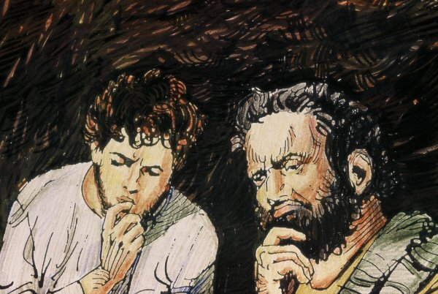

*Hold Visual 1 as you say*

**Two of Jesus’ disciples were travelling from Jerusalem to a village called Emmaus**. **They were talking with each other about the things that had been happening there, about Jesus their master and friend.**

**Then Jesus himself joined them but something stopped them from recognizing him.**

*Place Visual 1 on the ribbon to your far right*

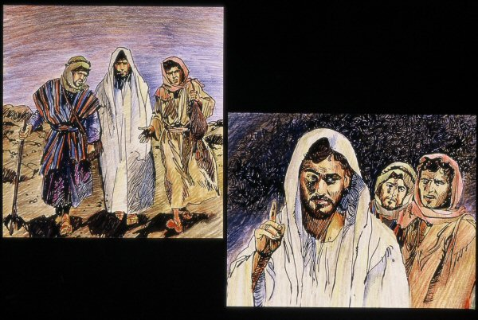

*Hold Visual 2 as you say*

**And he said to them, “What are you discussing with each other while you walk along?”**

**They stood still, looking sad. Then one of them said, “Are you the only person in Jerusalem who doesn’t know the things that have taken place the last few days. They told him all about Jesus of Nazareth, - the things he said, the things he did and how he was crucified; how they hoped he would be their king. They told him how some members of their group had found his tomb empty and had told them that Jesus is alive!**

*Place Visual 2 on the left of Visual 1*



*Hold Visual 3 as you say*

**The stranger then began to explain why Jesus died and how the things that happened to him were written in their Scriptures.**

*Place Visual 3 on the left of Visual 2*

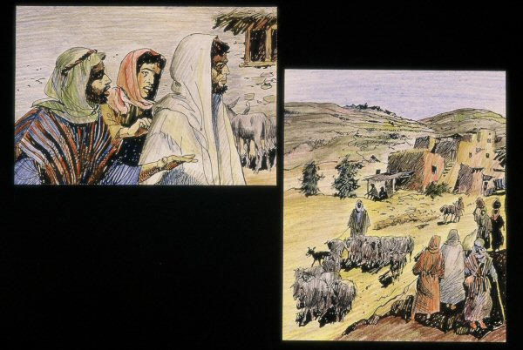

*Hold Visual 4 as you say*

**As they came near the village, the disciples strongly urged him to stay with them.**

*Place Visual 4 on the left of Visual 3*

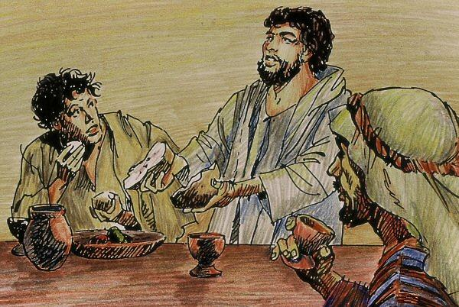

*Hold Visual 5 as you say*

**When he was at table with them he took the bread, blessed it, broke it and gave it to them.**

**Then their eyes were opened and they recognized him.**

**The stranger was Jesus. Jesus was risen from the dead!**

**Then he disappeared from their sight.**

*Place Visual 5 on the left of Visual 4*

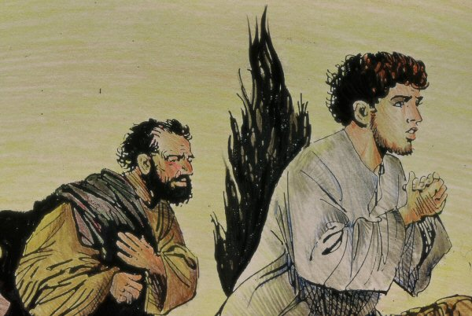

*Hold Visual 6 as you say*

**The friends of Jesus were so happy that Jesus was alive. They got up immediately, and ran as fast as they could back to Jerusalem to tell the disciples.**

*Place Visual 6 on the left of Visual 5*

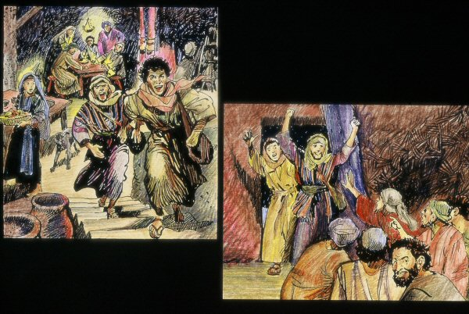

*Hold Visual 7 as you say*

**They told them what had happened on the road, and how they had recognized Jesus in the breaking of the bread.**

*Place Visual 7 on the left of Visual 6.*

*Sit back … Pause for a while before wondering with the students …*

**I wonder:**

* **I wonder why the disciples didn’t recognize Jesus.**
* **I wonder what it was like telling their story of Jesus to a stranger.**
* **I wonder why the disciples wanted the stranger to stay with them.**
* **I wonder what it felt like when they recognized that the stranger was really Jesus.**
* **I wonder why the disciples recognized Jesus at the breaking of the bread.**
* **I wonder how the disciples changed when they realized that Jesus was risen.**

**Resource Sheet 4**

3.3 together at mass

**You will need:**

* Posters: From Unit 1.4 – *Together at Mass:* or can be ordered from www.kwl.com.au/- Poster 1: We gather  
  - Poster 2: We listen to God’s word  
  - Poster 3: We offer gifts of bread and wine  
  - Poster 4: We praise and thank God  
  - Poster 5: People share Holy Communion  
  - Poster 6: We go in peace to love and serve

*Children are seated in a semi-circle ready to listen to the story. When the children are ready carry the materials carefully from the story shelf to the story area and place beside you.*

**In the Emmaus story we heard that the disciples recognised that the Risen Jesus was with them.**

*Hold the closed folder “Together at Mass” in front of you:*

**Each time *we* gather to celebrate the Mass we remember that Jesus is still with us too. The Risen Jesus is with us in each part of the Mass.***Take the visuals from the folder, place them beside you. Place the folder in the story area to your right.*

*Hold Visual 1 in front of you:*

**At the beginning of Mass we gather together. Jesus is with us when we do this. We believe Jesus is present in the people gathered together and in the priest, who leads the celebration.***Place Visual 1 to the left of the folder.*

*Hold Visual 2 in front of you:***At Mass we listen to God’s word. We believe Jesus is present with us in the Word of God.***Place Visual 2 to the left of Visual 1.*

*Hold Visual 3 in front of you:***When the gifts of bread and wine are brought to the priest we also bring the gift of ourselves to God.***Place Visual 3 to the left of Visual 2.*

*Hold Visual 4 in front of you:***In a very special prayer we praise and thank God for giving us Jesus. During this prayer we remember that Jesus is present when the bread and wine are changed into the body and blood of Jesus.***Place Visual 4 to the left of Visual 3.*

*Hold Visual 5 in front of you:*  **When people receive Holy Communion, we believe it is Jesus himself whom they receive.***Place Visual 5 to the left of Visual 4.*

*Hold Visual 6 in front of you:*  **At the end of Mass the priest says, “Go forth the Mass is ended.” This means that it is now our responsibility to take Jesus to others.***Place Visual 6 to the left of Visual 5.*

*Sit back. Pause for a while before wondering with the students.*

* **I wonder if you can talk about what’s happening in one of these posters.**
* **I wonder if you can find something in this story that is similar to our story about Jesus and the disciples on the road to Emmaus.**
* **In the story I said, “Jesus is with us in each part of the Mass.” I wonder in which part of the Mass you feel close to Jesus.**
* **If Jesus lived and died over two thousand years ago, I wonder how he can still be present with us today.**

**Resource Sheet 5**

**Baptism**

Adapted from KWL Year 3 Chapter 10

**You will need:**

* white felt or cloth
* a doll and basket
* a white blanket or garment
* large bowl of water for the baptismal font
* small pitcher of water
* perfumed oil
* large candle for the Paschal candle
* small candle and holder or container (not plastic) with sand to hold lighted candle
* matches *(keep away from students)*
* small hand towel

*Children are seated in a semi-circle ready to listen to the story. When the children are settled, go to the shelf and carry the materials as you would the Bible. Place these beside you.*

*Begin by spreading out the white cloth in front of you. Smooth it out and say:*

**Jesus told his friends to baptise people in the name of the Father and of the Son and of the Holy Spirit.**

*Pick up the bowl of water and pitcher. Place on white cloth and say:*

**In Baptism we use water – water cleans and renews, water keeps us alive. Jesus was baptised in water.**

*Pick up the large candle and place on white cloth.*

*Light the candle as you say:*

**This is the Easter candle. Jesus said “I am the Light of the World”.**

*Put small container of oil on white cloth saying:*

**This is perfumed oil – that heals and strengthens, oil that kings, queens, priests and prophets were anointed with to strengthen them for their special work.**

*Pick up baby doll and say:*

**Today I’ll use this baby doll to show what happens in Baptism. It’s not always babies that are baptised. Sometimes people are older when they are baptised.**

**The priest meets everyone at the entrance to the church. He asks the parents “What name do you give your child?” We’d better give this baby a name. Look up and say, What name will we give this child? Take the first name suggested, and say clearly and distinctly:**

**(N………………), the Christian community welcomes you with great joy. In its name, I claim you for Christ, our Saviour. The priest makes the sign of the cross on the baby’s forehead and invites the parents and godparents to do the same.**

*Make the Sign of the Cross on the doll’s head and invite two or three children to do this also.*

*Gently place the baby back in the basket and continue.*

**The people listen to the Word of God** (*point to the Bible in the prayer place),* **say some prayers and gather around the font of water.**

*Move large bowl of water in front of you and pick up the doll again. Fill small pitcher of water from the large bowl (baptismal font). Pour water three times over the doll’s head as you say clearly and distinctly:*

**(N………………), I baptise you in the name of the Father and of the Son and of the Holy Spirit.**

*Put some oil on your finger, make a cross on the doll’s head and say:*

**God our Father anoints you with the oil of Chrism. May you live always as a member of his body.**

*Wipe the doll’s forehead with towel and pick up white garment. Put it over the doll as you say:*

**(N………………), you are clothed in Christ. See in this white garment the sign of your Christian dignity.**

*Put doll back in basket. Pick up Easter candle, hold near doll and say:*

**The baby is given a candle that is lit from the Easter candle (Paschal candle). The priest asks the parents and godparents to help the child “to live always as a child of the light”.**

*Finally pick the doll up, cradling it and say:*

**When babies are born, they become part of a family.**

**When a person is baptised, that person becomes part of the Church.**

*Put doll back in basket and pause for a moment or two before engaging children with some of the ‘I wonder statements’.*

*Carefully pack story materials into storage box and put on shelf. Ensure that children are watching so they know how to pack the materials away and where to find them.*

**I wonder if you’ve ever seen something like this happen in the church.** (Give students the opportunity to share what they have seen)

**I wonder why the priest meets the people at the door of the church.**

**I wonder why the Sign of the Cross is made on the forehead of the person/people being baptised.**

**I wonder why white is the colour of the garment used in Baptism.**

**I wonder why the candle given to the newly baptised is lit from the Paschal or Easter candle.**

*Remember, there is no one response to these. Students will have different responses as they explore meaning in the symbols and actions.*

1. KWL, Teaching Companion, 3a, p81
2. KWL, Teaching Companion, 3a, p82