2.5 Reflecting God’s Goodness
This unit explores the concept of living as a follower of Jesus. It introduces Jesus’ commandment to love others as Jesus loved us. It draws on the children’s knowledge of stories about Jesus and of their experience of people who reflect God’s love. The unit introduces saints as ordinary people who reflected God’s goodness to the world and brought God’s love to others.

Outcomes
Students will be able to:
S1.4 demonstrate developing understanding and appreciation of the Church as a community that continues the mission of Jesus
S1.5.1 recognise that God is present in their lives, the lives of other people, the Church and the whole of creation
S1.6.1 recognise holy people and saints as people who reflect God’s goodness
S1.11 identify Christian ways of relating to others

Scripture | Doctrine
Students are introduced to doctrine through Scripture and the living Tradition of the Church.
John 13:34-35 Commandment of Love | - Through Baptism we are called to be saints
 | - Saints have followed God’s call with love
 | - The Holy Spirit helps us make right choices
 | - Jesus teaches us to love one another

Spiritual Reflection for Teachers
From a young age, an Australian woman, Donna Mulhearn felt that she was destined for a life in politics. In the mid-nineties she was elected to local government. By the year 2000 she had become a senior media advisor. Her career path was well on track. Others recognised Donna’s great potential in the political domain.
During those years Donna was introduced to Christian meditation. In times of meditation Donna began to question whether politics was the place for her. She spoke of a restlessness and a call to explore another path. “Christian meditation has led to my deepest, most intimate connections with God.”
Donna left her career in politics with the intention of beginning a pilgrimage overseas to explore other religions. As she was about to leave, she heard an invitation on the radio for ‘Human Shields’ in Iraq. Donna felt that something deep in her called her to respond. The war left many children homeless and orphaned so Donna and the other ‘Human Shields’ began a project to accommodate and care for these orphans.
Donna has returned to Iraq on numerous occasions to offer support to these young children. She has also organised fundraising events. Donna says that her inspiration for the decisions she has made comes from the words of St Francis: ‘Lord, make me an instrument of your peace.’
Not everyone agrees with the actions of human shields. However, Donna’s courage and commitment can both inspire and challenge.
- Who are people in your life who reflect God’s goodness? What qualities do they possess?
- Over the years the Church has recognised many people who reflect God’s goodness – they are called ‘saints’. Who are saints that you admire?

Catechism of the Catholic Church
Excerpts from the Catechism of the Catholic Church are included below as information for teachers. They present the Church’s teachings contained in the unit.
688 The Church, a communion living in the faith of the apostles which she transmits, is the place where we know the Holy Spirit: … - in the witness of saints through whom he manifests his holiness and continues the work of salvation
828 By canonising some of the faithful, ie by solemnly proclaiming that they practised heroic virtue and lived in fidelity to God’s grace, the Church recognises the power of the Spirit of holiness within her and sustains the hope of believers by proposing the saints to them as models and intercessors. “The saints have always been the source and origin of renewal in the most difficult moments in the Church’s history”. Indeed, “holiness is the hidden source and infallible measure of her apostolic activity and missionary zeal”.
1970 The Law of the Gospel requires us to make the decisive choice between “the two ways” and to put into practice the words of the Lord. It is summed up in the Golden Rule, “Whatever you wish that men would do to you, do so to them; this is the law and the prophets.” The entire Law of the Gospel is contained in the “new commandment” of Jesus, to love one another as he has loved us.
2013 “All Christians in any state or walk of life are called to the fullness of Christian life and to the perfection of charity.” All are called to holiness: “Be perfect, as your heavenly Father is perfect.”
2030 It is in the Church, in communion with all the baptised, that the Christian fulfils his vocation. From the Church he receives the Word of God containing the teachings of the “law of Christ”. From the Church he receives the grace of the sacraments that sustains him on the “way”. From the Church he learns the example of holiness and recognises its model and source in the all-holy Virgin Mary; he discerns it in the authentic witness of those who live it; he discovers it in the spiritual tradition and long history of the saints who have gone before him and whom the liturgy celebrates in the rhythms of the sanctoral cycle.

Scripture: Background Information
John 13:34–35 Commandment of Love
These beautiful words of Jesus are set in the context of the Last Supper. They are at the beginning of a very lengthy speech that is several chapters long. The message to love is all-important and a dominant theme in the fourth Gospel, the Gospel of John. It is of course not “new” in one sense, as it is already present in the Hebrew Bible (Leviticus 19:18). But it is “new” in another way – we are to love others as Jesus loves us. This is a high standard. Furthermore it is the love that identifies us as Christians.

Suggested Assessment
Suggestions for determining students’ development towards the achievement of the outcomes are included below:

S1.4 demonstrate developing understanding and appreciation of the Church as a community that continues the mission of Jesus
The students typically might:
- talk about loving others as the way to be a follower of Jesus

S1.5.1 recognise that God is present in their lives, the lives of other people, the Church and the whole of creation
The students typically might:
- identify people and experiences that speak of God to them
- relate ways that they both experience and show God’s goodness in their lives

S1.6.1 recognise holy people and saints as people who reflect God’s goodness
The students typically might:
- identify people who have followed God’s call to love others
- talk about some saints of the Catholic Church
- retell the story of St Patrick indicating qualities/actions of St Patrick
- respond through oral or written expression, art, movement, wondering

S1.11 identify Christian ways of relating to others
The students typically might:
- describe the qualities needed to follow Jesus’ commandment of love
- discuss ways that they can be like the Saints

Resources
To Know Worship and Love – Book 2, Chapters 4 and 5, (2005), James Goold House Publications, Melbourne, Victoria

Teacher Resources
McKean Z P, (1998), Echo Stories for Children – Celebrating Saints and Seasons in Word and Action, Twenty Third Publications, Mystic CT
Vos Wezeman P & Liechty A L, (2003), Many Saints, Many Ways (Multiple Intelligences Activities for Grades 1 to 6), Ave Maria Press Inc, Notre Dame IN

Music
Compilations, (2002), ‘Receive the Light’, ‘Jesus, You Live in Our Hearts’, ‘To Live Like Jesus’, As One Voice for Kids, Willow Connection, Sydney
Davey, S, (2000), The Deer’s Cry’, The Pilgrim, Tara
Haas D, (1995), ‘Prayer for Peace’, Blest Are They – The Best of David Haas Vol 1, GIA Publications, Chicago, USA
Landry C & Kinghorn C J, (1973), ‘What Makes Love Grow’, ‘A New Commandment’, Hi God
Mangan M, (1997), ‘We Are All Saints’, ‘The Shamrock Song’ and ‘The Light Of My Life’, from Saints and Celebrations, Litmus Productions, Brisbane, Australia

Websites
http://www.catholic.org/saints/ Catholic Online: Saints and Angels
http://www.pitt.edu/~eflst4/saint_bios.html Lives Of The Saints
http://www.catholic-forum.com/saints/indexsnt.htm Patron Saints Index
www.kidshotline.com/St.Patrick'sDayForChildren.htm St Patrick websites
www.just4kidsmagazine.com/stpatrick.html
www.kensmen.com/catholic/customslent4.html

NOTE: See RE Online for additional resources for this unit.

Unit Content A: The Commandment of Love

Jesus gave us a new commandment to love one another as he has loved us.
Students will:
- explore Jesus’ new commandment of love and reflect on ways that they can follow this in their own lives
- discuss and identify people who use their gifts to show God’s love
- listen to and tell stories of people that reflect God’s goodness and love in the world

Background Information
The entire message of the Gospel can be summed up in the new commandment Jesus gave during his Last Supper on the night before he died: love one another as I have loved you. This is the main focus of this Unit Content.
In teaching this Unit Content it is important that children are given the opportunity to wonder about the concept of discipleship and explore what it means to follow Jesus. The concept of relationships underpins this unit. Fundamental to being human is being ‘relational’; that is, existing in creative and loving relationships. Through this key Scripture passage we explore with the children relationship with others, themselves and with God.
At this age, Year 2 children are beginning to think about the choices they make and the good or bad consequences of these choices. Through the activities in this Unit Content, children identify people who follow the new commandment and display the qualities of a disciple of Jesus. Stories about Jesus and other people demonstrating love in their lives will lay the foundations for young children’s appreciation of Jesus’ commandment of love.

Suggested teaching/learning strategies
The following suggested activities are organised around the key elements of Telling the Story, Wondering, Exploring and Prayer. Teachers select, adapt or substitute activities, ensuring that each of the abovementioned elements is evident in the cycle of learning.
- To introduce the concept of following Jesus’ new commandment of love, play a game of Follow the Leader. Most children of this age are familiar with this game and what it means to follow and imitate someone. This activity is an introductory one before beginning the exploration of following Jesus
  - Teacher plays different rhythms on a drum, and the children copy or imitate the rhythm by clapping. Do this a number of times and then assemble the children in a line with the teacher at the front. Teacher leads them through various actions whilst moving around the room. Children follow the leader’s actions and take turns at being the leader.
  - Divide children into pairs and each pair plays Mirrors. One of each pair tries to imitate or mirror the actions of the other.

- After playing Follow the Leader and Mirrors discuss what it means to follow someone. Ask the children to identify some of the people that they follow or imitate in their own lives - parents, friends, teachers, siblings. Discuss if it is always good to follow and imitate people.
- (i) Discuss with children why their parents won’t allow them to do some things but allow them to do others.
- Introduce the word ‘rules’. Ask the children for the word we use to describe how their parents teach them to live well.
- In the time of Jesus, there were rules given to the people to help them live together in peace and to respect each other. These were called ‘commandments’. Jesus gave us a new commandment and it is one of the most important teachings that he gave. This commandment is often called The New Commandment. Read through John 13:34-35.
- Give each child a copy of the Scripture to read. See ‘Resource Sheet 1’. Allow the children time to reflect silently on the words. Invite the children into a simple lectio divina. Children listen as the Scripture is again read slowly, then the children pick a word or phrase that stands out for them. Children are invited to say aloud their word or phrase. Engage in wondering about the Scripture.
I wonder …
- what Jesus wants us to do
- how we can show love for one another
- what it means to be a disciple
- Sing ‘A New Commandment’ which has the lyrics taken directly from the Scripture verse. Encourage the children to create simple gestures and movements to accompany the song.
- Children identify people that they know who use their gifts in following Jesus’ commandment of love. Children write down the name of the person and use the sentence stem: This person follows the commandment of love by …
- Ask the children if they can recall ways that Jesus showed his love for others, eg Luke 19:1-10 Jesus and Zacchaeus, Mark 2:1-13 Jesus heals the paralysed man, Luke 17:11-19 Jesus heals the lepers, Mark 8:1-10 Jesus feeds a large crowd, Mark 10:13-16 Jesus blesses the children. Use ‘Resource Sheet 2’ to further explore stories of Jesus showing love. Ideally, read one or two of these stories yourself and then tell them to the children or read them from a Big Book.
Invite the children in pairs to list words that describe how Jesus shows love to others. Make a class display of these words that we can try to live by, eg kindness, love, care etc. Display words around the phrase, I give (class name) a new commandment to love one another as I have loved you.
- Brainstorm different ways that we can live by Jesus’ commandment to love one another as he has loved us. Role play situations which show the commandment of love in action, eg intervening in a bullying situation or playground disagreement, visiting and spending time with an elderly person, helping a classmate, inviting a friend to play.
- Using ‘Resource Sheet 3’ children draw pictures depicting Jesus’ way of showing love and their own way of showing love. Decorate, cut out and display as class mobiles.

- Prayer Celebration:
Gathering Rite: Gather the children around the prayer place. Begin with a suitable hymn.
Opening prayer
Proclaiming the Word: Teacher or child proclaims the Word: John 13:34-35
Commissioning Rite: Invite the children to come forward individually around the Christ candle and say to each:
Jesus gives you (child’s name) a new commandment, to love others as Jesus loves you. Follow him.
Sing ‘Receive the Light’, from As One Voice for Kids or another suitable song after each child’s commissioning.
Prayers of Intercession: Invite the children to pray their own prayers.
Concluding Rite: Sing ‘What Makes Love Grow’, ‘Jesus You Live in Our Hearts’, ‘To Live like Jesus’ or another suitable hymn related to the theme of loving others and following Jesus.

Unit Content B: Saints
Saints are ordinary people who reflect God’s goodness to the world.
Students will:
- listen to and reflect on the life of St Patrick and some other saints
- identify and describe the qualities of saints that they would like to follow

Background Information
This Unit Content introduces the children to the saints as people whom the Church formally recognises and venerates as role models. Through the activities, the children explore the saints as people of goodness whom we can look up to and follow. This Unit Content is an introduction to the term ‘saint’ and provides the opportunity for children to become familiar with some of the stories of the saints. It lays a foundation for further exploration of the saints in the Year 3 Unit 3.5 Called to be Saints.
Through the stories of the saints, the Church shows how people throughout the ages have followed Jesus and lived lives of holiness. The saints inspire us and can lead us to God. This Unit Content particularly focuses on the story of St Patrick. Students are invited to see Patrick as a person who trusted God in faith, even when he experienced great hardship and adversity. St Patrick revealed God’s love and compassion to the people of Ireland and lived Jesus’ commandment to love others.

Suggested teaching/learning strategies
The following suggested activities are organised around the key elements of Telling the Story, Wondering, Exploring and Prayer. Teachers select, adapt or substitute activities, ensuring that each of the abovementioned elements is evident in the cycle of learning.
- Use KWL ch 4, ‘Saints’, to introduce the children to those people venerated by the Church and whose lives reflect God’s goodness. Read through the pages together and allow for discussion. Make connections to previous Unit Content by explaining that saints are people who tried to follow Jesus’ commandment of love. Explore the ‘I Wonder’ statements with the children.
- Children complete ‘Home Activity’ in KWL ch 4, p45 - “Tell your child about your favourite saint”. Your local library or www.catholic.org/saints/ website may be helpful. Illustrate the saint and write some interesting facts about him or her. Use ‘Resource Sheet 4’. Children bring in their work to share with the class.
- Explain to the children that the saints could be regarded as ‘The Stars of the Church’ because we look up to them as role models. Create a class display of the night sky with stars. Invite the children to find the name of a saint and to write the name in a star.
- Focus on the life of St Patrick. Use the story of St Patrick in KWL ch 5. Teacher reads story. Allow time for the children to re-read the story on their own.

- Use the wondering statements in KWL ch 5, p52 to further engage children with the story of St Patrick.
- Using story in KWL ch 5, recall key episodes in St Patrick’s life. Children choose episodes to illustrate and/or write about.
- In groups, children create a frieze frame drama about the life of St Patrick based on the episodes illustrated in the previous activity. Share each drama with the class.
or
Use story from Echo Stories for Children – ‘St Patrick Means More Than Parades’, p119, to dramatise the story of St Patrick.
- Use some of the suggested activities focusing on St Patrick in Many Saints Many Ways (Multiple Intelligences Activities for Grades 1 to 6) pp44-59. These include activities exploring Gardner’s eight intelligences: bodily/kinesthetic, interpersonal/relational, intrapersonal/introspective, logical/mathematical, musical/rhythmic, naturalist, verbal/linguistic, visual/spatial.
- Pray St Patrick’s Breastplate prayer with actions, from KWL ch 5, p53. For another adaptation see ‘Resource Sheet 5’.
- Sing a song related to St Patrick or St Patrick’s Breastplate, eg ‘The Light Of My Life’ by Michael Mangan, ‘Prayer for Peace’ by David Haas or ‘The Deer’s Cry’ by Shaun Davey.
- Share stories of the lives of different saints. Collect a range of books (appropriate reading level) about the saints that children can read during quiet reading time. This will enable children to become more familiar with different saints.
- If possible, visit the local Church and locate and identify any statues or pictures of saints.
- Explore the story of the patron saint of the school. Identify the special qualities and characteristics that show how this person reflected the goodness of God. Complete a joint construction of an information report for this saint. This can provide the modeling for the children to follow when they write their own research report in a later activity.
- Create a class wall story or story map outlining the life of the patron saint of the school. Invite the parish priest to visit the class to view the children’s work and share his information about the patron saint.
- Ask the children in the class if they have a saint’s name. Invite those children to discover more about that particular saint. This could be a research task. Those children without a saint’s name could be given a list from which to choose a saint to research. Teacher to provide simple points for research based on previous class joint construction eg. name, birth date and place, feast day, patron of…, brief family background, something exciting or different that he/she did, how he/she tried to love others, as Jesus did. Locate suitable resources for the children to use (websites, books, videos).

Resource Sheet 1

The Commandment of Love
John 13:34-35

And now I give you a new commandment:
love one another.
As I have loved you, so you must
love one another.
If you have love for one another, then everyone will know that you are
my disciples.
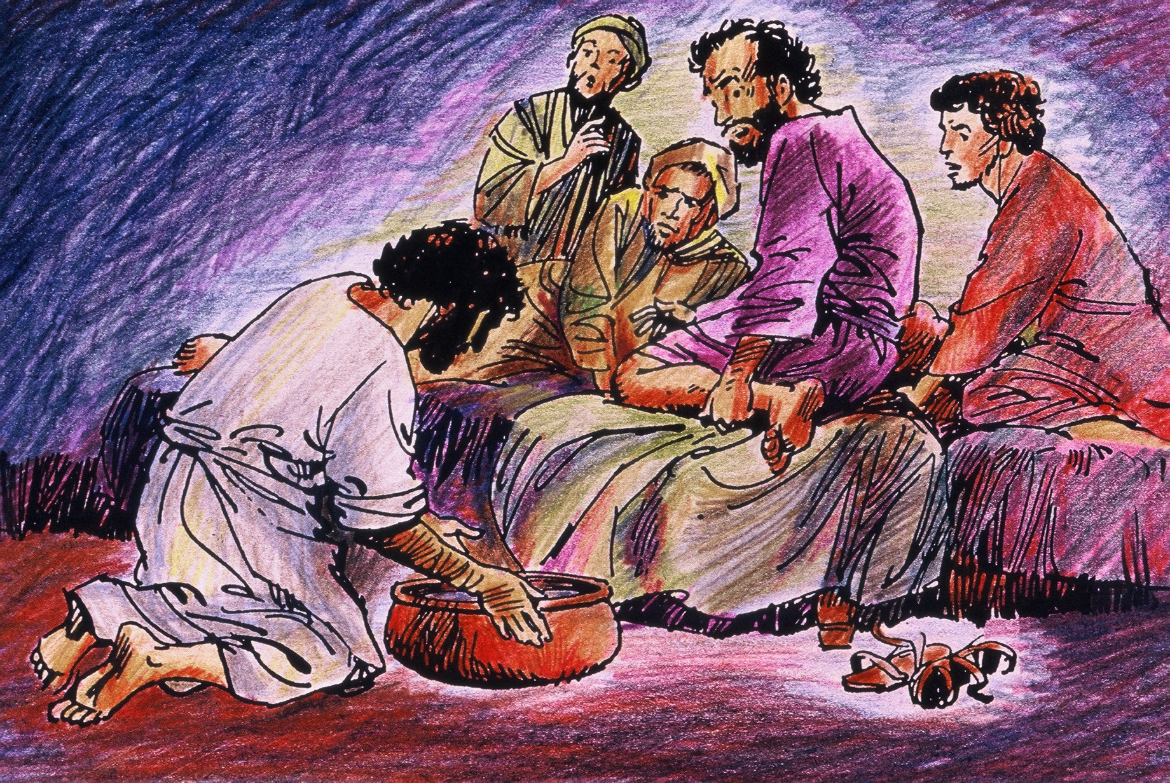

Resource Sheet 2
Some Gospel stories that tell us how Jesus loved others
Jesus blesses the little children
(Mark 10:13-16)

Jesus visits and shares a meal with Mary and Martha
(Luke 10:38-42)

Jesus performs a miracle at the Wedding Feast at Cana
(John 2:1-10)

Jesus heals the lepers
(Luke 17:11-19)

Jesus and Zacchaeus
(Luke 19:1-10)

Jesus feeds a large crowd
(Mark 8:1-10)

Jesus heals a blind man
(Mark 10:46-52)

Jesus invites people to come and see
(John 1:35-39)
My favourite Gospel story about how Jesus showed love for others is…

_____________________

_____________________

_____________________
This is because…
_____________________

_____________________

_____________________
It was written by…

_____________________
Some ways I can be like Jesus and show love for others are…

_____________________

_____________________

_____________________

_____________________

Resource Sheet 3
Jesus’ way of showing love…
Draw examples in each circle

Colour and display as a mobile
Cut around each circle and glue back to back

My way of showing love…

Resource Sheet 4
Name:
My Saint is ____________________________
Some interesting facts about my saint are:

___________________

___________________
___________________
___________________
___________________
___________________
___________________
Picture of Saint _________________
Home Activity: Tell your child about your favourite saint. Your local library or www.catholic.org/saints/ website may be helpful. Illustrate the saint and write some interesting facts about him or her.

Resource Sheet 5
St Patrick’s Breastplate
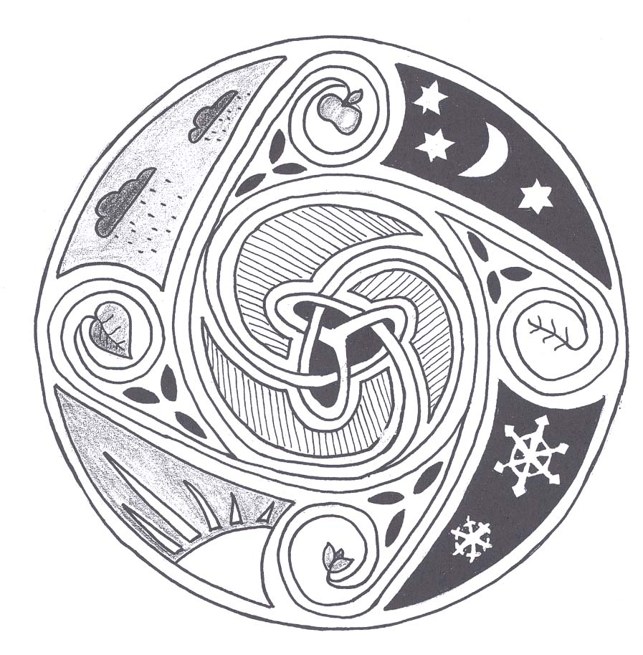
Christ with me,
Christ before me,
Christ behind me,
Christ beneath me,
Christ above me,
Christ at my right hand,

Christ at my left hand,
Christ all around me,
Christ in my lying down,
Christ in my sitting,
Christ in my rising,
Christ in the heart of everyone who thinks of me,
Christ in the mouth of everyone who speaks of me,
Christ in every eye that sees me,
Christ in every ear that hears me.

