2.4A – The Church’s Year - 2D masters (1)

The Seasons of the Year
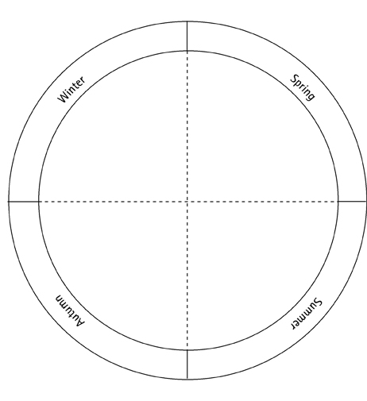
2.4A – The Church’s Year - 2D masters (2)

The Seasons of the Year


2.4A – The Church’s Year - 2D masters (3)

The Church’s Year

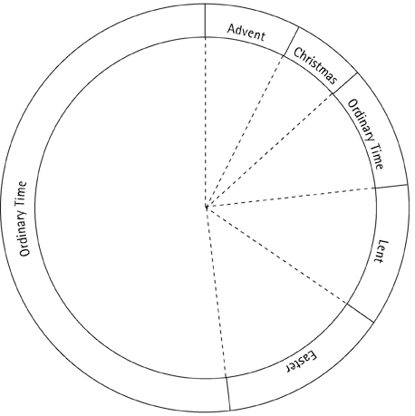
2.4A – The Church’s Year - 2D masters (4)
The Church’s Year


