1.6 Love One Another
This unit focuses on the concept of relationship. It begins with the children’s experience of friendship and broadens to the Christian way of relating to others. It then focuses on forgiveness and gratitude in relationships through two Gospel stories – ‘How many times must we forgive?’ and ‘The Ten Lepers’.

Outcomes
Students will be able to:
S1.5.2 express an understanding of God as loving and forgiving
S1.11 identify Christian ways of relating to others

Scripture | Doctrine
Students are introduced to doctrine through Scripture and the living Tradition of the Church.
Matthew 18:21-22 Seventy Seven Times  Luke 17:11-19 The Ten Lepers | - God loves all people  - God helps us show love and forgiveness  - Jesus teaches us to love one another as he loves us

Spiritual Reflection for Teachers
Relationships, especially friendships, are about sharing the good and bad times together.
Everyone makes mistakes. Forgiveness is not only about accepting someone else’s humanity. It is also about accepting our own humanity: a much harder challenge. It is about accepting God’s design for us rather than our own. Forgiving does not mean that all of a sudden you do not feel hurt or that the wrong choice someone made was right. It means that you find it in your heart to give the person another chance. Forgiveness is about acknowledging what is, moving ahead, ready to do things differently, with compassion for yourself and others, and faith that you and others can change.
The world craves for the energy of people who fail but who know that they are forgiven and attempt to model this Christian reality for others.
- What difficulty do I have with ‘forgiveness’?
- forgiving others?
- forgiving myself?

Catechism of the Catholic Church
Excerpts from the Catechism of the Catholic Church are included below as information for teachers. They present the Church’s teachings contained in the unit.
982 There is no offence, however serious, that the Church cannot forgive. "There is no one, however wicked and guilty, who may not confidently hope for forgiveness, provided his repentance is honest.” Christ who died for all men desires that in his Church the gates of forgiveness should always be open to anyone who turns away from sin.
1939 The principle of solidarity, also articulated in terms of "friendship" or "social charity," is a direct demand of human and Christian brotherhood.
An error, "today abundantly widespread, is disregard for the law of human solidarity and charity, dictated and imposed both by our common origin and by the equality in rational nature of all men, whatever nation they belong to. This law is sealed by the sacrifice of redemption offered by Jesus Christ on the altar of the Cross to his heavenly Father, on behalf of sinful humanity."
2638 As in the prayer of petition, every event and need can become an offering of thanksgiving. The letters of St Paul often begin and end with thanksgiving, and the Lord Jesus is always present in it: "Give thanks in all circumstances; for this is the will of God in Christ Jesus for you"; "Continue steadfastly in prayer, being watchful in it with thanksgiving."

Scripture: Background Information

Matthew 18:21-22 Seventy Seven Times
The gospel of Matthew is divided into five narratives and five speeches or discourses. Chapter 18 is known as the ‘community’ discourse and hence is about how to live together. One of the important necessities of living with others is the obligation to forgive over and over again. Jesus is asked here how many times we should forgive someone. He stipulates seventy seven times, as a way of saying – always. We forgive others continually. This is not an easy thing to do.

Luke 17:11-19 The Ten Lepers
This passage in Luke’s gospel about Jesus healing the ten lepers, is a familiar one. It is remarkable that this story is so familiar, as it appears in only one gospel. It is unique to Luke and fits in with Luke’s openness and inclusiveness of gentiles. The Samaritan leper, at the focus of this story, considered himself a son of Abraham and thus a true Israelite. However there was animosity between Jews and Samaritans at the time of Jesus. Jesus does call him a foreigner but nonetheless praises his faith. Jesus’ involvement in this healing is very minimal. He simply sends the lepers to the priests who had to pronounce them clean so that they could take their place with their families in society again. They are all cured on the way but the Samaritan, the foreigner, comes back to thank Jesus. High and solid barriers separated lepers from the rest of society, so the Samaritan leper was thus doubly ostracised. Ironically the one who is the outcast is the one who truly realises the significance of being humanly whole again. The one least expected to is the one who shows gratitude. The focus of the story is not on the healing but the meaning and consequences of accepting the outcast, the marginalised and those on the edges of our societies - those with thankful hearts.

Suggested Assessment
Suggestions for determining students’ development towards the achievement of the outcomes are included below:
S1.5.2 express an understanding of God as loving and forgiving
The students typically might:
- refer to God’s love and forgiveness in writing
- make comments about God’s love and forgiveness
- express gratitude for God’s gifts
S1.11 identify Christian ways of relating to others
The students typically might:
- talk or write about the importance of forgiveness and gratitude in relationships
- express thanks to others and God
- discuss or list qualities of good relationships
- role play scenarios of healthy relationships

Resources
To Know Worship and Love – Book 1, Chapters 18 and 19, (2005), James Goold House Publications, Melbourne, Victoria
To Know Worship and Love – Big Book, Jesus Cares for People, ‘The Ten Lepers’

Teacher Resources
Cooney J and Burton K, (1986), Photolanguage Australia: Human Values, Catholic Education Office, Sydney
Reehorst J, Guided Mediations for Children, Wm C Brown Company Publishers, Dubuque, Iowa

Literature (about Friendship/Relationship)
Allan N, (2004), The Dove, Red Fox, London
McBratney S, (2000) I’m Sorry, HarperCollins Publishers, Great Britain
Grindley S, (2000), What Are Friends For? London, Kingfisher
Lucardo M and Heinze M, (2000), Because I Love You, Crossway Books, Illinois

Websites
http://www.ncls.org.au/default.aspx?docid=3072 assorted photos

NOTE: See RE Online for additional resources for this unit.

Unit Content A: living as friends
Our friendships help us to know God’s love.
Students will:
- explore qualities of friendship
- explore choices that build healthy relationships

Background Information
This Unit Content could be either integrated with Unit Contents B and C, or taught separately. While it does not have a specific story, it allows for the possibility of using carefully chosen children’s literature to explore friendship and relationship and the qualities of these. See ‘Resources’ section and ‘RE Online’ for further suggestions. Unit Contents B and C deal with forgiveness and gratitude – two important qualities needed in Christian relationship. Hence another possibility is to use Unit Content A as an introduction and conclusion to this unit.
Relationships are at the heart of Christian life. God initiates relationship with each person. The Church community is people in relationship. Being human is to be in relationship. Christian morality requires right relationship with self, others, creation and with God. Right relationship is an expression of love: love others as I have loved you…love others as you love yourself … love the Lord your God with all your heart … . What does it mean to love?
In relationships there is always opportunity for giving of oneself, expressing gratitude, seeking forgiveness or forgiving, being with the other … Year 1 children bring some experience of relationship to this unit. They have family relationships, and friendships. They are also learning how to relate to other children in the class and school and to staff. At times they will need to think about ways of treating people they do not get along with or do not ‘like’. This is all part of the process of socialisation in the school and wider society. Hence there will be opportunities for talking about and solving real situations in relationships.
Making choices is also an important aspect of relationships. People in relationship can make choices that build or diminish relationship. In exploring friendship, encourage children to think about choices they make to be friends or not to be friends. Begin by using children’s literature to explore qualities of good friendship and what it looks like. Again there are opportunities within the life of the classroom and school where exploring real life situations is possible. For example, when children fight during lunch time, when there is a situation of bullying or isolation, the class could spend time talking about the Christian response. Here is a great opportunity to invite children to a lived response, appropriate to their level. Spend time exploring the joy and hope that comes from friendship.

Suggested teaching/learning strategies
The following suggested activities are organised around the key elements of Telling the Story, Wondering, Exploring and Prayer. Teachers select, adapt or substitute activities, ensuring that each of the abovementioned elements is evident in the cycle of learning.
- Prayer: Throughout the unit, use the prayers from KWL chapters 18 and 19 and prayers about relationships. Sometimes it might be appropriate to display a picture of the person for whom the students are praying. Pictures might include people in the class, photos to remind us of the poor…those that need our prayer/help… family members…
- Using children’s literature, read stories to the children with the theme of relationship and/or friendship. In selecting literature make sure you cover various types of relationships: peer friends, adult–child friendship, family relationships, friendships with a challenge / cross boundaries.
- Wonder about the story with the children. Design wondering statements specific to the story and adapt these generic ones when appropriate: I wonder…
      - what is your favourite part of the story
      - if you have experienced…
      - what the story tells us about friendship / relationship
Remember, wondering statements are open and call for children’s ideas. There are no right or wrong answers.
- Using the stories, begin to build up a list of qualities of good relationship. Add to this list periodically.
- Create a wall of words and images to describe the qualities of friendship.
- Children finish the following sentence: “Friendship is like…”
or
Brainstorm in groups possible answers to the questions:
- How is friendship like a sunny day?
- How is friendship like a rainy day?
or
In groups, children brainstorm possible endings to the following stems: Being friends feels like… Being friends looks like… Being friends sounds like… This could be done using diagrams, eg a circle divided into three.
- Explain that sometimes it is difficult to be friendly. What prevents us from being good friends? What choices can we make to be friendly with members of the class? Invite children to think of one way to show friendship at school or home and do it in the next few weeks. During daily prayer, give children time to reflect on some choices they have put into action to promote friendship.
- Have children from older grades talk to the class about making easy and difficult choices about friendship / relationship. This could also be an activity to conclude the whole unit – the older children might talk about forgiveness and gratitude in their friendships.

Unit Content B: Forgiveness
Forgiveness is an important part of relationships.
Students will:
- listen and respond to Jesus’ teaching on forgiveness in Matt 18:21-22
- explore the need for forgiveness in relationships

Background Information
In this short text of Matthew’s Gospel Jesus teaches about forgiveness. Christians need to always forgive. No person is perfect and no relationship is perfect. Hence healthy relationships need those involved to be willing to forgive and to seek forgiveness. This is a deeply human dynamic and a deeply religious dynamic. Only through the practice of forgiveness can a person find peace.
Underlying this teaching is belief in a God who forgives. God’s love and forgiveness is constant and unconditional. It is not dependent on the individual. The task of the individual in relationship with God is to be open to receiving God’s love and forgiveness. Often the concept of forgiveness is viewed negatively. However, the opportunity of forgiveness can be joyful and hopeful.
In this Unit Content, time is spent recalling God’s love and forgiveness and the human experience of forgiveness. Forgiveness is learnt by experience. Children begin to know God as forgiving when they experience forgiveness – being forgiven and forgiving others. The teacher can model this in his/her relationship with the children. There are times when the teacher needs to show forgiveness to the class or individual child. There are also times when the teacher needs to seek forgiveness from the class or individual child.
In Year 2 these concepts will be further developed as children learn about the Sacrament of Penance.

Suggested teaching/learning strategies
The following suggested activities are organised around the key elements of Telling the Story, Wondering, Exploring and Prayer. Teachers select, adapt or substitute activities, ensuring that each of the abovementioned elements is evident in the cycle of learning.
- Tell the story of forgiveness using the script from KWL ch 18 and 3D concrete material. Prepare yourself by reading Matt 18:21-22.
You might begin the story by making the connection with the Bible, eg “This story comes from our special book, the Bible, so we know it will tell us something about God. It will tell us how to treat one another.”
Materials needed: figures of Jesus, a few disciples, a card with 70x7 written on it.
- Wonder with the children using KWL p136 ‘I wonder’:
      - if anyone has ever been unkind to you
      - if you have ever been unkind to anyone
      - why Jesus told Simon Peter to forgive 70 times 7
      - when we need to forgive
      - how it feels when someone forgives you
      - to whom we say sorry
- Children role play situations showing forgiveness. The teacher may discuss scenarios with the class or give groups a predetermined scenario. Continue exploring forgiveness through drama – contrast feelings of being forgiven, not being forgiven; saying sorry, not saying sorry…
- Read KWL ch 18. Discuss illustrations on pp132 and 135. What is happening?
- Journaling – Children write in their journals about experiences of forgiveness, review the day or the previous day…
- Students illustrate ways they can forgive others – collate into a forgiveness book or a wall display. Add words. The computer programs: Kids Pix or Word Art could be used.
- Create a forgiveness wall in the classroom, with illustrations and words depicting all the ways we can forgive each other.
- Paint situation where people need to show forgiveness.
- Lead children through a painting strategy to show contrast in feelings between forgiving and not forgiving.
- Photo language: Children find photos that remind them of forgiveness. – published photo language kits might be useful, or collect pictures. See Photolanguage Kit.
- Write simple poems about forgiveness, eg Forgiveness is like… The teacher will need to take children through the steps and provide scaffolding. This can be integrated with English.

- Prayer: Before the end of the day, lead children through a very simple ‘Examination of Conscience’. Light a candle and settle children. Invite them to think about the day:
Proclaim Mt 18:21-22 from the Bible.
Teacher: Think of a time today when you were a good friend … helped someone … (pause)
Students: Thank you, God, for giving me the opportunity to be a good friend.
Teacher: Think about a time today when you could have been a better friend … did you upset someone?… did you not include people in your play?… (pause)
Students: God, forgive me for not always being a good friend to others. Help me be a better friend tomorrow.
Finish the quiet reflection time with a prayer that the children know, eg the ‘Our Father’.
- Children read KWL ch 18 with a family member and do the Home Activity.
- Discuss with children: “What do you find hard about forgiving?” As a class, pray the prayer on KWL p137.

Unit Content C: Giving Thanks
Expressing thanks is an important part of relationship.
Students will:
- listen and respond to the story of the Ten Lepers
- explore ways to express gratitude to others and to God

Background Information
Ten lepers are healed, one comes back to give thanks to Jesus. How often do people express gratitude or fail to express gratitude? Wouldn’t relationships be much better if we always said ‘thank you’ or communicated gratitude in some way?
Just as forgiveness is an essential quality for relationships, so too is gratitude. Gratitude is a form of affirmation that acknowledges the gift of others. Gratitude also acknowledges that there is choice in how we relate in the world, and to each other. Human beings are relational. For what are we grateful? And to whom are we grateful?
How do we express gratitude? Spend some time with children looking at ways they can communicate gratitude and invite them to do so in the classroom, school playground and home. Also spend some time reflecting on experiences where they expressed gratitude and where they were shown gratitude. How do we express gratitude to God? Give children experiences of prayers and liturgies of thanksgiving, eg a psalm of thanksgiving.
As with forgiveness, gratitude is learned by experience. The teacher can model gratitude in his/her relationship with the children. There are many times when we can say ‘thank you’, express gratitude for a person’s actions or words or something that happens. Included here is modelling gratitude to God. It is important that children see the teachers expressing gratitude to God.

Suggested teaching/learning strategies
The following suggested activities are organised around the key elements of Telling the Story, Wondering, Exploring and Prayer. Teachers select, adapt or substitute activities, ensuring that each of the abovementioned elements is evident in the cycle of learning.
- Tell the story of the Ten Lepers using 3D concrete materials. See ‘Resource Sheet 1’ for script. Prepare yourself by reading Lk 17:11-19.
- Wonder with the children using KWL p144. I wonder:
      - what it would be like to be a leper
      - why people would be afraid of going near a leper
      - why the lepers asked Jesus to help them
      - what you think the leper who came back said to Jesus
      - what you would say
      - why the others did not come back
      - how the lepers felt when they were healed
        - Discuss with the children:
- When do people say ‘thank you’?
- When can we say ‘thank you’ to each other?
List some alternative ways of saying thanks and display these in the classroom.
        - Revisit the story using KWL Big Book, Jesus Cares for People, ‘The Ten Lepers’.
        - Drama: Role-play the story of the Ten Lepers. Use various drama strategies to explore the three dramatic moments of the story:
      - Pleading for help
      - Being healed
      - Gratitude
        - Re-tell the story. Use Guided Meditations for Children, p51 for prayer. This is a guided meditation that puts the child into the story of the Ten Lepers.
        - Make a large ‘Thank You’ banner and display it on the wall. Add to the wall display using children’s work around gratitude. Possible activities that can be added to the wall display on ‘Gratitude’:
    - Paint or draw their favourite part of the story or illustrate how the lepers may have felt after they were healed.
    - Paint / draw / illustrate what you are grateful for: people, objects, gifts and talents, experiences…
    - Write a short dialogue between the grateful leper and Jesus. What might the leper have said and what might Jesus have said in response. This can be an individual, group or class construction.
    - Children finish the sentence: “I give thanks for ...”
    - Children brainstorm ways to express gratitude. Children could discuss and dramatise these. Invite the children to take one idea and use it at home – show gratitude to a family member. Provide time in the following days for the students to reflect upon whether they showed gratitude or not.

- Children use the concrete materials to revisit the story.
- Prayer: use KWL p145. Give each child one line to read aloud. Children might read their own statements from the previous activity – “I give thanks for…” Sing a hymn of thanksgiving.
- Give children the ‘Thank you card’ (‘Resource Sheet 2’). Each child thinks of someone they would like to thank. Decorate the card and write a message of thanks to that person. Alternatively, children could design their own thank you cards on the computer.
- Repeat the above activity for homework – making thank you cards. Children could read KWL ch 19 with their parents/guardians. Share the things for which they are grateful.
- Give thanks in prayer each morning. For example:
- Pray Psalms of thanksgiving, eg Ps 9:1-2; 33:1-5; 34:1-5; 108:1-5; selected verses from Ps 96, 103, 104. The language will need to be adapted for children. The book Praise would also be helpful here.
- Have all the names of the children in a bowl. Each day choose a name, or a few names, from the bowl and give thanks for that child. Another option could be to call each child by name to place their written name in a bowl, then invite the class members to give thanks for them. If known, students could conclude prayer by singing the hymn – I have called you by your name you are mine
- Use prayers of thanksgiving from books which have collections of prayers and reflections.
- Write a class ‘thank you’ prayer. Ask the children to first think about what the class is grateful to God for and why. Then write the prayer together with the teacher as scribe. Use photos to give children ideas of what they might thank God for.
See http://www.ncls.org.au/default.aspx?docid=3072 for possible photos.
Resource Sheet 1
ONLY ONE SAID ‘THANK YOU’
KWL Chapter 19
(Luke 17:11-19)
You will need:
- figures: Jesus, ten lepers
- green or brown felt for the ground

Children are seated in a semi-circle ready to listen to the story. When the children are settled, go to the shelf and carry the materials as you would the Bible. Place these beside you.
This story comes from our special book, the Bible, so we know it will tell us something about God. It will tell us something about relating to one another.
Lay out the felt and begin.
Put the figure of Jesus on the felt.
Lepers were people who had a terrible skin disease – and a terrible life.
Add the ten lepers to the scene
Lepers were not allowed to live with other people, because people were afraid of catching their disease. If anyone came near a leper, the leper had to warn the other person to go away. No one was allowed to touch lepers.
Put you hands between the lepers
and Jesus to create a barrier.
One day, ten lepers called out to Jesus, and asked for his help. Jesus told them to go and show themselves to the priests.
Move lepers towards Jesus one at a time.
The priests were the people who had to say whether or not they were really healed. On the way to the priests, the lepers saw that they were cured. Jesus had healed them.
Move lepers away from Jesus.
One of them came back to Jesus to say thank you. Jesus was surprised. Even though ten had been cured, only one of them came back to say thank you.
Move one leper to the figure of Jesus
and have them facing each other.
Engage with ‘I wonder’, KWL p144.
Carefully pack story materials into storage box and put on shelf. Ensure that children are watching so they know how to pack the materials away and where to find them.
Thank you card Resource Sheet 2
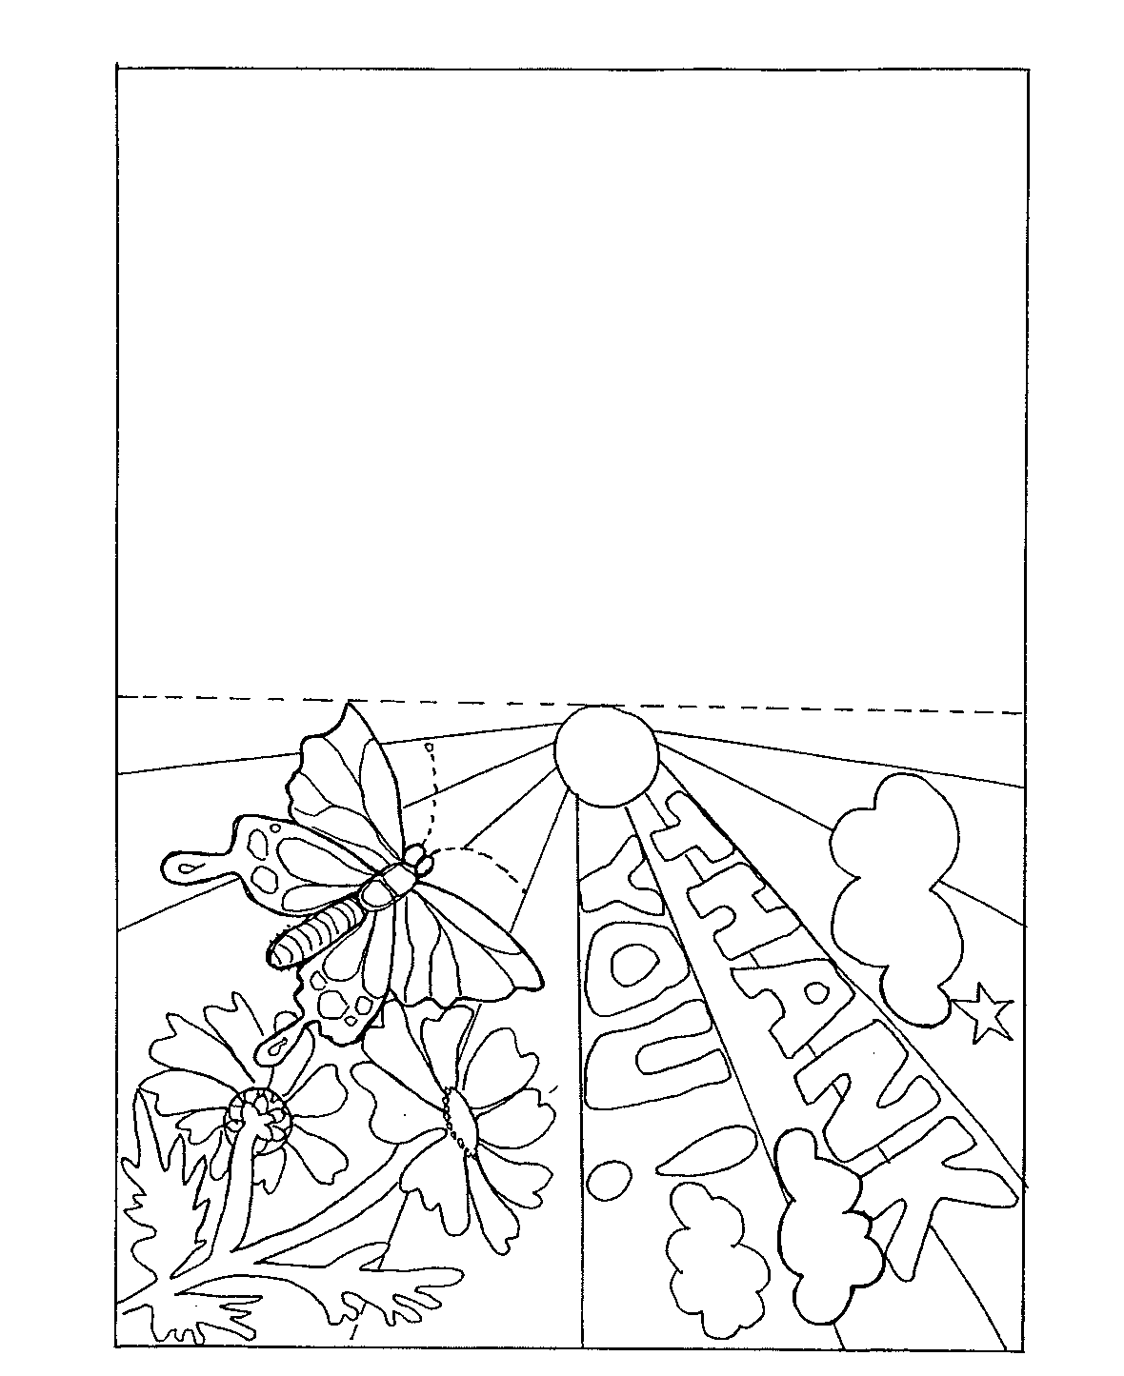
(From KWL Teaching Companion, Level 2a: p214)

